THE CYCLE

Whole Planet Coupling,
The Organic Solar System’s influence on Earth,
The Great Year,

And a Comprehensible Mechanism for the
Core Mantle Decoupling Event.

By P.S.H.S

INTRODUCTION

Understanding the dynamic processes within Earth's interior is essential for deciphering the planet’s geological past and anticipating its future evolution. Central to this endeavor is the core-mantle boundary (CMB), a critical interface where the liquid outer core meets the solid mantle, driving Earth’s geodynamic engine. The widely accepted Core Mantle Decoupling Dzhanibekov Oscillation Theory (ECDO) posits that periodic decoupling of the core and mantle arises from shifts in the core’s hexagonal packing, ultimately forming Large Low Shear Velocity Provinces (LLSVPs). Yet, this theory’s focus on structural mechanics alone overlooks the intricate chemical and dynamic interactions increasingly evident at the CMB.

Through an integrated analysis of geochemical and geophysical data, I attempt to provide a mechanism propelled by the interplay of water and hydrogen at the CMB. This model reveals that water, transported to the deep mantle through subduction, reacts with the iron-rich core, producing compounds like FeO and FeH. These reactions reshape mantle dynamics, triggering the formation of Ultra-Low Velocity Zones (ULVZs) and fueling hydrogen-driven mantle plumes that manifest as LLSVPs, volcanic activity, aid for core-mantle coupling, and surface expressions.

Beyond Earth’s interior, I investigate how external cosmic factors, such as solar cycles, planetary alignments, and lunar tides, modulate these deep processes. These findings unveil a synchronized cycle linking Earth’s core and Space to its tectonic and atmospheric evolution, offering new insights into historical geological shifts and future predictions. This interdisciplinary perspective seeks to dismantle outdated paradigms, providing a comprehensive view of Earth’s geodynamic system and its cosmic connections.

By blending geochemistry, geophysics, and astronomy, this study hopefully lays the groundwork for exploring the profound interplay of forces shaping Earth, from its deepest recesses to the wider universe.

To improve reading accesibility of this work, with aid of ChatGPT, I’ve included in the start of each section a layman’s terms synthesis paragraph in bold letters, so that any reader can quickly understand what each section is about.

Index

PART 1. THE CORE
- The Composition of Earth’s Core
- Core-Mantle Interaction
- Ferric Oxide
PART 2. THE MANTLE
- The Earth’s Mantle
- Water and Hydrogen content in the Mantle
- Dissolved water weakens mantle minerals
- Interaction of Water in the Core-Mantle Boundary (CMB)
- Formation of ULVZs
- Approximate Order-of-Magnitude Calculation for Yearly FeO Mass Creation at the CMB
- The Large Low Shear Velocity Provinces (LLSVPs)
PART 3. THE DEGASSING
- The Pathways of Hydrogen
- Plume Creation
- Volcanic Degassing and VOC/H2O Balance
- Reaction Pathways, P-T Ranges, and Kinetic Constraints
PART 4. THE SURFACE
- Amagmatic Ghost Plumes: A Source of Liquid Water
- The Troposphere and Stratosphere’s Balance
- The Great Greenhouse Contradiction
- Hydrogen at the Atmosphere
- Solar Flares and Coronal Mass Ejections
PART 5. THE COSMOS
- The Influences Outside of the Earth
- The Influence of the Moon
- Solar Flares, Solar Sunspot Activity, and the 11 year Sun Cycle can be Predicted by Planet Alignment
- Planetary Alignment
- The Jupiter and Saturn Connection
PART 6. THE CYCLE
- What does it take for the CMB Event to Happen
- A Geomagnetic Weakening?
- The Lunar Tetrad and the Great Conjunctions
- The Comet Research Group
- Comets, Gobekli Tepe and Noah’s Flood
- Where we are Now, and What’s Next
PART 7. CONCLUSIONS
- Mentions for Future Work
BIBLIOGRAPHY

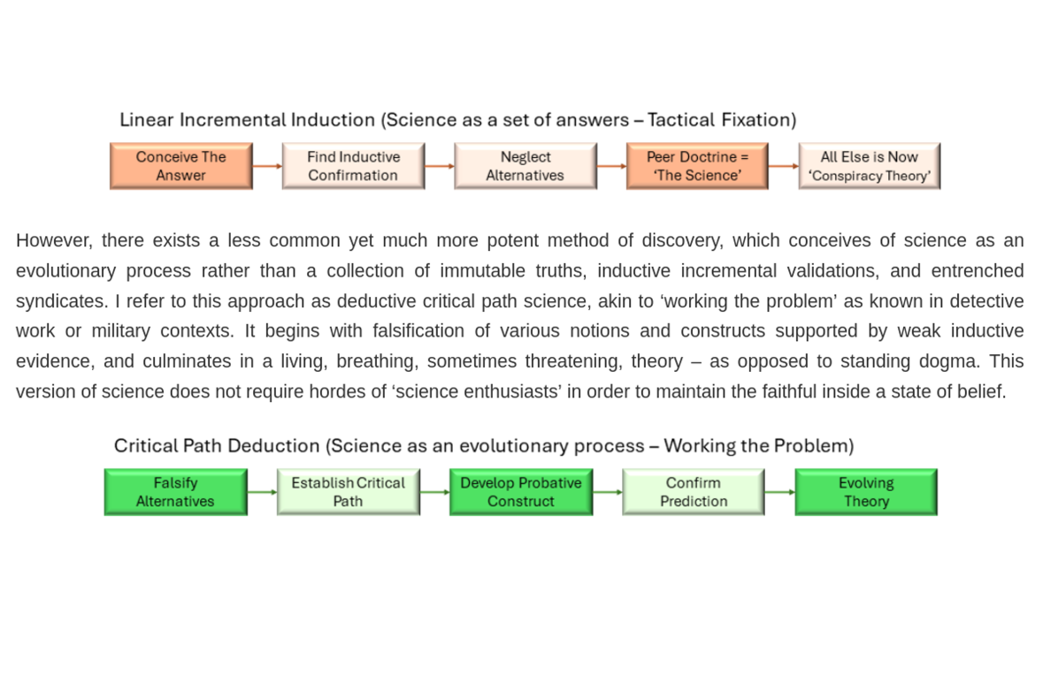

In honor of this scientific path construct as construed by the author of ECDO, I will be taking the second path, Critical Path Deduction.

Falsify alternatives and Establish Critical Path:

PART 1.

THE CORE

The Composition of Earth’s Core

Imagine the Earth’s center as a giant ball of iron and nickel metal, but when researchers “listen” to it with seismic (earthquake) waves, it sounds about 5–10% lighter than pure iron and nickel should be, like finding your bag of sugar is mysteriously missing a few spoonfuls. To fix that mystery “missing weight,” studies suggest bits of lighter ingredients like silicon, hydrogen, oxygen, carbon, or sulfur got mixed in. Silicon and hydrogen are top suspects because the early Earth had lots of water and rocks, and when molten iron met water in a deep magma ocean, it grabbed hydrogen (and some oxygen and silicon) into the core. Over time, this created a lighter, oxygen-rich layer at the core-mantle boundary, which may explain big events in Earth’s history, like massive oxygen releases and even the rise of life’s oxygen in the atmosphere.

The Earth's core is believed to be primarily composed of an Fe-Ni alloy. However, seismic observations show that the density of the core (both liquid outer core and solid inner core) is lower than that of pure iron or Fe-Ni alloy at the relevant pressure and temperature conditions. [4][17] [29] This is known as the "density deficit"[17]. To explain this density deficit, it is generally accepted that the core contains light impurities or light elements alloyed with the iron and nickel. [17][4][5][1] The specific identity and relative amounts of these light elements are still debated, due to mismatch in seismic data and density compared with the Fe-Ni theory. [3]

“The Earth's core is believed to primarily consist of Fe-Ni alloy according to cosmoschemical and geochemical constraints (Badro et al., 2015; McDonough & Sun, 1995). However, the seismologically-constrained density of the Earth's core, such as one from the preliminary reference Earth model (PREM) (Dziewonski & Anderson, 1981), is 5%–10% lower than that of Fe and Fe-Ni alloy at the pressure and temperature (P-T) condi-tions expected to the core (Dewaele et al., 2006; Fei et al., 2016; Sakai et al., 2014), which is known as the density deficit (Birch, 1952). Extensive experimental and geochemical studies have proposed different light elements to explain such a density deficit, including silicon (Si), sulfur (S), oxygen (O), carbon (C), and hydrogen (H) (Hirose et al., 2021). Among them, Si and H are important candidates due to their abundances in the Earth system (McDonough & Sun, 1995) and their high solubilities in Fe metal at high P-T (Badding et al., 1991; Fischer et al., 2013; Fu et al., 2022, 2023). “ [17]

Candidate light elements proposed by experimental and geochemical studies include Silicon (Si), Sulfur (S), Oxygen (O), Carbon (C), and Hydrogen (H)[17][4][1][]. Silicon (Si) and Hydrogen (H) are considered important candidates due to their abundances in the Earth system and their high solubilities in Fe metal at high pressures and temperatures[3]. Geochemistry, metal-silicate partitioning experiments, and isotope fractionation experiments support Si as the dominant light element.[1] Carbon (C) might also have been present in the core in the past due to its abundance in primitive chondritic meteorites and its siderophile nature during metal-silicate differentiation.

Recent planet formation theories suggest that a large amount of water could have been delivered to the growing Earth.

“Since Birch reported the density deficit and velocity excess of the Earth’s outer core with respect to pure iron (Fe), light elements in the core have long been explored but still remain controversial. Recent planet formation theories suggested that a large amount of water could have been delivered to the growing Earth. The chemical reaction of water with Fe metals in a magma ocean led to the incorporation of hydrogen (H) along with silicon (Si) and oxygen (O) into the core6–9. While O is least partitioned into solid Fe and should therefore be negligible in the inner core10–12, both Si and H could be present in both the outer and inner core. Indeed, measurements of the density and sound velocity of solid Fe and Fe alloys supported that Si and H are important impurity elements in the inner core. Recent theoretical calculations suggested that the Earth’s solid inner core is an hcp Fe60Si4H1–15 alloy, depending on the temperature at the inner core boundary (ICB), TICB = 5500–6500 K. “[3]

The chemical reaction of water with Fe metals in a magma ocean could lead to the incorporation of H, along with Si and O, into the core, causing the great Oxidation event.

“Hydrous minerals in subducted crust can transport large amounts of water into Earth’s deep mantle. Our laboratory experiments revealed the surprising pressure-induced chemistry that, when water meets iron at the core–mantle boundary, they react to form an interlayer with an extremely oxygen-rich form of iron, iron dioxide, together with iron hydride. Hydrogen in the layer will escape upon further heating and rise to the crust, sustaining the water cycle. With water supplied by the subducting slabs meeting the nearly inexhaustible iron source in the core, an oxygen-rich layer would cumulate and thicken, leading to major global consequences in our planet. The seismic signature of the D′′ layer may echo the chemical complexity of this layer. Over the course of geological time, the enormous oxygen reservoir accumulating between the mantle and core may have eventually reached a critical eruption point. Very large-scale oxygen eruptions could possibly cause major activities in the mantle convection and leave evidence such as the rifting of supercontinents and the Great Oxidation Event. “[26]

Regarding the inner core:

The Earth’s solid inner core is mostly iron packed in a hexagonal close‐packed structure, but it’s a little “lightened” by small amounts of other elements, mainly about 1.6–3 weight % in silicon and 0.15–0.6 weight % in hydrogen. These silicon and hydrogen levels can explain why the core’s density is about 4% lower than pure iron and why seismic waves travel through it more slowly. There’s a trade-off between Si and H: if you put in more silicon, you need less hydrogen, and vice versa, and while some models push silicon up to ~4.7 wt% or hydrogen to ~1.4 wt%, oxygen and carbon barely get into solid iron under those extreme pressures, so they don’t matter in the inner core.

The solid inner core is primarily hexagonal close-packed (hcp) Fe [17][4][3] containing some light elements. However, based on combining new data with existing datasets, models suggest the inner core likely contains around 1.6%–3% silicon and 0.15%–0.6% hydrogen by weight. [17]

“The Earth's inner core is believed to be made up of solid iron and nickel alloys, but there are also some lighter elements alloyed in. We studied how silicon and hydrogen affect the density and sound wave velocity of the iron alloys in the inner core. We combine our new data with existing datasets to create a model that shows that the inner core likely contains around 1.6%–3% silicon and 0.15%–0.6% hydrogen. These amounts can explain the density and sound velocity of the inner core as observed through seismic measurements. ”

There is a large trade-off between the estimated Si and H contents needed to match seismic data; for instance, higher Si content would mean lower required H content and vice versa. Other sources suggest that the maximum estimated Si content is approximately 4.7 wt% and maximum H content is approximately 1.43 wt%

Oxygen (O) is considered highly incompatible with solid Fe metal, so only a trace amount of O may exist in the inner core [3]. Carbon (C) is also unlikely to be an important impurity element in the inner core due to its low solid-hcp/liquid partitioning coefficient.

“Discussion Crystallization of hcp Fe–Si–H at Earth’s inner core. The solid inner core of our planet consists of hcp Fe containing some light elements; the inner core density deficit with respect to pure Fe has been estimated to be about 4%41,47. While the least amounts of O and C are incorporated into solid Fe in the inner core10,12,22, Si, H and S are known to form solid solution with Fe to some extent18,19,23,33 and likely present in the solid core. Nevertheless, interactions among Si, H and S atoms in hcp Fe could be strong and affect their simultaneous solubilities as well as solid–liquid partitioning48,49. Indeed, the liquid immiscibility, a typical consequence of the strong interaction, has been observed between Fe–H and Fe–S liquids to > 100 GPa50. ”[3]

“Recent ab initio simulations performed by Refs.17 and 51 emphasized the presence of C and/or H in the solid inner core, in order to account for not only the density but the low P- and S-wave velocities observed. As mentioned above, C is unlikely to be an important impurity element in the inner core because of its low DC (solid-hcp/ liquid) ~ 0.122; otherwise the liquid core should be enriched in C, which is not compatible with its density and velocity observations . Alternatively the inner core alloy may be H-bearing hcp Fe60Si4H1–15 when TICB ranges from 5500 to 6500 K (more H is necessary for lower TICB). “ [3]

H is particularly emphasized as necessary to account for the low P- and S-wave velocities observed in the inner core, in addition to density.

Regarding the outer core:

Recent studies show that Earth’s liquid outer core has about 2–3.6% silicon by weight, and experiments tell us that silicon and hydrogen basically go into the solid inner core almost as much as they stay in the liquid outer core (their “preference numbers” are near one), so they can’t explain why the outer core is lighter than the inner core. To make up the density difference, we need another light element that really hates being part of iron; oxygen fits the bill: it stays almost entirely in the liquid, is barely found in the growing solid inner core, and so its presence in the outer core is what makes that layer less dense than the inner core.

Recent models considering both geochemical and geophysical constraints (Badro et al., 2015) suggest that the outer core contains 2–3.6 wt% Si. [17]

Experimental measurements indicate relatively high solid/liquid partition coefficients for Si (DSi = 0.94(4)) and H (DH = 0.70(12)) between hexagonal close-packed (hcp) Fe and the coexisting liquid. These values, being close to 1.0, imply that the concentrations of Si and H do not differ significantly between the outer and inner core. This relatively small difference in Si and H concentrations between the outer and inner core requires the inclusion of other light elements in the outer core to explain the observed density contrast between the outer and inner core. Oxygen (O) is identified as a key candidate for this role, as it is least partitioned into solid Fe compared to S and Si, and is expected to be negligible or exist only in trace amounts in the solid inner core due to its high incompatibility with solid Fe metal. The presence of Oxygen in the liquid outer core, which is largely excluded from the solid inner core during crystallization, is thus crucial to account for the density difference between the outer and inner core. [3] [17]

The outer core liquid may include 1.7–4.4 wt% O, along with Si and H, depending on the inner core boundary (ICB) temperature [1][2][17]. The reduction of the Fe-FeO miscibility gap with increasing pressure is expected to significantly affect core differentiation mechanisms, controlling oxygen partitioning.

Precious Metals as Core Components and Tracers

The Earth's core, comprising a liquid outer core and a solid inner core, is widely considered to be a significant reservoir for various elements, including what are often referred to as precious or noble metals [1][3][37]. Precious metals, particularly ruthenium (Ru), are highly concentrated in the metallic core and are extremely depleted in the silicate mantle [37]. This is because highly siderophile elements (iron-loving, HSEs), like Ru, were almost entirely removed from the mantle and preferentially partitioned into the core during Earth's main accretion phase. Similarly, tungsten (W) is a moderately siderophile element that also preferentially partitioned into the Earth's core during its segregation. The core is estimated to contain about 90% of Earth's total W, and tungsten is much more abundant in the metallic core compared to the mantle [37][38]. The presence of gold (Au) and platinoids in the core, with some suggestions of their escape from it, is also discussed in some models, linking their origin to early Earth differentiation processes.

The distinct isotopic compositions of these elements in mantle-derived rocks provide compelling evidence for core-mantle interaction and the core's role as a reservoir:

Tungsten (W) Isotopes
The short-lived 182W system is a strong tracer for core-mantle interaction. Since hafnium (Hf) is a lithophile (silicate-loving) element and W is siderophile (iron-loving), W preferentially entered the core, leaving the mantle depleted in W but enriched in Hf. This differentiation means the W-rich core has a W ratio approximately 200 parts per million (ppm) lower than the mantle [36][38].

Ocean island basalts (OIBs), believed to originate from deep mantle plumes, exhibit anomalous (unradiogenic) tungsten isotope ratios. This signature, observed in basalts from locations like Hawaii and Réunion Island, is diagnostic of a core contribution to their mantle sources. The anti-correlation between negative W and high He signatures in OIBs further strengthens the argument for direct core-mantle interaction. [36][37][38]

“Traditionally, the high 3He/4He signature has been attributed to an undegassed reservoir in the deep mantle. Additional processes needed to obtain low 182W/184W often entail unobserved ancillary geochemical effects. It has been suggested, however, that the core feeds the lower mantle with primordial helium, obviating the need for an undegassed mantle reservoir. Independently, the tungsten-rich core has been suggested to impart the plume source with anomalous tungsten isotope signatures. We advance the idea that isotopic diffusion may simultaneously transport both tungsten and helium across the core–mantle boundary, with the striking implication that diffusion can naturally account for the observed isotopic trend. By modeling the long-term isotopic evolution of mantle domains, we demonstrate that this mechanism can account for more than sufficient isotopic ratios in plume-source material, which, after dynamical transport to the Earth’s surface, are consistent with the present-day mantle W-He isotopic heterogeneities. No undegassed mantle reservoir is required, bearing significance on early Earth conditions such as the extent of magma oceans. “ [38]

Ruthenium (Ru) Isotopes
Recent research on mass-independent Ru isotope variations indicates that the core and mantle possess different Ru isotopic compositions. This difference arises because the Earth's mantle's Ru composition is predominantly a result of late-accreted material (a "late veneer" of chondritic material added after core formation ceased), which was compositionally distinct from Earth's main building blocks that formed the core.

Hawaiian basalts show higher Ru than the ambient mantle. When combined with their unradiogenic W isotope ratios, this is a clear diagnostic of a core contribution to their mantle sources. The Earth's core is currently considered the most viable source to explain the coupled positive Ru and negative W values observed in OIBs [37].

“The incorporation of core material derived from an s-process-enriched late impactor, stranded in the mantle, could hypothetically explain the coupled isotope systematics of Hawaiian OIBs. Yet, the last impactors incorporated into Earth’s mantle as part of the late veneer, that are more likely to contribute to the OIB source, are required to have ε100Ru to lower the 100Ru > 0 composition of the Eoarchean mantle to the present day mantle value (ε100Ru ≈ 0) and, therefore, do not have an appropriate composition. As such, the Earth’s core is at present the most viable source to explain the combined origin of positive ε100Ru and negative μ182W values observed in OIBs. [38] “

Helium (He) Isotopes:

The Earth's core is also proposed to be a reservoir of primordial helium. This primordial helium, with its high He signature, can migrate to the deep mantle via diffusive equilibration. This mechanism could explain the observed high He ratios in OIBs, potentially removing the necessity to invoke an undegassed, primitive mantle reservoir that has survived the entire history of Earth's convection and magma ocean stages. Experiments suggest the core may house large amounts of primordial helium.

Core Mantle Interaction

Components can exit the Earth's core primarily through interactions occurring at the Core-Mantle Boundary (CMB). Several potential mechanisms are here described:

Diffusive Isotopic Exchange and Migration:

Diffusive isotopic exchange at the CMB is a plausible mechanism for core-mantle interaction. This process involves the exchange of tungsten isotopes across the boundary. The core is much more abundant in tungsten, allowing it to continuously supply the lower mantle with tungsten characterized by a specific isotopic signature (µ182W = -220).

This process is suggested to simultaneously transport both tungsten and helium across the core-mantle boundary (CMB). Tungsten self-diffusion in the lower mantle is thought to be efficient enough to allow for this isotopic exchange. Given that tungsten is much more abundant in the metallic core, the core can continuously supply the lower mantle with its characteristic 182W/184W signature. This diffusive exchange can naturally account for the observed 182W – 3He - 4He anti-correlation in OIBs.

Primordial helium and neon may migrate from the core to the deep mantle via diffusive equilibration. Experiments support the idea that noble gases partition similarly between liquid metal and solid silicate, which is relevant for diffusive transport across the CMB. A large disequilibrium at the CMB in helium concentration, induced by mantle degassing, drives core-mantle diffusion. The core may act as a reservoir of both tungsten and helium isotopes, fed to the lower mantle via isotopic diffusion, potentially explaining their signatures in mantle plumes.

Si-Mg-Fe Oxide Exsolution:

Core-mantle interaction could be a consequence of Si-Mg-Fe oxide ex-solutions from the core. These oxides (like FeO) can efficiently incorporate tungsten into their structure without accompanying highly siderophile elements.

Exsolutions are expected to form due to simple secular core cooling, as the solubility of oxides in liquid iron decreases with decreasing temperature. Crystallization of the inner core likely increases oxygen concentrations in the outer liquid core, leading to increased Si-Mg-Fe oxide precipitation. More oxidizing conditions in the outer core decrease tungsten's affinity for liquid metal, inducing its extraction from the core and incorporation into the mantle via these oxides.

Experimental data indicate that tungsten is enriched in FeO-rich regions of quenched metal alloys, whereas HSEs generally show oxygen-avoiding behavior. This process could increase HSE concentrations in the plume mantle source by a smaller, harder-to-detect margin (3–40%). This exsolution mechanism is also consistent with the observation that oxygen is not easily incorporated into solid iron during inner core crystallization, potentially leading to increased oxygen concentrations in the outer liquid core and promoting oxide precipitation.

Bulk Core Entrainment:

The simplest model involves the direct addition of bulk core material to a lower mantle source. To explain the W and Ru isotope variability in OIBs, less than 0.25% of a bulk core component would be required. However, this model faces the challenge that such entrainment should significantly increase the concentration of HSEs in OIBs, which is not consistently observed.

Compositional Convection and Buoyant Fluid Release:

Compositional convection can drive core dynamics. This can involve a phase change in the liquid where a density gradient develops or the dissolution of an incompatible element due to solubility changes. As the inner core crystallizes from below, it releases buoyant light element-rich fluid into the surrounding liquid iron, driving compositional convection in the outer core. This process could effectively transfer lighter elements from the crystallizing inner core into the outer core.

A hydrogen-enriched layer in the topmost outer core could be sourced from deeply subducted water interacting at the CMB. This compositional difference can create a stratified layer at the top of the outer core.

Hydrogen degassing from the core has been suggested to account for core expansion by reducing hydrogen concentration. This degassing might require a rise in temperature. Vigorous hydrogen degassing must have been a consequence of core heating and pressure elevation caused by an increased flux of ambient proton hydrogen early in Earth’s history. The flow of hydrogen from the core is described as uninterrupted, potentially forming numerous jets by the time it reaches the mantle.

Iron-Water Exchange:

Iron-water exchange at the CMB can lead to hydrogen and oxygen being simultaneously incorporated into the outer core, along with FeO enrichment in the mantle. This reaction mechanism is considered dynamic.

Mass balance calculations suggest this exchange, even if forming ultra-low velocity zones (ULVZs), might not significantly affect the composition of the whole outer core, but a thin, stable layer at the topmost outer core could see increases in oxygen and hydrogen by a few percent. This incorporation of hydrogen offers a plausible explanation for the formation of a low-velocity layer in the outermost core. The chemical exchange reactions involve the Fe–Si–O–H system in the CMB region.

Ferric Oxide (FeO)

What is FeO?

FeO is just iron and oxygen stuck together in a one-to-one ratio (“iron monoxide”), and it’s everywhere in the rocky parts of planets like Earth. In the mantle, FeO helps determine at what temperatures and pressures rocks melt and crystallize, which in turn shapes how a planet’s interior cools and evolves. Deep down, where pressures and temperatures get so extreme, FeO changes from being an electrical insulator (like a ceramic) into a metal (able to carry electricity) and even helps shuttle heat and light elements (like oxygen and water) between Earth’s core and mantle. Because of these properties, its melting point, its ability to flip from insulator to metal, and its chemical reactivity, FeO is a key ingredient in models of how planets form, what their insides look like, and how they behave over geological time.
There may be a thin, sloppy layer of iron oxide (FeO) right where the solid rock of the Earth’s mantle meets the liquid iron core, and this layer “wires up” the two like an electrical bridge. Because it conducts electricity so well, it lets the moving molten core tug on the solid mantle with electromagnetic forces, which can tweak how fast our planet spins and even wobble its rotation axis (changing the length of a day or causing tiny nods in Earth’s tilt). The conductivity of FeO depends on how its internal defects arrange themselves, and at the super-hot, high-pressure conditions down there it shifts between ordered and disordered defect patterns, right at the temperatures estimated for the core–mantle boundary. Those shifts mean some patches conduct better than others, helping explain why we see “ultra-low velocity zones” in seismic data (areas where waves slow dramatically because FeO-rich pockets scatter them). In short, a patchy, highly conductive FeO layer at the core–mantle boundary can electrically link mantle and core motions and account for odd rotation quirks and weird seismic hotspots.

Wüstite, or Fe1-xO, is an iron Monoxide. It is recognized for its prominent role in controlling the properties of rocky planetary bodies. [18]
“Wüstite (Fe1-xO) has long been recognized for its prominent role in controlling the properties and evolution of Earth and other rocky planetary bodies1–4. In particular, FeO represents an end-member component in Earth’s major mineralogical systems, with its melting point being an essential parameter for constructing planetary interior models. In the FeO-MgO-SiO2 system of the mantle, the melting curve of FeO controls crystallization sequences of Earth’s primordial magma ocean The Fe-FeO system has been extensively studied to assess the viability of oxygen as a major light element in Earth’s outer core. FeO has further been implicated in chemical and heat exchanges between the core and mantle, as well as in the deep mantle water cycle over geologic time. “

FeO is a main component of mantle rock. It represents an end-member component in Earth’s major mineralogical systems, such as the FeO-MgO-SiO2 system in the mantle.[9][18]

In the Fe-O-H system, FeO is a key compound involved in reactions, such as the reaction between iron and water which can produce FeO alongside iron hydride (FeH)[20]. Starting compositions for reactions in the Fe-O-H ternary system can include FeO [26].

FeO is the iron endmember of ferropericlase (Mg,Fe)O, which is the second most common mineral in Earth’s lower mantle. [9][22]

- Wüstite (Fe1-xO) is known for its iron defects, consisting of Fe²⁺ vacancies and interstitial Fe³⁺ atoms. [18]
- Stoichiometric FeO can occur as a metastable intermediate during the decomposition of wüstite when samples prepared above 1000 °C are annealed at 225 °C. [23]

At 136 GPa, the melting temperature is constrained to 4140 ± 110K. This relatively high melting temperature at core-mantle boundary (CMB) pressures supports the viability of solid FeO-rich structures at the base of the mantle. [18]

Under ambient conditions, FeO is typically described as a Mott or charge-transfer insulator, thus its use in MOSFETs.[22]

However, investigations reveal that FeO undergoes a significant transition in its electrical properties under the high pressures and temperatures found within the Earth's interior. Experimental measurements using a laser-heated diamond-anvil cell have shown that rock-salt (B1) structured FeO metallizes at around 70 GPa and 1900 K [9]. Other studies also suggest this transition occurs in the B1 structure at high temperatures between 30 and 80 GPa.[22] This transition happens without a structural phase transition in the solid state[9].

In the liquid state, the insulator-to-metal transition appears to be related to structural changes. In liquid FeO, the insulator-to-metal transition could likely be occurring around 40 GPa. This transition in the liquid state is correlated with a strong shortening of the Fe-Fe bond length, particularly pronounced between ambient pressure and ~40 GPa. This change in the liquid's compressibility regime happens at a pressure corresponding to the insulator-to-metal transition pressure range in solid B1 FeO. [22]

The metallization of FeO at high pressure and temperature is fundamentally related to electronic properties. It is related to a spin crossover or magnetic collapse transition. [9][22] At high temperatures and pressures, electrons in FeO can fluctuate between a magnetic state (where they are tied to atoms) and a nonmagnetic state (where they are detached and move freely like in a metal)[28]. While the spin crossover and the insulator-to-metal transition are related, there might be a decorrelation between them, particularly at high temperatures. [22]

At the pressure and temperature conditions estimated for the Core-Mantle Boundary (CMB), solid FeO and iron-rich (Mg,Fe)O can exhibit high electrical conductivity and metallic-like behavior. [9]. The electrical conductivity of metallic B1 FeO in both observed experimental and theoretical evidence has been measured to be around 9.0 × 10⁴ S/m at 135 GPa and 3700 K, conditions corresponding to the CMB region. This level of conductivity is significantly higher than that of typical natural mantle materials. [9] Graphite (used in pencil leads) clocks in around 10^4 to 10^5 S/m, so it’s actually in the same range as graphite in conductivity.

Highly conductive FeO at the CMB region has important implications:

1. Highly conductive FeO at the CMB can enhance electromagnetic interaction between the solid mantle and the liquid core. That is, improve core mantle coupling [9]

2. This enhanced EM interaction could potentially explain observed anomalies in Earth's rotation, including variations in the length of day and nutations of Earth's rotation axis [9][18][28]. The existence of a non-zero mantle electrical conductivity is a precondition for the presence of currents and EM coupling torques on the mantle [28]. Geophysical models studying EM coupling often assume conductive layers near the CMB, sometimes approximated as thin shells with significant conductivity[14][16]. A conductance of approximately 10⁸ S may be necessary to explain phase shifts in observed nutation and precession[14], and the magnitude of the EM torque is sufficient, especially if high conductivity is concentrated toward the CMB, requiring a conductance of 10⁸ S to explain changes in the length of day [19]. That the FeO layer is heterogenous is highly relevant.

3. A defect order-disorder transition in FeO has been observed up to lowermost mantle pressures, several hundred Kelvin below melting. The structure of iron defects strongly influences properties like conductivity. The temperature of this transition at CMB pressure (~3550 K) closely aligns with recent CMB temperature estimates, suggesting that temperature variations at the mantle base could lead to strong variations in physical properties, including conductivity [18], potentially explaining observations of patchy ULVZs (explored later). FeO-rich structures have been suggested to explain ULVZs, enigmatic regions of extremely reduced seismic wave speeds dispersed across Earth’s heterogeneous mantle base. The diminished seismic wave velocities observed in FeO-rich mantle minerals quantitatively align with those of ULVZs. [8][18]

Where does this FeO come from and how does it get to the CMB? Is there evidence for the presence of this FeO?

PART 2.

THE MANTLE

The Earth’s Mantle

Think of the Earth like a boiled egg: the thin shell is the crust, the gooey white is the mantle, and the yolk is the core. The mantle “white” is made of rock so hot it’s almost soft, and its makeup changes as you go deeper. Near the top it’s mostly two minerals you can call O‐rock and P‐rock (scientists call them olivine and pyroxene). From about 410 km down, O‐rock squishes into two new forms (wadsleyite then ringwoodite), and below 660 km those break down into even denser rocks named perovskite and ferro-periclase (that’s F-rock), which dominate until you reach the core. At the very bottom of the mantle there’s another tweak called post-perovskite. Overall, it’s usually convenient to treat the whole mantle as a single “pyrolite” blend, a rough recipe that matches these layered changes.

The Earth’s mantle is a layer of softened hot rock between the crust and the core [21]. Its composition is complex and varies with depth [19], primarily consisting of silicate minerals and non-silicate oxides.[19][21]
In the upper mantle, olivine ((Mg,Fe)2SiO4) is the most abundant mineral. Pyroxene ((Mg,Fe)SiO3) is also an important constituent. Magnesium, Iron, Silicate Oxides. [19][21].

In the mantle transition zone, between 410 and 660km depth, olivine transforms into high-pressure polymorphs, wadsleyite, and ringwoodite, at 410km and 520km seismic discontinuities, respectively. [19]

In the lower mantle, below 660km depth, the high pressure polymorphs of olivine decompose into silicate perovskite ((Mg,Fe)SiO3) and ferro-periclase ((Mg,Fe)O) at the 660km discontinuity. Ferro-periclase is the second most abundant mineral in the lower mantle, as we previously established. The base of the lower mantle, known as the D” layer, also contains silicate perovskite, post perovskite, and ferro-periclase. [19]

A generalized mineralogy across the mantle can be represented by a “pyrolitic composition”.[19][25][29]

Water and Hydrogen content in the Mantle

The rocks deep under our feet, especially in the layer between about 410 and 660 km down (the “transition zone”), aren’t bone-dry, they actually soak up a lot of water by trapping tiny bits of hydrogen in their crystal structures. The main minerals there (wadsleyite and ringwoodite) can hold as much water, by weight, as wet minerals you find on the surface. If the whole transition zone is as wet as those minerals, it could hide two to three times more water than all our oceans combined, though some spots might be much drier. Deeper still in the lower mantle, we’re not sure how much water minerals like bridgmanite can store, estimates range from around a half ocean to the equivalent of a few oceans, but overall, the solid Earth likely hides a water stash rivaling or exceeding the oceans.

The Earth’s deep interior is a hidden water reservoir[10]. Nominally anhydrous minerals (NAMs) in the silicate Earth host a significant amount of water by accommodating H point defects in their crystal lattices[10]. Mineralogical studies spanning the past several decades have established that nominally anhydrous phases can contain significant amounts of hydrogen as defects [20]. In olivine and other NAMs, which constitute the main body of the bulk silicate Earth, hydrogen generally occurs in point defects and bonds to oxygen to form OH[10]. Water distribution in the silicate Earth is highly heterogeneous, meaning, it's not the same everywhere, which is important to take into consideration.[10]
The mantle transition zone, between 410 and 660 km depth, especially, may be a gigantic water reservoir [10], and extensive studies have provided evidence for the possibility that the transition zone is a major water reservoir [25]. It may contain more water than the upper and lower mantles [10]. The potential amount of water in the transition zone could be on a par with the hydrosphere, or even perhaps several times the mass of the entire hydrosphere [10]. Silicate minerals in the upper 660 km of the Earth, including the transition zone, are likely to constitute the planet’s largest reservoir of water and can incorporate many times the amount of water in the oceans [21].
Nominally anhydrous minerals (NAMs), which constitute the main body of the bulk silicate Earth, can host a significant amount of water by accommodating hydrogen defects in their crystal lattices[10],[20]. The major minerals in the transition zone, such as wadsleyite (β phase) and ringwoodite (γ phase), have long been known to be capable of accommodating a significant amount of water comparable with hydrous minerals[10][21]. Wadsleyite (b-Mg2SiO4) can incorporate up to about 3.3 wt% H2O[21]. Ringwoodite (g-Mg2SiO4) has been reported with up to about 2.2 wt% H2O"[21]. Hydrous ringwoodite containing up to 1 wt.% water has been discovered as inclusions in diamonds [25].
If the inferred water content of ∼1 wt% in ringwoodite (a key mineral in the transition zone) were globally representative, the transition zone alone would be a gigantic water reservoir triple the size of the hydrosphere. One table estimates the total amount of water in the transition zone to be approximately 4.5 × 10²¹ kg, which is listed as about 3 times that of the hydrosphere (1.4 × 10²¹ kg). Other more conservative estimates suggest the transition zone contains between 0.2 and 1 ocean of water. However, there is geophysical evidence suggesting that the transition zone can also be locally dry. [10]
Specifically, NAMs that compose the upper 660 km of the Earth are likely to constitute the planet’s largest reservoir of water. [10][21]
Estimates for the lower mantle’s content vary widely, ranging from 1 to 4000 ppm.[25] Some studies suggest the major lower mantle mineral, bridgmanite, could hold 0.1–0.4 wt% water, while others argue its intrinsic capacity is only a few ppm[10][19]. The lower mantle is often coded in grey in diagrams due to its poorly constrained water content. One estimate suggests the lower mantle contains less than 2 oceans of water.[10]
While the precise amount of water in the mantle, particularly the lower mantle, is not definitively known and is a subject of ongoing research, multiple sources indicate that the mantle, especially the transition zone, has the potential to store a volume of water equal to or exceeding that of the Earth's surface hydrosphere. [10][25]

Dissolved water weakens mantle minerals

Water sneaks into “dry” Earth rocks and makes them much weaker and easier to flow, which helps the hot mantle slowly circulate and drives plates around. Even a tiny bit of water in minerals lowers their melting point, so rocks start to melt deeper and more easily. This fuels volcanoes at subduction zones, mid-ocean ridges, and hotspots. When ocean plates dive back into the Earth, they carry water down inside both hydrated minerals and as hidden hydrogen defects in so-called “nominally anhydrous” minerals; most of that water gets squeezed out and causes melting in the overlying mantle, but some stays locked in new high-pressure minerals and may ride all the way to the lower mantle. In this grand “deep water cycle,” water is constantly shuttled down on sinking slabs and returned to the surface by volcanic eruptions and oceanic ridges, controlling everything from how strong the lithosphere is to where and how much melting, and therefore volcanism, happens.

Water dissolved in nominally anhydrous minerals (NAMs) significantly reduces their rheological strength through a mechanism known as the hydrolytic weakening effect. This weakening affects the mechanical strength of mantle minerals like olivine [10][20]. While there is debate on the precise magnitude of this effect, it is generally believed to profoundly influence mantle convection and plate motion. The boundary between the asthenosphere and the lithosphere, for example, may reflect a viscosity contrast caused by differing water contents. Hydration at the base of the cratonic mantle lithosphere can also lead to its weakening and thinning [10][20].

Water is a highly incompatible component that dissolves more easily in silicate melts than in minerals, which significantly lowers the solidus (melting temperature) of rocks and enhances melting[10][11][25]. This effect is particularly evident in subduction zones, leading to processes like flush melting of the oceanic crust and dehydration melting of the metasomatic mantle wedge [10]. Even in decompression melting at mid-ocean ridges and thermal anomaly-related melting at hotspots, water in mantle minerals increases the onset depth and degree of melting. The presence of even small quantities of water can significantly affect melting, playing a pivotal role in the generation of voluminous continental flood basalts and komatiites[10][20]. Different zones of the mantle have contrasting water storage capacities, and when rocks move from a zone with high capacity to one with low capacity, the excess water can induce partial melting. [10] This might occur at boundaries like the lithosphere–asthenosphere, upper mantle–transition zone, and transition zone–lower mantle. [5][10][27]

“There are indications that the upper mantle could have been significantly hydrated in the early Earth: Komatiites, an early abundant deeply-derived ultramafic magma type, may have been produced through hydrous melting of the mantle. This is in marked contrast to current-day oceanic upper mantle, which appears largely degassed: On the order of 125 ppm of water is present in the normal mid-ocean ridge basalt source region. However, more geochemically enriched (and likely more deeply derived) hot spot–associated upwelling zones have significantly higher water contents, implying that the degree of hydration of the mantle may (grossly) increase with depth. Indeed, the degree to which the lower mantle retains water depends heavily on how efficiently lower mantle material has been cycled through the upper mantle over the course of Earth’s history. Yet the abundance of primordial (undegassed) water relative to recycled subducted water within the mantle remains unknown. “[20]

Plate subduction seems to be the predominant mechanism that delivers water into the Earth’s interior [5][8][10][20][26]. In subducting slabs, water is accommodated in hydrous minerals, which have OH as an innate component of their crystal lattice. Water is also hosted in NAMs, which constitute the main body of the bulk silicate Earth, by accommodating H point defects in their crystal lattices, where hydrogen generally occurs in point defects and bonds to oxygen to form OH[10]. Dense hydrous magnesium silicates (DHMS), FeO2Hx, δ-AlOOH and hydrous stishovite are among the dense hydrous phases stable at the pressure–temperature (P–T) conditions of the lower mantle that may play an important role in deep water transport[5]. As the subducting slab descends and experiences changes in temperature and pressure along subduction paths, water is redistributed among coexisting mineral phases (including some that are newly formed) in subducting slabs. With the increase of temperature and pressure along the subduction path, the subducting slab undergoes metamorphic dehydration, phase transformations, and even partial melting.

“Most water in the subducting slab is cycled back to the surface via the breakdown of hydrous (that is, water-containing) minerals by shallow-to-intermediate depths of ca. 300 km (ref. 12). However, some recently discovered dense hydrous phases (for example, hydrous magnesium silicates, FeO2Hx, δ-AlOOH and hydrous stishovite) that are stable at the pressure–temperature (P–T) conditions of the lower mantle may play an important role in the deep water transport. Seismologic and geodynamic studies have shown that cold slabs could penetrate the mantle transition zone and accumulate at the bottom of the lower mantle, owing to a rapid increase in temperature in the D″ [5]

Due to compaction and heating, a significant amount of pore water in the upper oceanic crust is expelled from the slab during the initial stage of subduction. Upon further P-T increase, the slab continues to dehydrate appreciably. [10]

“Due to compaction and heating, a significant amount of pore water in the upper oceanic crust is expelled from the slab during the initial stage of subduction. Approaching 300◦C and 1 GPa, water is mainly stored in zeolite, prehnite and pumpellyite, and the bulk water content of the upper crust is 6–9 wt% [61,73]. Upon further P-T increase to around 600◦C and 2.5 GPa (high-pressure blueschist to eclogite facies at the forearc depths, <80 km), the slab continues to dehydrate appreciably (Fig. 3).The major hydrous minerals include chlorite, amphibole, micas, and epidote, with lawsonite only stable for a cold subduction path [12]. Across the amphibole-out boundary, the bulkwater content decreases from ∼2wt% to∼1wt%, corresponding to a volume fraction increase of NAMs from∼50% to>70%. “[10]

Some water is released in the form of aqueous solutions, hydrous melts, or supercritical fluids into the overlying mantle wedge. This process metasomatizes (alters) the mantle wedge, and subsequent partial melting of these hydrated domains leads to arc volcanism, which, along with volcanism at mid-ocean ridges and hotspots, returns water to the surface, completing the deep water cycle. [10] Globally, subducting slabs carry a significant amount of water into the interior, though a portion is lost at shallower depths. Hydrous delta-H solid solution (AlO2H–MgSiO4H2) is considered a major carrier of water into the deep lower mantle. [5][10][25]

“Alongside other chemical components, water on Earth’s surface is carried by plate subduction into Earth’s interior, probably down to the core–mantle boundary. In response to changes in temperature (T) and pressure (P) along subduction paths, water is redistributed among coexisting mineral phases (including some that are newly formed) in subducting slabs [7–9]. On the other hand, the subducting slabs release some of their water, in the form of liquid phases such as aqueous solutions, hydrous melts and supercritical fluids, into the overlying mantle wedge [10–13]. The hydrated mantle domains are destined to partially melt over time, eventually evolving into volcanism. Volcanic eruptions at arcs along with those at mid-ocean ridges and hotspots return water to the Earth’s surface. This grand journey of water transport into and out of the Earth’s interior is commonly referred to as the deep water cycle [14]. “[10]

Interaction of Water in the CMB

Deep inside Earth, water trapped in minerals gets squeezed and heated so much that it breaks rocks and makes earthquakes, and when it reaches the core‐mantle boundary (about 2,900 km down) the heat (around a 1,000 degrees Kelvin jump) drives those minerals to spit out water again. That water then sneaks into the iron alloy of the outer core, turning some iron into “iron hydride” (FeH) and leaving behind oxidized iron (FeO), while also swapping hydrogen for silicon, so hydrogen stays in the core mantle boundary and silicon gets pushed back up into the mantle as silica (SiO₂). Those bits of silica then mix with other mantle minerals to form new high‐pressure crystals like bridgmanite. Under lower deep‐mantle pressures (above ~5 GPa) the basic reaction is 3Fe + H₂O → FeO + 2 FeH, and even deeper (around 96 GPa and 2,200 K) it makes a special FeO₂Hₓ phase plus FeH via 4Fe + 2 H₂O → FeO₂Hₓ + 3 FeH.

Dehydration of hydrous minerals, particularly in subducting slabs, can cause fracturing, a phenomenon known as dehydration embrittlement, which can trigger intermediate- to deep-focus earthquakes. Slab dehydration at the top of the lower mantle due to differences in water solubility can also produce fluids or hydrous melts and cause anomalous seismic regions. [10][25]

The hydrous delta-H solid solution especially, are expected to dehydrate due to the steep geothermal profile (sharply rising temperature of ~1000 K) near the CMB boundary[25]. A sharply rising temperature of ~1000 K near the core will dehydrate minerals and release water [26]. Fluids generated there from the dehydration of the delta-H solid solution such as aqueous solutions, hydrous melts, or supercritical fluids can hydrate the lowermost mantle, which give host to a very relevant and interesting path of chemical reactions involving iron.[5][8][10][25][26]

These fluids (released water) then react with the core material. The core material is primarily iron and can include light elements like silicon. Experiments show that this reaction can also involve an exchange of Si and H between the mantle and the core. The reaction hydrogenates the Fe-rich liquid in the core while oxidizing Si to form silica (SiO2). Hydrogen is incorporated into the outer core, while silicon from the outer core is oxidized and released to the mantle. The silica extracted from the core may then react with mantle minerals like ferropericlase to form bridgmanite or post-perovskite. [5][8][18][25][26]

The reaction between iron and water is known to occur under a wide range of pressures and temperatures. [8][20] At moderate pressure and temperature conditions above 5 GPa, water oxidizes and hydrogenates iron to form wüstite (FeO) and iron hydride (FeH)[20]. This reaction can be represented as 3Fe + H2O = FeO + 2FeH[8][26]. This specific reaction has been discussed in the context of iron-water exchange at the CMB interface. In this simplified reaction, FeO (wüstite) represents an oxygenated iron product, and FeH represents a hydrogenated iron product. This reaction occurs at pressures above ~5 Gpa.[20][26]

This reaction (3Fe + H2O = FeO + 2FeH) is triggered by water inducing iron oxidation and hydrogenation under high pressure [8]. The resulting FeO can then participate in further partitioning reactions, forming Fe-bearing bridgmanite and ferropericlase. Specifically, FeO generation leads to partition reactions that form (Mg,Fe)O and (Mg,Fe)SiO3. This process, referred to as iron-water exchange, is initiated by water-induced iron oxidation and subsequent excess FeO partitioning among iron and minerals. At higher pressures corresponding to the deep lower mantle (DLM) conditions (e.g., 96 GPa and 2200 K), the reaction observed between iron and water is different and produces the pyrite-structured FeO2Hx phase along with FeH[26]. This reaction can be shown as 4Fe + 2H2O = FeO2Hx + 3FeH. The pyrite-type FeO2Hx is also a product of the iron-water reaction at the CMB. [8][25][26]

Formation of ULVZs

At the extreme pressures and temperatures right where Earth’s molten core meets its solid mantle, water reacts with iron in a totally different way than it does near the surface. Instead of just making FeO (“wüstite”) and iron hydride (FeH), water becomes such a strong oxidizer that it pushes iron all the way to a new, oxygen-rich compound called FeO₂Hₓ (the “pyrite-type” phase or “P-phase”) plus extra FeH. Early experiments at 5 GPa showed the simpler reaction 3Fe + H₂O → FeO + 2FeH, but when scientists cranked conditions to 96 GPa and 2200 K, they observed 4Fe + 2H₂O → FeO₂Hₓ + 3FeH instead. This exotic P-phase FeO₂Hₓ likely forms where hydrated slab material touches the core, but it’s unstable there, it decomposes, sheds hydrogen back toward the surface, creates carbonate, and leaves behind an iron-rich melt of FeO layers.

That melting and decomposing P-phase ( FeO₂Hₓ) can’t explain ultralow-velocity seismic zones on its own, but the leftover FeO can undergo a separate defect order–disorder transition near 3550 Kelvin at CMB pressures, which could change its strength and conductivity a lot towards even higher conductivity, explaining the origin of patchy, slow-wave regions at the base of the mantle.

This process creates a thin layer deep inside the Earth, right where the solid mantle touches the liquid core, that’s super good at conducting electricity because it has a lot of a metal-like material ((FeO). This layer helps the Earth’s solid and liquid parts stay “connected” through electromagnetic forces, instead of sliding loosely past each other. That connection keeps Earth’s spin and wobble stable, like a well-balanced top. If more FeO keeps piling up, the connection would get even stronger, making Earth’s rotation more steady and less affected by things like melting ice or shifting oceans. Also, if this layer melts just a little because of all that FeO and heat, instead of it getting less efficient, it gets even more conductive, which helps all of this work even better.

Some sources highlight a reaction pathway that becomes prominent at the very high pressures and temperatures found in the deep lower mantle and specifically at the CMB [5][8][26]

Experiments simulating deep lower mantle conditions show a dramatically different pressure-induced chemistry where H2O becomes a much more powerful oxidizer[26]. When iron and water react at conditions up to 96 GPa and 2200 K, the oxidation product goes far beyond wüstite (FeO) to the most oxygen-rich dioxide (Py-phase) FeO2Hx, along with FeH. The reaction is given as 4Fe + 2H2O = FeO2Hx (Py-phase) + 3FeH

“When water meets iron at moderate P-T above 5 GPa, it oxidizes and hydrogenates iron to form wüstite and iron hydride [13,14], namely,

3Fe + H2O = FeO (wüstite) + 2FeH. (1)

For simplification, here we refer to wüstite FexO with x= 0.9–0.947 as FeO, and FeHx with x≤ 1 as FeH. The simplification does not affect our discus-sion and conclusion. The assemblage FeO + FeH can coexist with excess water or iron under moder-ate pressures.
We conducted the same experiment at high P-T corresponding to DLM conditions, and ob-served a dramatically different pressure-induced chemistry that made H2O a much more powerful oxidizer. We suspended a piece of iron foil in ex-cess H2O in a Re gasket, which was compressed in a diamond-anvil cell (DAC) up to 96 GPa and heated with infrared lasers to 2200 K. As shown in the x-ray diffraction (XRD) pattern (Fig. 1), the oxidation product went far beyond wüstite, passing across the entire oxidation series of iron oxides to the most oxygen-rich dioxide (Py-phase) FeO2Hx with x ≤ 0.73 (see the ‘Methods’ section and Supplementary)”

This FeO2Hx phase, also referred to as pyrite-type FeO2Hx, is frequently mentioned as a potential reaction product at the CMB[25][26]. Its formation is a result of the reaction between the core and hydrated slabs at the CMB.

Ultralow‐velocity zones (ULVZs) are 5–40‐km‐thick patches lying above Earth's core–mantle boundary. They are characterized with anomalously low seismic velocities compared with the ambient mantle and may contain important clues on the thermochemical evolution of the Earth[8][18]. An experimental study argued that ULVZs may be caused by the accumulation of pyrite‐type FeO2Hx (P phase) at the bottom of the mantle, later being cited multiple times [8][11][12][25][26]. In 2019, for the first time, a team systematically studied the thermoelastic properties of both FeO2Hx solid and liquid phases at high pressure. They found that P phase is likely decomposed near the core–mantle boundary and thus cannot be the source of ULVZs. Furthermore, in order for the molten product of P phase to cause ULVZs, the dense and nearly inviscid melts must be dynamically stable and confined within the ULVZs, which requires that the mantle is highly viscous and/or convects vigorously.[12][31]

Furthermore, this FeO2Hx phase is possibly quickly decomposed, and transports hydrogen back to the surface, along with being an important part of the carbonate cycle and hydrogen release.

“Volatiles, such as carbon and water, modulate the Earth’s mantle rheology, partial melting and redox state, thereby playing a crucial role in the Earth’s internal dynamics. We experimentally show the transformation of goethite FeOOH in the presence of CO2 into a tetrahedral carbonate phase, Fe4 C3 O12 , at conditions above 107 GPa—2300 K. At temperatures below 2300 K, no interactions are evidenced between goethite and CO2 , and instead a pyrite-structured FeO2 Hx is formed as recently reported by Hu et al. (2016; 2017) and Nishi et al. (2017). The interpretation is that, above a critical temperature, FeO2 Hx reacts with CO2 and H2 , yielding Fe4 C3 O12 and H2 O. Our findings provide strong support for the stability of carbon-oxygen-bearing phases at lower-mantle conditions. In both subducting slabs and lower-mantle lithologies, the tetrahedral carbonate Fe4 C3 O12 would replace the pyrite-structured FeO2 Hx through carbonation of these phases. This reaction provides a new mechanism for hydrogen release as H2O within the deep lower mantle. Our study shows that the deep carbon and hydrogen cycles may be more complex than previously thought, as they strongly depend on the control exerted by local mineralogical and chemical environments on the CO2 and H2 thermodynamic activities.”[8][11]

So, if P-phase does not constitute the ULVZ nor can explain its electrical anomalies, what constitues the ULVZ?

The reaction between water and iron at the CMB that creates P-phase can lead to the formation of an interlayer with an extremely oxygen-rich form of iron, iron dioxide (FeO2Hx), together with iron hydride [26]. It can also result in the local accumulation of FeO-rich layers at the bottom of the mantle, along with partial melting:

“Water emerges as a crucial component facilitating active chemical reactions between the core and mantle owing to its siderophile nature and exceptionally high mobility through minerals. Experimental studies suggest that surface water is transported to the deep lower mantle via hydrous phases and nominally anhydrous minerals through plate subduction. FeO2Hx domains resulting from iron–water reactions at the CMB can effectively explain the density and seismic wave velo-cities of both P- and S-waves in ULVZs. However, a recent study considering realistic water concentration, the unlimited availability of iron in the core and the limited water supply resulting from mantle downflow revealed that the FeO2Hx phase becomes unstable and looses hydrogen, leading to the local accumulation of FeO-rich layers at the bottom of the mantle. Strong partitioning of hydrogen into liquid iron within ULVZs, as revealed in recent studies, also suggests instability of FeO2Hx owing to hydrogen incorporation into the core.”[8]

Returning to the defect order-disorder transitions in FeO,

A defect order-disorder transition has been observed in FeO at simultaneous high pressures and temperatures, extending up to conditions found in the core-mantle boundary. This transition involves changes in the arrangement of iron defects within the FeO structure. Specifically, studies at ambient pressure reported the formation of short-range defect clusters (consisting of Fe2+ vacancies and interstitial Fe3+ atoms) which can develop into long-range periodic superstructures within the Fe1-xO lattice at moderately elevated temperatures.[18][19] At higher temperatures, but still below melting, a defect order-disorder transition is suggested to occur in Fe1-xO, where the iron defects lose their long-range order and transition to a disordered state. This behavior, previously suggested for Fe1-xO at ambient pressure, has now shown evidence of occurring at simultaneous high pressures and temperatures.[18]

This solid-solid transition occurs several hundred Kelvin below the melting temperature of FeO. For example, the melting temperature of FeO at the pressure of the Core-Mantle Boundary (CMB), ~136 GPa, is reported as 4140 ± 110 K. [18]

The structure of these iron defects could strongly influence key physical properties, including both viscosity and conductivity. The temperature of this defect order-disorder transition at CMB pressure, estimated to be around 3550 K, coincides closely with recent temperature estimates for the region. This finding reveals a novel mechanism where temperature variations at the mantle base could produce strong variations in physical properties, matching the high conductivity measurements previously stated:

“The high-pressure melting curve of FeO controls key aspects of Earth’s deep interior and the evolution of rocky planets more broadly. However, existing melting studies on wüstite were conducted across a limited pressure range and exhibit substantial disagreement. Here we use an in-situ dual-technique approach that combines a suite of >1000 x-ray diffraction and synchrotron Mössbauer measurements to report the melting curve for Fe1-xO wüstite to pressures of Earth’s lowermost mantle. We further observe features in the data suggesting an order-disorder transition in the iron defect structure several hundred kelvin below melting. This solid-solid transition, suggested by decades of ambient pressure research, is detected across the full pressure range of the study (30 to 140GPa). At 136GPa, our results constrain a relatively high melting temperature of 4140 ± 110K, which falls above recent temperature estimates for Earth’s present-day core-mantle boundary and supports the viability of solid FeO-rich structures at the roots of mantle plumes. The coincidence of the defect order-disorder transition with pressure-temperature conditions of Earth’s mantle base raises broad questions about its possible influence on key physical properties of the region, including rheology and conductivity…

In the last decade, the properties of FeO have received renewed attention in the context of ultralow velocity zones, enigmatic regions of extremely reduced seismic wave speeds dispersed across Earth’s heterogeneous mantle base, co-located at edges of large thermochemical piles and at roots of major mantle plumes that source volcanic hotspots like Hawai’i, Iceland, and Yellowstone (e.g., refs. 17–20). Recent work has suggested that these structures, originally posited to consist of partial melt, can be explained by the presence of solid (Mg,Fe)O with high concentrations of FeO, leading to remarkably low seismic velocities, low viscosity, high seismic anisotropy, and high conductivity.“

This variability in physical properties could potentially relate to observations of patchy or variably thick ultralow velocity zone (ULVZ) regions. ULVZs are enigmatic regions at Earth's heterogeneous mantle base characterized by extremely reduced seismic wave speeds. [5][8][18] Recent work suggests that these structures can be explained by the presence of solid (Mg,Fe)O with high concentrations of FeO. [8][18]

Given reports of high electrical conductivity and metallic-like behavior for solid FeO and iron-rich (Mg,Fe)O at high pressures and temperatures, solid FeO-rich ULVZs may exhibit higher bulk electrical and thermal conductivity than the surrounding mantle. [18]

A high electrical conductivity right at the Core–Mantle Boundary (CMB) as would be produced by a layer enriched in metallic‐like FeO in the ULVZ zones, means that the solid mantle and the liquid outer core are electromagnetically coupled, rather than mechanically decoupled, by induced currents.

They are produced by the chemical reaction between the enormous amounts of water in the mantle and iron from the core, and the same areas are a key factor of the deep water cycle.

Geophysical models show that to explain observed phase shifts in Earth’s nutations and the small but measurable variations in day‐length, you need a CMB conductance on the order of 10⁸ S of integrated sheet conductance . Without that conductivity, the mantle would “slip” too freely over the core, and we would not see the tight coupling evident in length-of-day records or in the precession/nutation data. This conductivity need is actually covered by the FeO layer that is sustained by the deep hydrogen cycle.

This means that the FeO in the ULVZ does the following:
Phase‐locking of nutations. The observed lag (or lead) in Earth’s nutation angles relative to purely mechanical models arises because the mantle’s conducting layer exerts a restoring magnetic torque on the core’s flow. A more conductive CMB means a shorter lag time and smaller nutation amplitude.
Damping of rotational irregularities. As conductivity grows, electromagnetic torques become stronger, smoothing out transient wobble and limiting how far the mantle can drift relative to the core.
What if FeO Kept Accumulating?
Stronger Core–Mantle Torque. Continued build-up of FeO at the base of the mantle would increase the local conductivity (and thus the integrated conductance). That would further strengthen the electromagnetic coupling torque, potentially over-damping natural rotational modes, making Earth’s spin axis and length of day even more impervious to perturbations (e.g. from mass redistributions in ice sheets or oceans).
Altered Heat‐Flux & Dynamo Feedback. A thicker FeO layer is also more thermally conductive. By drawing heat away from the core more efficiently, it could accelerate core cooling, modifying the convective regime that sustains the geodynamo and thus subtly changing the intensity or pattern of Earth’s magnetic field towards higher stability.
A highly conductive CMB layer is essential for the tight electromagnetic coupling that underpins the stability of Earth’s rotation and nutations. If FeO were to keep accumulating there due to water, it would reinforce that coupling, damping out rotational wobble even more strongly.
FeO-enriched ULVZs are formed by the partitioning of excess FeO into the mantle (and core) after heating and are detectable locally. FeO-enriched ULVZs are formed by the partitioning of excess FeO into the mantle (and core) after heating and are detectable locally[8][18]. The increase in FeO content, for example, in ferropericlase, substantially lowers its melting temperature, potentially triggering partial melting in ULVZs[8][31], which do not decrease their conductivity. [10][15][19][20]

Finally, regarding the effect of potential partial melting on conductivity, the sources indicate that the presence of melt is the most likely cause for observed high-conductivity anomalies in the mantle. Laboratory experiments reinforce this. Even low volumes of melt, such as 0.1% carbonatite melts, are sufficient to explain high conductivities. The conductivity of carbonatite melts, for example, is much higher than that of solid or even hydrated silicate minerals. Therefore, if partial melting is triggered in FeO-rich ULVZs due to the lowered melting temperature, the presence of this melt would lead to significantly higher conductivity, not a decrease in conductivity.[8][9][10][15][19][20][31]

Approximate Order-of-Magnitude Calculation for Yearly FeO Mass Creation at the CMB (without exosphere hydrogen escape)

Imagine you have a giant conveyor belt of water, about a trillion kilos every year, sliding down into Earth’s insides, and let’s say just 1% of that water actually makes it all the way down to where the rocky mantle meets the metal core. There, each drop of water splits iron into iron oxide (FeO) and iron–hydrogen bits; the chemistry works out so that every kilo of water turned into FeO produces four kilos of FeO. So if 1% of 1 × 10¹² kg of water (that’s 1 × 10¹⁰ kg) actually reacts each year, you end up making about 40 billion kilograms per year of FeO at the core-mantle boundary annually. This is a crude, back-of-the-envelope number; it depends hugely on how much water really reaches and reacts at that depth and on the exact split of products, but it shows that over the years you could build up a very thick, conductive oxygen-rich layer down there.

The deep Earth water cycle plays a crucial role in transporting volatiles from the surface into the interior, and the interaction of this subducted water with the core material at the CMB is a process with significant implications for Earth's dynamics and composition. Sources indicate that hydrous minerals in subducted crust can transport large amounts of water into the deep mantle [26]. This water can eventually reach the CMB region. [5]
At the CMB, water meeting iron leads to chemical reactions. A proposed reaction is H₂O + 3Fe = XFeO[mantle] + (1-X)FeO[core] + 2FeH[core], where FeO is partitioned between the mantle and the core, and iron hydride (FeH) is formed in the core. For calculations, the variable X, representing the FeO component partitioned into the mantle, is often fixed at 0.5. This implies that for every mole of water reacting, one mole of FeO is created (split 50/50 between mantle and core components) and two moles of FeH are created in the core. [8]
To calculate the yearly mass of FeO created at the CMB based on this reaction, I need the following data:
- Yearly water subduction rate: Estimates suggest around 1 × 10¹² kg/year of water enters subduction zones. [5][26]
- Fraction of subducted water reacting at the CMB: This represents the efficiency (C(x)) of water transport from the surface through the mantle to the CMB where it reacts with core material. While studies estimate that a significant fraction reaches the deep mantle (e.g., 30% to the deep mantle), the fraction that specifically reaches and reacts at the CMB is less constrained. Examples of the fraction reacting with outer core materials range from 0.4% to 1% [5]. For an order-of-magnitude calculation, let's use a conservative efficiency factor of 1% (0.01), as this is explicitly mentioned as a possible fraction delivered to the core to participate in the reaction. It is important to note that this chosen efficiency is highly uncertain and highly conservative. [5]
- Stoichiometry of the reaction: The reaction shows that 1 mole of H₂O reacts to produce 1 mole of FeO (split between mantle and core components, with X=0.5 assumed).
- Molar masses: We need the molar masses of H₂O and FeO.
  - Hydrogen (H) ≈ 1 g/mol
  - Oxygen (O) ≈ 16 g/mol
  - Iron (Fe) ≈ 56 g/mol
  - Molar mass of H₂O = 2*(1 g/mol) + 1*(16 g/mol) = 18 g/mol.
  - Molar mass of FeO = 1*(56 g/mol) + 1*(16 g/mol) = 72 g/mol.
Now, let's perform the calculation:
Yearly water entering subduction zones: ≈ 1 × 10¹² kg/year.
Yearly water reaching and reacting at the CMB:
(Yearly subducted water) × (Efficiency C(x)).
Using 1% (0.01) as the efficiency: (1 × 10¹² kg/year) × 0.01 = 1 × 10¹⁰ kg/year.
Mass ratio of FeO produced per H₂O reacted: From the stoichiometry (1 mole H₂O produces 1 mole FeO), the mass ratio is (Molar mass of FeO) / (Molar mass of H₂O) = (72 g/mol) / (18 g/mol) = 4.
Yearly FeO mass creation at the CMB: (Yearly water reacting at CMB) × (Mass ratio FeO/H₂O). (1 × 10¹⁰ kg/year) × 4 = 4 × 10¹⁰ kg/year.
Therefore, based on the available information and a conservative estimate for the efficiency of water delivery to the CMB, the order-of-magnitude yearly mass creation of FeO at the CMB is approximately 4 × 10¹⁰ kg/year.
This calculation relies heavily on the estimated yearly subduction rate and, critically, the assumed efficiency of water transport and reaction at the CMB. The efficiency is subject to large uncertainties related to water loss through arc magmatism and retention/release processes throughout the mantle. Furthermore, the assumed fixed value of X=0.5 in the reaction is a simplification based on lab data from studies.
The production of FeO at the CMB, along with iron hydride (FeH), forms an oxygen-rich layer (ORP). This layer's growth rate depends on the rate of water delivery and reaction. The accumulation of this oxygen reservoir can have significant implications, potentially explaining seismic signatures like Ultra-Low Velocity Zones (ULVZs) and influencing mantle convection and global events over geological time. This yearly production rate, sustained over millions or billions of years, could build a substantial layer.
For this specific calculation, I have excluded the effect of hydrogen escape from the exosphere. While hydrogen escape is a known process that has influenced Earth's atmosphere and water inventory over geological time (more on this later), there is a potential fate of hydrogen produced at the CMB, suggesting it is mobile and may cycle back towards the surface or potentially dissolve into the outer core. The assumption for this calculation is simply to quantify the rate of FeO formation driven by the incoming water flux before considering subsequent hydrogen migration or loss pathways.
To grasp the scale of 4 × 10¹⁰ kg/year:

This is equivalent to 40 billion kilograms per year, or 40 gigatons (Gt) per year.

We can compare this to rates of mass change happening on Earth's surface that are studied using similar units. For instance, recent studies of the Antarctic Ice Sheet (AIS) indicate significant mass loss until a few years ago. The AIS mass change rate from 2002 to 2023 was calculated at approximately –111.13 ± 55.58 Gt a⁻¹. During the period 2011–2020, the mass loss rate was even higher, around 142.06 ± 56.12 Gt a⁻¹. So, the yearly mass of FeO created at the CMB (40 Gt/year) is roughly one-quarter to one-half the rate at which the Antarctic Ice Sheet has been losing mass in the last decade.

I hope this gives the reader a sense that the amount of FeO being created annually at this deep boundary is comparable to, though smaller than, some of the largest observed annual mass changes occurring on the Earth's surface.

Another comparison is the rate at which water cycles through the deep Earth. Estimates for the yearly water flux entering subduction zones are around 8.7 × 10¹¹ kg/year, which is equivalent to 870 Gt/year. The outgassing of water through mid-ocean ridge volcanism is estimated to be around 6 × 10¹⁰ kg/yr, or 60 Gt/year, while return through arc magmatism is estimated at 1.4 × 10¹¹ kg/year or 3 × 10¹¹ kg/year, which are 140 Gt/year and 300 Gt/year, respectively.

The calculated FeO mass creation rate of 40 Gt/year is within the same order of magnitude as these major water fluxes moving in and out of the deep Earth, which are figures normally grasped as substantial in geology. Specifically, it is comparable to the outgassing rate at mid-ocean ridges and smaller than the arc magmatism return or the total subduction influx. This connection makes sense, as the subducted water is the source material driving the FeO creation at the CMB.

The Large Low Shear Velocity Provinces (LLSVPs)

Imagine you have a giant rock sandwich inside the Earth where the “bread” is the mantle and the “filling” is the impure iron-nickel core. When tiny drops of water sneak down from the top and meet hot iron at that boundary, they cook up rusty bits (like FeO), squishy iron-water mixes (FeO₂Hx) that fall apart quickly, and hydrogen-heavy goo (FeHx). The feeble FeO₂Hx bursts open under heat and lets hydrogen slip away, especially if there’s extra CO₂ or H₂O around. Meanwhile, deep-down, old ocean slabs or melting rocks carry water-rich minerals (δ-H) all the way to that hot rock-iron border, where they dehydrate, releasing watery fluids that soak nearby rocks. Those soggy rock zones slow seismic waves so much that we see them as the huge, slow-wave blobs (LLSVPs) on seismic maps; the tiny, iron-rich patches made directly by water + iron reactions explain the tinier ultra-low velocity zones (ULVZs) often found clinging to those blobs. In short, water dragged deep reacts with iron to make squishy, hydrogen-rich goo and rust, spills fluids to soak the lower mantle, and these wet zones show up as big and small slow-wave regions in deep-Earth seismic scans, the LLSVPs and ULVZs.

The reaction between water from the mantle and iron from the core at the CMB can produce oxygen-rich patches (ORP) that include phases like FeO, pyrite-structured FeO2Hx (Py-phase), and iron hydride (FeHx)[5][8][26][31]. The FeO2Hx phase, which is not as conductive, is quickly destabilized, due to its thermal instability[25][31] and, crucially, it aids the escape or partitioning of hydrogen from it, which is even aided by CO2 and H2O [11][26].

Now, addressing the sources of LLSVPs:

- Large Low Shear Velocity Provinces (LLSVPs) may be linked to hydrated regions at the base of the lower mantle [25][26],
- Water is transported into the deep lower mantle by hydrous phases in subducting slabs, particularly the δ-H solid solution (AlO2H–MgSiO4H2) [5][8][10][25]
- Due to the steep geothermal profile near the CMB, this δ-H solid solution is expected to dehydrate and produce fluids, [25]
- These fluids can then hydrate the surrounding mantle at the base of the lower mantle. [25]

These hydrated regions may be the LLSVPs.

As previously stated, the FeO-rich ULVZs, formed by the iron-water reaction, are suggested as potential candidates for the seismic anomalies of ULVZs [8][20][25][26][31]. These ULVZs are often found associated with LLSVPs [18][25]. The iron enrichment facilitated by water explains the density and seismic properties observed in ULVZs. So, while the water-iron reaction forms the FeO-rich ULVZs, the larger LLSVPs seem to be explained by the hydration of the surrounding mantle by fluids released from those same subducting slabs near the CMB [25].

This present a compelling model where water delivered to the base of the mantle leads to hydration and/or the formation of hydrous melts [8][25]. This water significantly impacts the seismic properties of the lowermost mantle, reducing seismic velocity, which is consistent with the observed characteristics of LLSVPs [10][]. Therefore, LLSVPs are plausibly explained, at least in part, as large regions in the deep lower mantle that are acting as reservoirs for water delivered by ancient and ongoing subduction and other water transport [5][8][10][11][20][25]. Some research directly links the origin of LLSVPs to plate tectonics, which necessarily involves the subduction process carrying water.

“Water has a disproportionately large effect on the elastic properties and density of minerals, and hence on seismic velocities (VP and VS) and VP/VS ratio [144–147], which is probably due to the formation of cation vacancies [148]. A number of velocity anomalies in the upper mantle and in the transition zone cannot be explained by lateral temperature variation alone, and are suggested to be associated with the effect of water (e.g. [149–152]). Based on experimental and computational data for olivine polymorphs, the most abundant minerals in the mantle until the 660 km discontinuity, modeling results suggest that water could cause up to a 0.7% reduction in the velocity of the upper mantle and up to a 4.7% reduction in the transition zone [145] (Fig. 7). In the transition zone, the addition of water has a greater effect on the sound velocities of wadsleyite than for ringwoodite.“ [10]

Now, what happens with the hydrogen after P-phase decomposes or FeH gets created?

PART 3.

THE DEGASSING

The Pathways of Hydrogen

It was believed that hydrogen produced when iron metal from Earth’s core reacts with water delivered by sinking (“subducting”) minerals could take this route: Under the extreme heat and pressure at the core–mantle boundary (around 130 GPa and >3000 K), iron and silicates produce iron hydride (FeHₓ) and silica (SiO₂). The hot liquid iron at the top of the outer core soaks up this hydrogen, because hydrogen dissolves more easily in molten iron than in solid FeHₓ. Over billions of years, this process can build up a buoyant, hydrogen-rich layer (the so-called E′ layer) just above the core, helping stabilize the boundary between core and mantle and locking huge amounts of water-derived hydrogen deep in Earth’s core. However, the laboratory constraints used to theorize the first option as a viable path, chemically, were not accurate to the CMB.
This secondary route seems to be the most likely: If the local temperature is high enough, iron hydride and hydrogen-bearing iron oxides (the Py-phase) tend to shed their hydrogen instead of trapping it. Because FeH melts about 1000 K below major mantle minerals, hydrogen can escape from melts or decompose in iron oxide phases, then migrate upward through tiny cracks between mantle grains or transform into other volatile molecules (for example, reacting with CO₂ to form carbonate phases and releasing H₂O). This released hydrogen or water can then continue circulating back into the mantle, rise toward Earth’s surface, and complete a deep hydrogen cycle rather than remaining locked in the core.
Both the very bottom of the Earth’s mantle (the CMB) and the layer above it have hydrogen in them. Instead of the core suddenly changing shape and dumping out heat, what’s really happening is iron in the deep Earth reacts with water. That reaction makes iron oxide (FeO), and having a thin patch of FeO at the boundary actually helps the solid mantle and the liquid outer core stay connected (coupled) and transfer forces to each other to help the planet’s stability.
Also, when iron plus water reacts, the brief strange form of iron called “P-phase iron,” falls apart almost right away. It also forms iron hydride (FeH), but that melts fast and splits back into iron and free hydrogen. That hydrogen is very light, so it floats sideways into hotter spots in the mantle, where it can join up with more water or keep moving, heating up the area a lot due to contact with metals. This looping of hydrogen around the planet’s CMB is what keeps the deep part of the water cycle going.

The reaction between iron from the core and water delivered from the mantle by subducting hydrous minerals can produce iron hydride (FeHx or FeH) along with oxygen-rich phases like FeO and the Py-phase (FeO2Hx). Experiments simulating CMB conditions also show chemical reactions occur between Fe-Si alloys and water from hydrous minerals, forming products like SiO₂ because of the presence of water.

“For a more realistic composition for the lower mantle, a hydrous silicate mixture of partially dehydrated lizardite and enstatite (MgSiO3) for a bulk composition of 44.3 wt% MgO, 54.0 wt% SiO2 and 1.7 wt% H2O was used for reaction with Fe–9wt%Si. During heating above 3,000 K at 130–135 GPa, the seifertite-type SiO2 and FeHx were observed (for example, run A12D_32) (Fig. 1c for after quench, A12D_34), consistent with the results from the simplified system discussed above. The diffraction peaks of bridgmanite or post-perovskite were also observed with enhanced diffraction intensity due to the use of a hydrous magnesium silicate as the starting sample (Fig. 1c and Extended Data Fig. 1b). We also examined a hydrous aluminous silicate system, that is, a mix-ture of Al(OH)3 and MgSiO3 for a bulk composition of 38.0 wt% MgO, 56.8 wt% SiO2, 3.4 wt% Al2O3 and 1.8 wt% H2O. The starting material was heated together with Fe–9wt%Si at 110 GPa. We observed NiAs-type SiO2 (refs. 33,34) as an oxidation product from Fe–9wt%Si, and fcc FeHx (or its melt) as the major iron phase above 3,500 K (Extended Data Fig. 1C) … Our experiments show that water from hydrous minerals reacts with Fe–Si alloys at the pressure, temperature and redox conditions relevant for the Earth’s deep interior. The reaction hydrogenates the Fe-rich liquid while oxidizing Si to form silica (Fig. 1 and Extended Data Fig. 1). In this reaction, the amount of H2O required for oxidizing Si can be constrained through a redox reaction: Si0 (metal) + 2H2O → 4H0 (metal) + SiO2. The amount of H alloyed with Fe metal can also be estimated …“ [5]

Studies have suggested two main pathways for the free hydrogen involved in these reactions:

1. Dissolution into the Liquid Outer Core: This is a significant fate discussed in several sources.[5][8][20]

At high pressures and temperatures relevant to the deep Earth and CMB, the solubility of hydrogen in iron, particularly in liquid iron, increases significantly. [5][8][20]

The high temperatures at the CMB play a crucial role here, as they enhance the uptake of hydrogen in liquid Fe under pressure. Experiments show higher hydrogen solubility in molten Fe metal compared to solid FeHx quenched from lower temperatures. [3][20]

The FeH formed by the reaction, or the hydrogen released from it or the Py-phase at high temperatures, can dissolve into the liquid iron of the outer core. [8][26]

This process of the core absorbing hydrogen and iron is proposed as a plausible explanation for the formation of a hydrogen-enriched layer in the topmost outer core, known as the E' layer [5][8][20]. The addition of hydrogen makes the metallic liquid less dense and more buoyant compared to the bulk core material below, contributing to a stable stratified layer. [5][17][20]

Over geological timescales, this core–mantle chemical exchange could have contributed to the formation of the E' layer. This process supports the idea that a very large amount of water has been sequestered in the Earth's core [5][8][26]. Under these conditions, Hydrogen goes in, and Si goes out:

“The Earth’s core–mantle boundary presents a dramatic change in materials, from silicate to metal. While little is known about chemical interactions between them, a thin layer with a lower velocity has been proposed at the topmost outer core (Eʹ layer) that is difficult to explain with a change in concentration of a single light element. Here we perform high-temperature and -pressure laser-heated diamond-anvil cell experiments and report the formation of SiO2 and FeHx from a reaction between water from hydrous minerals and Fe–Si alloys at the pressure–temperature conditions relevant to the Earth’s core–mantle boundary. We suggest that, if water has been delivered to the core–mantle boundary by subduction, this reaction could enable exchange of hydrogen and silicon between the mantle and the core. The resulting H-rich, Si-deficient layer formed at the topmost core would have a lower density, stabilizing chemical stratification at the top of the core, and a lower velocity. We suggest that such chemical exchange between the core and mantle over gigayears of deep transport of water may have contributed to the formation of the putative Eʹ layer. “ [5]

“The largest reservoir of hydrogen on the planet potentially lies in the core. Unfortunately, it is also the least well-understood reservoir on the planet. The amount of hydrogen incorporated into the core hinges on the degree of interaction be-tween iron-rich material and hydrated silicates at pressures above∼5 GPa during accretion and planetary differentiation. This oxygen-fugacity–dependent interaction could be better understood through a combination of improved experimental constraints and geodynamic modeling of the core formation process. The rationale for such studies is simple: The core’s hydrogen content is of crucial importance for the bulk hydrogen budget of the planet, as the equivalent of up to 102 hydrospheres of hydrogen could be sequestered within the iron alloy of the innermost layers of the planet. “[20]

2. However, it has been proposed that, instead, hydrogen mostly escapes and continue its circulation, rather than being trapped like oxygen in oxygen rich patches, in the higher temperature of the CMB[26]. FeH melts at temperatures significantly lower (~1000 K lower) than major mantle silicates and oxides, which would facilitate the release of hydrogen from this phase. Dissolved hydrogen in the Py-phase (FeO2Hx) also decreases with increasing temperature and prolonged heating. If this Py-phase decomposes due to CO2, the escaped hydrogen could potentially infiltrate through mantle grain boundaries or form other volatiles that ascend towards the surface[11][20]. Some sources mention hydrogen escaping from metallic melt upon decompression in recovered samples, indicated by porous textures, which is consistent with its mobility[5]. This highlights the possibility of hydrogen loss or circulation back towards the mantle. Under this condition, the hotter it gets in the lower mantle (For example, in areas where there’s already oxidation taking place) the quicker FeH dehydrates. [8][26]

“With the unlimited supply of iron from the core and oxygen from the mantle, and a relatively small amount of hydrogen in the Earth (other than the one sequestered by the core), sustaining the growth of the ORP relies on recycling of hydrogen. According to Reactions (2)–(5), while H2O causes oxidation of iron to dioxide, it also causes hydrogenation of iron to FeHx hydride. However, the hy-drogen will not be trapped like oxygen, but will most likely escape and continue its circulation. A large amount of hydrogen escaped at the initial reaction stage as the missing balance of the Reactions (2)– (5). The ORP moving laterally into hotter regions [18] would cause continuous hydrogen release because FeH melts at ∼1000 K lower temperature [21,22] than major lower-mantle silicates and oxides and because the dissolved hydrogen in the FeO2Hx Py-phase decreases with increasing T and prolonged heating (see ‘Methods’ section). The hydrogen loss pushes the overall composition of the ORP toward the Fe-O axis of the ternary diagram, as shown by large downward arrows and the bottom shaded area (Fig. 3). “[26]

One historical model from 1993, “Hydridic Earth”, also proposed that the dissociation of hydrides in the inner core could be linked to episodic hydrogen degassing in early Earth and planetary dynamics, involving Hydrogen escaping the core.

“Thus it is that the cycle, which started with the decomposition of
hydrides, led to heating and higher pressures from proton hydrogen in the
outer sphere of the inner core. That process resulted in vigorous degassing
and subsequent decompaction of the outer zone of the core. Consequentially,
with every new cycle the outer/inner core boundary moved some distance
closer to the center of the planet. It is readily apparent that this cyclic
rhythm is dependent on the systematics of hydride separation in the most
central zone of the planet, the inner core.” [29]

Therefore, both the CMB and the mantle seem to have hydrogen, and it is not an exothermic sloughing of the core due to a sudden change in the core’s hexagonal structure, it is a chemical reaction of iron and water. This reaction of iron and water creates FeO, which actually aids Core-Mantle Coupling. The LLSVPs are hydrated regions of the mantle, that are on top of FeO ULVZ formations. The other product of the reaction with water, P-phase iron, is quickly decomposed after formation. FeH is also quickly melted into separate Hydrogen and Iron. This escaped Hydrogen is light and mobile, and moves laterally into hotter regions of the mantle, completing the hydrogen cycle.

The escaped hydrogen can infiltrate through the grain boundaries of mantle minerals or form other volatiles, such as hydrocarbons, and ascends through the mantle towards the Earth's surface [12][26][29]. Specifically the Py-phase FeO2Hx, formed from the reaction with water, can react with CO2 and H2 even before the CMB, yielding other phases like Fe4C3O12 and H2O or H2O + O2. [11]

“ … The P-T conditions at which FeO2Hx and Fe4C3O12 have been observed are presented in Fig. 5 along with mantle geotherms and hypothetical slab geotherms [44,45]. The exact chemistry and stability of the high-pressure pyrite-structured FeO2Hx are still controversial: Nishi et al. [35] propose a pyrite-structured oxyhydroxide FeOOH that is stable down to the core–mantle boundary and might undergo dehydration in the D′′layer, whereas Hu et al. [34] and Liu et al. [46] suggest a pyrite-structured peroxide/hydride FeO2Hx that would undergo progressive dehydrogenation from about 1800-km depth down to the core–mantle boundary. However, our present study demonstrates that the presence of CO2, produced for example by decarbonation reactions involving silicate phases, could completely alter these interpretations. Indeed, the pyrite-structured FeO2Hx would react with CO2 to form a high-pressure carbon-bearing phase Fe4C3O12 at P-T conditions of the lower-mantle geotherm, as well as of those of a ‘hot’ slab path (such as Central America slabs [47]), and even on geotherms of cold slabs close to the core–mantle boundary. Unfortunately, we currently lack thermodynamic constraints to evaluate the activity of CO2 in the mantle and its stability relative to carbonates or C-reduced species. This should be addressed in the future to confirm that Fe4C3O12-forming reaction actually takes place in the mantle. Although the thermodynamic stability of tetrahedral carbonates with respect to reduced carbon phases is still unknown, it appears that Fe4C3O12 tetrahedral carbonate is an excellent candidate for a stable carbon host in the lower mantle [15,40]. The carbonation reaction (R3) is associated with release of H2O. Therefore, the carbonation reaction provides a new mechanism for releasing hydrogen into the deep mantle as H2O. It adds up to dehydration reactions that take place at shallower depths in subduction settings and to the progressive dehydrogenation of FeOOH at about 1800-km depth [34,46]. Similarly to carbon [12,48], H2 would be oxidized to produce OH or H2O through the reduction of Fe3+ in silicate minerals during mantle upwelling. Such release of OH or H2O could trigger partial melting, since H2O is much more soluble in silicate melts than H2 [49,50]. In hot subducting slabs, the carbonation reaction from oxyhydroxide may take place as shallow as 1200 km [15], before any transformation ofα -FeOOH into FeO2Hx.“[11]

Even given low estimates of hydrogen diffusion rates in metals, the time needed for it to travel from the core to the outer geospheres through a metallic mantle is estimated to be less than 104 years [29]. If FeO is generated at the ULVZ, the hydrogen subproducts will most likely decompose quickly[25][26]. The decomposing products which are FeH and P-phase hydrate the mantle, providing a path for hydrogen ascension and interaction with oxygen, creating water. [8]

“The escaped hydrogen is light and mobile. It may infiltrate through the grain boundaries of mantle minerals or form other volatiles, such as hydrocarbons, that ascend to Earth’s surface through the mantle, thus completing the hydrogen cycle and leaving behind the ORP. The net result of the hydrogen cycle, therefore, works like an oxygen pump that transports and delivers oxygen to the CMB.

An alternative hypothesis assumed that the liquid outer core was undersaturated with hydrogen, then the liquid core would dissolve and absorb all hydrogen [6].We do not consider this a viable hypothesis. The only available data on hydrogen solubility came from Okuchi’s experimental study [21,22] of hydrogen in molten iron at pressures below 7.5 Gpa, which is not a plausible constraint for the CMB condition at 130 GPa in view of the drastic change of iron chemistry under pressure. In addition, if a significant fraction of the hydrogen cycle ended as a one-way journey to the core, the hydrosphere would be long gone and the Earth’s surface would be as dry as that of Mars.”[26]

The oxidation of deep-seated oxygen-free metals with water would result in the release of large amounts of heat. This process is indeed Exothermic. If water can access unoxidized metals in the rest of the mantle, or P-phase interacts with CO2, energy could be obtained in the form of "hot hydrogen" by burning it, and the thermal effect of this process would be comparable to burning high-grade coal. [11][29] This is consistent with the observed asymmetry of heat of the planet and VOC release.

Therefore, in order to keep the core mantle boundary coupled, a consistent and continuous supply of water to the Core-Mantle Boundary (CMB) is crucial for maintaining the presence of highly conductive iron-rich phases, which end up accumulating into ULVZ, LLSVP, and exothermic reactions, releasing VOCs. [11][18][25][27][29]

Exothermal decomposition of inner core hydrides is linked to abrupt temperature rises in the Earth's bowels, leading to the softening and partial melting of the lower silicate-oxide shell and a considerable increase in asthenospheric thickness. Increased heat from deep exothermic reactions is proposed to intermittently heat the interior geospheres. [11][20][29]

Abrupt heating of silicate material in mantle conduits ("throats") is accompanied by the formation of water and other volatile compounds, causing decompaction, reduced viscosity, and the rise of silicate material as asthenoliths, which can become a source of heat and magmatism at higher levels… [29]

For instance, an order of magnitude difference in water content can lead to a greater than 10-fold difference in the viscosity of both silicate melts and solid silicates, which is sufficient to inhibit mixing and preserve heterogeneities over billions of years [40].

“The plume mantle has experienced significant processing and incorporation of recycled slabs and is not a primordial mantle reservoir (31). However, a higher viscosity may explain why the plume mantle experienced less processing and retained a greater proportion of its initial volatile budget than the MORB mantle (Fig. 3) over Earth’s history. If plumes originate from the mantle below ∼1000 km, a decrease in mantle water contents could contribute to the abrupt increase in viscosity in the midmantle (45), in which case high present-day plume H2O concentrations would reflect entrainment of water-rich material during plume ascent, potentially from the transition zone. However, plume noble gas isotopes are equally consistent with a smaller plume mantle reservoir (∼10% of the mass of the mantle, consistent with large low shear velocity provinces) (43) (SI Appendix, Fig. S6C) with 400 to 1,000 ppm H2O resulting from regassing. “ [40]

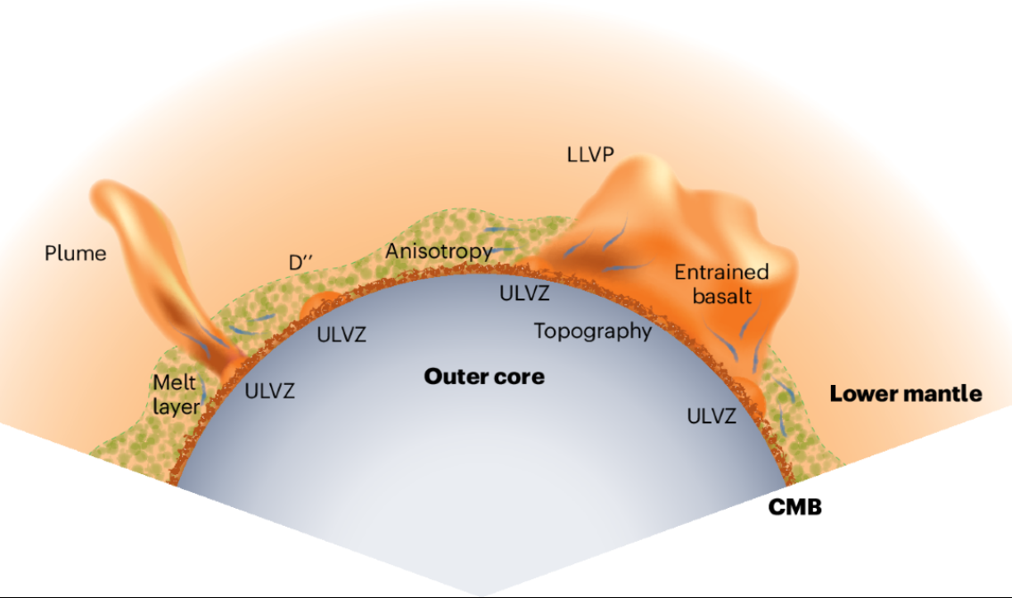

Hydrogen that escapes from the CMB reaction and ascends upwards may be oxidized into water in the crust and relatedly, water generation is described as a consequence of magma generation under the influence of hydrogen-containing fluids, suggesting that magma is a "birthplace of water". [26][29]

The deep hydrogen/water cycle involves subducted water reaching the CMB, reacting with iron to transfer oxygen to the iron (forming an FeO₂Hx/FeO rich layer) and forming iron hydride. Hydrogen can then either ascend through the mantle or dissolve into the core. While water is consumed in this deep reaction, H₂O is re-created closer to the surface, potentially in the crust through oxidation of ascending hydrogen or during magma genesis. Mid Ocean Ridges and Hotspots then return this water (along with other volatiles degassed from the mantle) to the surface reservoirs, completing the larger deep water cycle. [5][8][10][11][20][26][29]

Plume Creation

Imagine the Earth’s deep interior like a layer cake where water acts like a secret ingredient that makes the top layer (the rigid outer shell) peel away a bit and melt at the boundary below. As hot rock rises, it drags water along, which melts part of the mantle and creates soft zones where plumes, hot, buoyant blobs, can form. Some of that water collects at the base of the mantle near the core and reacts with iron there to make an oxygen-rich patch. If that patch loses hydrogen over time, it can suddenly “erupt” oxygen and other gases, thinning the mantle above and supercharging plume upwelling, kind of like a carbon dioxide burst from a lake, but on a much bigger, slower scale, potentially driving big geological events.

Partial melting, which can be induced by volatile components, including water, has been used to explain conductive anomalies observed at the LAB [15]. The presence of water can significantly lower the solidus (melting temperature) of mantle rocks and enhance melting [10][20]. When mantle rocks migrate from a zone with high water storage capacity to another zone with low water storage capacity, the excessive water that cannot be accommodated in the mineral crystal structure induces partial melting, and this could occur at the lithosphere–asthenosphere boundary. [10]

The strong partitioning of water into melts means that as upwelling mantle material begins to melt, water is efficiently stripped into the melt, leaving behind a strong, mostly dehydrated residual solid. This dehydration-induced strengthening can contribute to the viscosity contrasts observed in the planet. [10][20]

The Strong ultra-low-velocity zone (ULVZ) and slab interaction at the northeastern edge of the Pacific Large Low Shear Velocity Province (LLSVP) is suggested to favor plume generation [8][20][32]. This is interesting, as laterally moving Hydrogen, as previously stated, may be abundant in the areas next to FeO production.

“Seismic waves sampling the northeastern edge of the Pacific Large Low Shear Velocity Province (LLSVP) show strong waveform complexity and rapid change in differential time. Waveform and mineralogical modeling suggest a magnesiowüstite-bearing ultra-low velocity zone adjacent to slab at edge of LLSVP, conducive to plume formation. The structural anomalies and proposed plume are located ∼12° southeast of present-day Hawaiʻi, in agreement with recent mantle flow models “ [32]

After Water reacts at the CMB and creates FeO, hydrogen then migrates through the mantle, often in channelled flows. Hydrogen is described as a highly mobile, efficient heat-transfer agent that can reduce mantle viscosity, and contribute to magma generation and tectonic activity. Reduced viscosity can facilitate plastic flow and enable upwelling. This creates plumes. [10][20][25][26][27][29]

Fluids from the deep mantle are predominantly hydrogen and are oxidized to water primarily in the crust. An oxidized (wet, rusty) upper mantle favors the degassing of CO2 and hot water over reduced gases like methane (CH4) and H2.

The Oxygen-Rich Patch (ORP) is proposed to form at the Core-Mantle Boundary (CMB) where water from subducting slabs reacts with iron from the core. These reactions produce phases like pyrite-structured FeO2Hx (the Py-phase) and iron hydride (FeH). The specific reactions can vary depending on the starting iron oxide (Fe, FeO, Fe3O4, Fe2O3) reacting with water, but they all yield an assemblage involving FeO2Hx and FeH. The ORP is described as a multilayer with increasing oxygen content, consisting of the Py-phase and other iron oxides and hydrides. While the FeO that facilitates the CMB coupling is both an intermediate phase and end phase in the reaction series, the ORP itself is a complex layer containing multiple oxidized iron species.

A pure or dry mantle makes it less likely for the hydrogen to quickly return to the deep hydrogen cycle, given it is not H2O or CO2 what gets released by degassing. This has major snowball consequences:

“Fe2O3 was also observed in Ref. [5] and in our preliminary experiments, although the exact temperature is not well constrained. Reference [5] postulates an isochemical transition from ε-FeO2H to Py-FeO2H that implies x = 1 and no O2. However, the isochemical assumption is in direct contradiction with their own report of excess FeH which mandates change of chemistry. For x 1 [4], the released material will be essentially oxygen. The oxygen may rise as O2 or react to form other volatiles, such as CO, CO2, H2O, SO2 and NO2, thus reducing the viscosity and accelerating the plume uprising. A small-scale oxygen release would be uneventful and unnoticeable as a part of regular mantle convection. A large-scale oxygen eruption in ORP, however, could cause geodynamic instability and mantle overturn analogous to the limnic eruption of oversaturated dissolved CO2 causing runaway lake overturn [30], except the solid mantle is on a much larger scale and longer process than the fluid lake water. The perturbation could come from a variety of sources ranging from the steady growth of the ORP that reached a critical isostasy overload that bends the CMB to cross the thermal boundary to a sudden impact by an astronomical object that could also shift the thermal boundary layer and cause a runaway oxygen eruption. “ [26]

How the "FeO-rich" Patch (ORP) Could "Erupt":

The "eruption" is described as a large-scale decomposition of the oxygen-rich patch (ORP) accumulated at the CMB due to lack of Hydrogen.
The primary reaction discussed for this decomposition is 2FeO2Hx = Fe2O3 + xH2O + 1/2 (1 − x)O2.

If the parameter 'x' in FeO2Hx is not equal to 1, this decomposition would release elemental oxygen (O2). This released oxygen could rise as O2 or react with other components to form other volatile species such as CO, CO2, H2O, SO2, and NO2.
This large-scale release of volatiles is hypothesized to reduce the viscosity of the mantle in that region and accelerate plume uprising.
The process is compared to a limnic eruption of dissolved CO2 from a lake, but on a much larger scale and over a longer geological timeframe. The trigger for such a large-scale event would be a major perturbation, like in Early Earth’s Great Oxidation event. [25]

“… Over the course of geological time, the enormous oxygen reservoir accumulating between the mantle and core may have eventually reached a critical eruption point. Very large-scale oxygen eruptions could possibly cause major activities in the mantle convection and leave evidence such as the rifting of supercontinents and the Great Oxidation Event. “

Volcanic Degassing and VOC/H2O Balance

Volcanic degassing is like Earth burping out water and gases from deep underground. When volcanoes erupt or lava rises slowly, they release water (H₂O), carbon dioxide (CO₂), hydrogen (H₂), and other vapors. Water gets into the melt from minerals that can’t hold it anymore, boiling off as the rock cools and cracks. Most of Earth’s deep-water output comes from these eruptions, especially where one tectonic plate dives under another (subduction zones), mid‐ocean ridges, and hot spots. Roughly the same amount of water that goes down into the mantle on subducting plates (about 3×10¹¹ kg every year) comes back up through volcanic arcs, keeping a rough balance over long times. Carbon moves in a similar cycle: some stays locked in the deep mantle, but much CO₂ returns to the air through volcanoes, and weathering of rocks on land and the seafloor pulls CO₂ back down, helping regulate Earth’s climate.
In very simple terms, the deep Earth has layers that can be more “rusty” (oxidized) or more “fresh” (reduced). When the upper mantle is rusty, any carbon and hydrogen down there turn into things like carbonate minerals and water, and when they escape back to the surface they become mainly CO₂ and H₂O. Those two gases are exactly what we need to keep Earth’s climate stable over billions of years. In contrast, if the mantle is too dry and fresh, you get sudden bursts of pure oxygen (and even methane or hydrogen), which can cause huge, runaway eruptions and mess up both the climate and how the planet spins.
Deep at the boundary between Earth’s rocky mantle and its metal core, there can be a pocket of ultra-rusty iron compounds (an “oxygen-rich patch,” or ORP). If that pocket loses its hydrogen, it breaks apart and squirts out free O₂ bubbles, weakening the rock and sending a hot plume up toward the surface, sort of like popping a fizzy lake. But if the upper mantle is wet, rising hydrogen recombines with that escaped oxygen to make water again, patching everything up, calming the plume, and keeping things balanced. If there’s no water up there, however, the process runs away: the ORP keeps erupting massive oxygen blasts, the crust churns violently, the iron-oxide layer at the core–mantle boundary falls apart because there’s no more water feeding it (so the core can even decouple from the mantle electromagnetically), and the planet becomes a much less friendly place.

Volcanic degassing refers to the release of volatiles, such as carbon dioxide (CO2) and water (H2O), from Earth's interior to the atmosphere and hydrosphere. [10] This process is a fundamental component of planetary evolution and plays a critical role in regulating climate and facilitating geological activity. For water, volcanic eruptions are described as the most predominant mechanism for the output of water from the deep Earth to the surface reservoirs. Fractional crystallization of NAMs (nominally anhydrous minerals) can increase the concentration of volatiles in melts, leading to volatile saturation and the exsolution of magmatic-hydrothermal fluids, also known as boiling. These fluids can evolve into volcanic gases and reach Earth's surface. [10][20][25][27]

“A geodynamic model by van Keken et al. [70] estimates that globally subducting slabs carry ∼10^12 kg/year of water into the Earth’s interior. One-third of it is lost by 100 km depth (i.e. at the forearc and subarc depths), another one-third is lost by 230 km depth, and the remaining one-third is transported into the Earth’s deeper interior.

FROM DEPTHS TO SURFACE

Buoyancy drives the hydrous liquid phases released by the subducting slab to migrate upward, in porous or channeled flow, to the overlying mantle wedge, leading to metasomatism [12,97]. Hydrous miner-als in metasomatic mantle domains, with estimated bulk water content of 0.3–4 wt% [53,54], mainly include serpertine, talc, phlogopite and amphibole [8]. The mantle wedge probably starts to melt after a period of storage and heating [12]. Melt inclusion records suggest that water contents in primarymafic melts generally fall in the range of 2–6wt%, although significantly higher or lowerwater contents have also been reported [26,98]. Water contents in the melts change continuously along the path of magma evo-lution and ascent, due to processes such as crustal contamination, magma mixing, and fractional crystallization” [10]

Volcanic outgassing occurs predominantly at volcanic arcs (often associated with subduction zones), mid-ocean ridges (where new oceanic crust is formed), and hotspots (mantle plumes). [10]
The global flux of outgassing water through arc volcanism is estimated to be approximately 3 × 10^11 kg/yr, [10][25] which is suggested to approximate the amount of water loss by subducting slabs by 100 km depth, indicating a balance between subduction input and eruption output. Degassing at mid-ocean ridges contributes an estimated 6 × 10^10 kg/yr of water, significantly less than arc volcanism. [10][25]

“The flux of water on Earth has been estimated by several authors. According to Peacock [1], the amount of water degassed to the surface through magmatism is 2 × 10^11 kg/year. The water flux returned to the mantle by subducting slabs is ∼8.7 × 10^11 kg/year. Thus, 6.7 × 10^11 kg/year of water move to the deep interior associated with slab subduction. According to Wallace [2], there might be a balance in the flux of water between the input through subducting slabs and the output through degassing through arc volcanism to the surface, both with 3 × 10^11 kg/year. On the other hand, van Keken et al. [3] estimated that a third of water, i.e. 7–10 × 10^11 kg/year, penetrating through subduction is recycled into the mantle, whereas two-thirds of this water is degassed through dehydration of the slabs during subduction. In spite of uncertainties, it is important to specify the water reservoirs in the mantle, since a small amount of water can modify the properties of mantle materials.” [25]

Hydrogen is noted as one of the most abundant trace species in volcanic emissions. The gas composition of a volcanic plume can provide insights into the redox conditions of the lava lake or magma, assuming thermodynamic equilibrium is achieved between the gas phase and the melt. At Erebus volcano in Antartica, the plume results mainly from passive degassing of magma in the lava lake, and H2 is kinetically inert in the gas/aerosol plume, retaining the high-temperature chemical equilibrium signature. Measurements at Erebus show cyclical variations in the H2/SO2 ratio, corresponding to pulsatory magma supply. [33]

“The continuous measurement of molecular hydrogen (H2) emissions from passively degassing volcanoes has recently been made possible using a new generation of low-cost electrochemical sensors. We have used such sensors to measure H2, along with SO2, H2O and CO2, in the gas and aerosol plume emitted from the phonolite lava lake at Erebus volcano, Antarctica. The measurements were made at the crater rim between December 2010 and January 2011. Combined with measurements of the long-term SO2 emission rate for Erebus, they indicate a characteristic H2 flux of 0.03 kg s–1 (2.8 Mg day–1). The observed H2 content in the plume is consistent with previous estimates of redox conditions in the lava lake inferred from mineral
compositions and the observed CO2/CO ratio in the gas plume (∼0.9 log units below the quartz–fayalite–magnetite buffer). These measurements suggest that H2 does not combust at the surface of the lake, and that H2 is kinetically inert in the gas/aerosol plume, retaining the signature of the high-temperature chemical equilibrium reached in the lava lake. We also observe a cyclical variation in the H2/SO2 ratio with a period of ∼10 min. These cycles correspond to oscillatory patterns of surface motion of the lava lake that have been interpreted as signs of a pulsatory magma supply at the top of the magmatic conduit. “

Volcanic degassing contributes to the transfer of mass and heat. Early Earth degassing is considered of seminal importance for the development of the hydrosphere and the dynamics of the deep interior [10][20]. Parameterized convection models suggest rapid degassing within the first 500 million years of Earth's history, with 25% to 45% of the initial mantle water complement being degassed. After the first 600 million to 2 billion years, regassing through subduction approximately balances degassing through mid-ocean ridge volcanism. The current hydrosphere seems like it was (mostly) degassed from Earth's interior.

“... Although the first two of these assumptions are likely to be inaccurate, the parameterized convection models do show rapid degassing of the planet within the first 500 million years of Earth’s history, with between 25% and 45% of the mantle’s initial complement of water being degassed in this time period. Notably, after the first 600 million to 2 billion years of Earth’s history, the regassing of the planet through subduction closely balances the degassing through mid-ocean ridge volcanism. Nevertheless, in spite of their considerable uncertainties, these models produce three useful predictions: (a) that considerable quantities of water are retained in the mantle (on the order of 60% of the original mantle complement, or 1.5 ocean masses of water); (b) that the size of the hydrosphere may have remained relatively constant from the Archean to the present; and (c) that much of the hydrosphere was degassed in the first several hundred million years of Earth’s history. “ [20]

In a related area, the other important part of the Hydrogen cycle is CO2 [11]. Volcanic degassing of CO2 is a key part of the long-term carbon cycle. [27]

“Water (H2O) and carbon dioxide (CO2) both play an important role in the history of the Earth, as they strongly influence the chemical and physical properties of minerals, melts and fluids. Distribution and circulation of H2O and CO2 between the Earth’s surface and the mantle have dominated the evolution of the crust, the oceans and the atmosphere, controlling several aspects of the Earth’s habitability. It is therefore crucial to determine the stability and circulation of hydrous and CO2-bearing minerals in the Earth’s interior. Sedimentary material together with altered mafic and ultramafic rocks that constitute the subducted slabs represents the main source for recycling of H2O and CO2 as well as other volatiles at great depth, possibly down to the core—mantle boundary. The transport of H2O and CO2 via subducting slabs down to the transition zone and to the lower mantle has been the subject of many studies but is still under debate [1,2]. As for the carbon cycle, carbonates preserved during subduction are estimated to account for a flux of 3.6 × 1012 mol/year of carbon being returned into the deep mantle [3–5]. This quantity accounts for 10–30 wt% of the carbon reservoir in the deep mantle [6]. Regarding the water cycle, Van Keken et al. [2] suggested that 4–6 × 1013 mol/year of H2O are recycled into the mantle through slab subduc-tion. Dehydration of the slab accounts for the loss of two-thirds of this amount of H2O, while one-third of the H2O remains bounded to the slab (i.e. ≈1.5 × 1013 mol/year) reaching depths exceeding 240 km. Although this amount of H2O entering the deep mantle may not appear very large, it provides a mechanism for having significant amounts of water in the deep mantle. In addition, part of the CO2 and H2O present in the deep mantle may also originate from primitive mantle reservoirs [7], leading potentially to fairly large amounts of these volatiles in the deep mantle. “ [11]

The distribution and circulation of CO2 between the Earth’s surface and the mantle strongly influence the evolution of the crust, oceans, and atmosphere, playing a crucial role in Earth's habitability.

Subducting slabs represent the main source for recycling CO2 into the deep mantle [10][27]. While a significant amount of carbon is returned into the deep mantle via subduction, a fraction of this subducted carbon devolatilizes and returns to the atmosphere through arc volcanoes. In addition to arc volcanism, mantle carbon is degassed through mid-ocean ridge and plume volcanism back to the atmosphere and ocean reservoirs. [27]

Plate subduction and volcanic eruptions (at subduction zones, mid-ocean ridges, and hotspots) are the predominant mechanisms for the input and output of water in the deep water cycle, which also depicts volcanic eruptions. Similarly, these mechanisms are integral to the carbon cycle. [10][20][25][27]

The balance between silicate weathering (a sink for atmospheric CO2) and volcanic outgassing dictates the atmospheric CO2 content. The total volcanic outgassing flux (Fvol) is the sum of degassing from volcanic arcs (Farc) and degassing at ridges (Fridge). Plate tectonics leads to long-lived CO2 degassing by recycling carbon into the mantle at subduction zones. The present-day degassing flux is estimated to be around 6–10 × 10^12 mol/yr, quite close to the quantity of water. [27] The concept of whole planet coupling highlights that interior processes like plate tectonics, the electromagnetic coupling at the CMB and the geodynamo are vital for habitability, and plate tectonics facilitates the long-term carbon cycle which helps maintain a temperate climate by regulating atmospheric CO2. [27]

“Hydrothermal alteration of basalt can also act as a sink for CO2 dissolved in the oceans, and given rapid equilibration between the atmosphere and ocean, a sink for atmospheric CO2 as well [Staudigel et al., 1989; Alt and Teagle, 1999; Gillis and Coogan, 2011]. Carbonates on the seafloor, both in the form of sediments and altered basalt, are subducted into the mantle at trenches. Here a fraction of the carbon devolatilizes and returns to the atmosphere through arc volcanoes, with the remaining carbon being recycled to the deep mantle. To close the cycle, mantle carbon is degassed through mid-ocean ridge and plume volcanism back to the atmosphere and ocean reservoirs. The balance between weathering and volcanic outgassing dictates atmospheric CO2 content. This balance is formulated as

Fweather 1 Fsfw 5 Farc 1 Fridge; (13)
where Fweather is the silicate weathering flux on land, Fsfw is the seafloor weathering flux, Farc is the flux of CO2 degassing from volcanic arcs, and Fridge is the degassing flux at ridges. Balance between silicate weathering and degassing typically occurs rapidly, on a time scale of 1 Myr or less [e.g., Sundquist, 1991; Berner and Caldeira, 1997; Driscoll and Bercovici, 2013; Foley, 2015], so assuming that weathering always balances degassing is reasonable when studying long-term climate evolution. “ [27]

Mantle temperature is identified as one likely influencing factor on the rate of CO2 subduction; a hotter mantle is expected to cause more slab CO2 to devolatilize during subduction. This suggests that the thermal structure of the subduction zone plays a significant role in determining how much carbon is released at arcs versus how much continues deeper into the mantle:

“ On the other hand, when weathering becomes supply limited, it can no longer increase with atmospheric CO2 level and is therefore unable to balance the degassing flux (globally supply limited weathering requires that Fvol Fws , otherwise weathering would not be supply limited). As a result, atmospheric CO2 accumulation from volcanic outgassing continues unabated until the mantle and plate reservoirs are depleted in carbon, and extremely hot climates, that are unfavorable for plate tectonics, prevail (Figure 6). Small land areas or low erosion rates lead to supply limited weathering, because both factors limit the supply of fresh rock to the surface, and hence lower Fws [see Foley, 2015, for details]. Alternatively, factors that increase the degassing rate can also drive a planet into the supply limited weathering regime, even with a large land area or high erosion rates. Planets with large total CO2 inventories are more susceptible to supply limited weathering because degassing rates are higher. Another important factor is the fraction of subducted carbon that reaches the deep mantle, instead of devolatilizing and returning to the atmosphere at arcs (f from equation (14)). When more carbon can be subducted and stored in the mantle, Farc is lower and kinetically limited weathering is easier to maintain (Figure 6d). The fraction of subducted carbon that degasses at arcs is not well constrained, and the physical and chemical processes controlling this number are poorly understood [e.g., Kerrick and Connolly, 2001; Dasgupta and Hirsch-mann, 2010; Ague and Nicolescu, 2014; Kelemen and Manning, 2015]. Moreover, f is likely a function of mantle temperature, as more slab CO2 will devolatilize during subduction into a hotter mantle [e.g., Dasgupta and Hirschmann, 2010]. Thus, planets with hot mantles, as expected for young planets or those with high radiogenic heating budgets (see section 4.2), may be more susceptible to supply limited weathering. Better constraints on carbon subduction and devolatilization are clearly needed for understanding global climate feedbacks. “ [27]

The redox state of the Earth's mantle is a critical factor that determines the composition of volcanic gases released during planetary magmatism. If the mantle is more reduced, degassing tends to release species like H2 and CH4. Conversely, an oxidized upper mantle favors the release of H2O and CO2.

The redox state of the mantle reflects the balance between oxidized and reduced chemical species. A key indicator is the oxidation state of iron. An oxidized mantle has elements, particularly iron, in higher oxidation states (e.g., Fe³⁺ in Fe2O3). This state is linked to a higher oxygen fugacity (the partial pressure of oxygen in equilibrium with the system). Conversely, a reduced mantle has elements in lower oxidation states (e.g., Fe²⁺ in FeO or even metallic iron) and a lower oxygen fugacity.

A key mechanism involves the disproportionation of FeO in the lower mantle. This process breaks down FeO into Fe2O3-bearing perovskite and iron metal. The iron metal, being dense, would then sink and be lost to the core, leaving behind the oxidized perovskite which then mixes with the rest of the mantle. Exchange of FeO between the mantle and core can be a main process during core-mantle interaction. This FeO disproportionation is expected to occur on rocky planets that are Earth-sized or larger.

Earth's mantle is believed to have maintained its present level of oxidation since at least the early Archean, and potentially even the Hadean eon. While hydrogen escape from the atmosphere, leaving oxygen behind, was proposed as a mechanism that could have changed the mantle's redox state, other studies based on petrologic indicators suggest this is unlikely. The oxidation of rocks on the continents may have played a role in the rise of oxygen in the atmosphere around 2.4 billion years ago.

The release of CO2 via mantle volcanism is particularly important because it is described as the only major greenhouse gas known to be regulated by negative feedbacks that help stabilize the climate. Weathering rates are sensitive to climate, increasing with higher temperatures, which creates a negative feedback loop that helps maintain temperate conditions:

“Another important consideration is the redox state of the mantle, which determines whether degassing via planetary magmatism releases H2O and CO2 to the atmosphere or reduced species such as H2 and CH4 [e.g., Kasting et al., 1993a]. Carbon dioxide is the only major greenhouse gas known to be regulated by negative feedbacks such that it has a stabilizing influence on climate. Thus, having CO2 as a primary greenhouse gas is important for the whole planet coupling discussed here to operate. An oxidized upper mantle favors CO2 over CH4 and other reduced gases. Earth’s mantle has been oxidized at present-day levels since at least the early Archean [Delano, 2001], and possibly even since the Hadean [Trail et al., 2011]. Oxidation of the mantle is thought to occur by disproportionation of FeO to Fe2O3-bearing perovskite and iron metal in the lower mantle during accretion and core formation. The iron metal is then lost to the core leaving behind oxidized perovskite that mixes with the rest of the mantle [Frost et al., 2008; Frost and McCammon, 2008]. Disproportionation of FeO is expected to occur on rocky planets Earth sized or larger [Wade and Wood, 2005; Wood et al., 2006], so CO2 is likely to be an important greenhouse gas on exoplanets. Though other greenhouse gases can still be important, any planet where significant amounts of CO2 are degassed by mantle volcanism will need silicate weathering to act as a CO2 sink to avoid extremely hot climates. “[27] … A very interesting paragraph.

However, the effectiveness of silicate weathering for stabilizing depends not only on the presence of CO2 but also on a sufficient supply of fresh, weatherable rock at the surface. Planets that lack liquid mantle water to weather rock, such as Venus, do not have this mechanism for regulating atmospheric CO2, leading to its accumulation and extremely hot climates. [27][34]

“Indeed, on early Earth, steam atmospheres probably formed intermittently due to ocean-vaporizing impacts from a few asteroids that were larger than about 500 km across. Such bodies roamed the inner Solar System prior to about four billion years ago—an inference drawn from the large, ancient impact craters seen on the Moon. Steam atmospheres evidently condensed back into an ocean on Earth. On Venus though, which is closer to the Sun, atmospheric water vapor may have persisted instead of collapsing into swelteringly hot oceans. Either way, the consequences for Venus were a searing greenhouse effect from so much water vapor. Water vapor (H2O) itself is not especially prone to escape but its ultraviolet decomposition at high altitude produces hydrogen and oxygen. In the 1980s, James Kasting (now at Penn State University) showed that an amount of hydrogen comparable to that in Earth’s ocean could have escaped hydrodynamically from early Venus in less than a few hundred million years. One of us [Kevin Zahnle], together with Kasting, subsequently showed that such escape would also have dragged along much of the oxygen. Meanwhile, heavier carbon dioxide would have remained behind. Without water to mediate the chemistry that turns carbon dioxide into carbonate minerals, Venus is left with all its carbon dioxide in its atmosphere rather than predominantly in limestone, as on the Earth. However, a hellish fate lies in store for the future Earth (See Box). “

Under oxidized conditions, carbon is present as carbonate or carbonatite melt.[15] Carbonates are a form of carbon that is bonded to oxygen (e.g., CO₃²⁻). When magma containing these oxidized carbon species rises and degasses, the stable gas phase is CO2.[27] In contrast, in a more reducing environment, carbon would tend to be in less oxidized forms, such as elemental carbon (like diamond) or carbides. Reduced fluids are described as being dominated by H2 and CH4 in earlier, more reduced mantle conditions. [29]

Similarly, the oxidation state affects the forms hydrogen takes. [27][33] In an oxidized environment, hydrogen readily combines with oxygen to form H2O (water), either dissolved in melts or as hydroxyl groups in minerals. When magma degasses from an oxidized source, H2O is a primary volatile released. In a reduced environment, hydrogen is less likely to bond with oxygen and is more stable as elemental hydrogen (H2).

In an oxidized environment, hydrogen readily combines with oxygen to form H2O (water), either dissolved in melts or as hydroxyl groups in minerals [10][25]. Hydrogen exists as hydroxyls in hydrous and nominally anhydrous minerals and as protons and hydroxyls (OH) in magmas. Silicate melts primarily contain molecular H2O or hydroxyl groups bonded to Si or other cations. In nominally anhydrous minerals (NAMs), hydrogen generally occurs as point defects bonding to oxygen to form OH. Stoichiometrically hydrous minerals contain OH as an innate component. When magma degasses from an oxidized source, H2O is a primary volatile released. [10][20][25]. An oxidized upper mantle favors CO2 over CH4 and other reduced gases, releasing H2O and CO2 through degassing. In a reduced environment, hydrogen is less likely to bond with oxygen and is more stable as elemental hydrogen (H2)[10][11][20][29]. Therefore, in the reduced deep mantle, a fraction of hydrogen could dissolve into silicate minerals as molecular H2.

“In silicate melts, it is chiefly molecular H2O or hydroxyl groups (OH) bonded to Si or other cations [28,29], but pressure of the order of 10 GPa gives rise to more extended structures such as Si– O–H–O–Si [30] and low oxygen fugacity leads to molecular H2 [31]. In stoichiometrically hydrous minerals such as amphiboles and dense hydrous magnesium silicates (DHMS),OH is an innate component of the crystal lattice [32]. In olivine and other nominally anhydrous minerals (NAMs), which constitute the main body of the bulk silicate Earth, hydrogen generally occurs in point defects and bonds to oxygen to form OH [33,34]. One exception is that the open structure of feldspars can accommodate H2O molecules [35,36]. Mineral grains may also enclose fluid inclusions or other microscopic hydrous impurities, especially at shallow depths. In the reduced deep mantle, a fraction of hydrogen could dissolve into silicate minerals as molecular H2 [37]. “[10]

Low oxygen fugacity in silicate melts can give rise to molecular H2. Sources discussing reduced mantle fluids and eruptions mention H2 as a dominant component. [33]

“Hydrogen is one of the most abundant trace species in volcanic emissions (e.g. Giggenbach
1987; Oppenheimer et al. 2012) and is an essential participant in key redox reactions that
take place in magmatic gases, e.g.
H2+12O2=H2O
and
H2S+2H2O=SO2+3H2. “[33]

The composition of volcanic gases released is determined by the chemical reactions and equilibrium that occur as magma ascends and pressure decreases. Volcanic gas composition provides insights into the redox conditions of the lava lake, assuming thermodynamic equilibrium between the gas phase and the melt. Chemical modeling of the gas phase in ascending magmas suggests an evolution of the magma redox state during ascent, and not in the crater, meaning that the source of H2 is from the mantle. [33]

“In situ measurements of the gas plume emitted from the lava lake of Erebus volcano by
means of a multi-gas sensing instrument indicate that the hydrogen abundance in the
magmatic gas phase is around 1.6 mol%. These measurements constrain the oxidation state
of the lava lake to ΔQFM = −0.9 log units, consistent with previous estimates; provide strong
evidence that hydrogen burning is not prevalent at the surface of the lake; and that hydrogen
is at least largely kinetically inert in the gas/aerosol plume rising in the crater. The hydrogen
flux to the atmosphere from the summit of Erebus is estimated at 2.8 Mg day–1. A strong
∼10-min cyclicity in the proportions of H2 and other species in the plume infers corresponding
redox state variations and points to a pulsatory supply of magma to the lava lake.”[33]

In an oxidized mantle environment, the equilibrium composition of the released gas phase is shifted towards the more oxidized species, such as CO2 and H2O, simply because there is more "available" oxygen to react with carbon and hydrogen from water.

In summary, an upper oxidized mantle corresponds to a chemical environment where high oxygen fugacity leads to carbon and hydrogen existing primarily in oxidized forms (carbonates, hydroxyls/water), which upon degassing are released as CO2 and H2O. This is considered crucial for the planet's long-term climate regulation.

Both of these mechanisms, oxidation in the mantle and decomposition of mantle FeO into P-phase and then back into CMB FeO thanks to Hydrogen, interact in a complex manner, that is not grasped quite easily at first glance (apparently not even by the study that talks about the ORP and decomposition):

The oxygen released by the CMB during ORP decomposition, when it interacts with a wet mantle high in Hydrogen, creates water and liberates CO2, and not VOCs. This makes the planet habitable. If the mantle is dry, the Hydrogen cycle is not only cut short, but increases the instability of the ORP due to lack of Hydrogen feedback.

In the context of an oxygen-rich patch (ORP) at the core–mantle boundary, plume initiation hinges on the thermochemical destabilization of hydrous iron oxides (FeO₂Hx) once their hydrogen inventory becomes depleted. Under the generalized reaction if x<1x<1 the residual solid releases free O₂ (and/or forms other oxidized volatiles by reacting with ambient C–, S–, or N–bearing phases). This sudden injection of molecular oxygen (or secondary CO₂, H₂O, SO₂, NO₂) into the lowermost mantle dramatically lowers local rock viscosity, because oxygen‐rich fluids dramatically weaken silicate frameworks, and generates a large buoyancy anomaly. In effect, the ORP “erupts,” much as oversaturated CO₂ catastrophically degasses from a stratified lake: the buoyant, low‐viscosity mixture ascends rapidly, nucleating a thermal‐chemical upwelling or mantle plume.
However, for this process to be self‐limiting rather than runaway, hydrogen must recycle back into the deep hydrous cycle. In a “wet,” oxidized mantle, ascending H₂ (or protons transported in hydrous melts) recombines with O₂ to reform H₂O, re‐wetting the mantle and buffering redox conditions. That feedback restores viscosity and damps subsequent oxygen pulses. In contrast, a “dry” (hydrogen‐starved) mantle cannot recombine O₂ efficiently; the ORP remains over‐oxidized, large successive oxygen eruptions become more likely, and the mantle can undergo large‐scale overturn, with large scale VOC release. These large oxygen eruptions, due to convection, could plausibly speed up Earth’s rotation to an abnormal degree.
I.E, the upper mantle must have an abundance of water, and a disproportionation of FeO to Fe2O3-bearing perovskite and iron metal in the lower mantle from reactions with hydrogen (also from water), to favor the production of the CMB FeO layer (created as shedding from P-phase decomposition). This triggers H2O and CO2 liberation in the mantle, and makes the planet’s rotation stable, coupled, and habitable.

If the mantle does not receive water, the lower mantle undergoes large scale oxidation, the CMB FeO decomposes due to lack of P-phase creation, liberating O2 and creating very large plumes, which, under failure to interact with a wet mantle, liberate CH4 (Methane) and H2 in the Lithosphere-Asthenosphere boundary. This Methane then decomposes to CO2 due to tropospheric oxidation.

Reaction Pathways, P-T Ranges, and Kinetic Constraints

This section outlines the key chemical reaction pathways, associated pressure-temperature (P-T) ranges and phase stabilities, and available insights into their mechanisms, kinetics, and constraints. These processes are crucial for understanding the behavior of volatiles, particularly water and hydrogen, and their interactions with iron-bearing phases under deep Earth conditions.
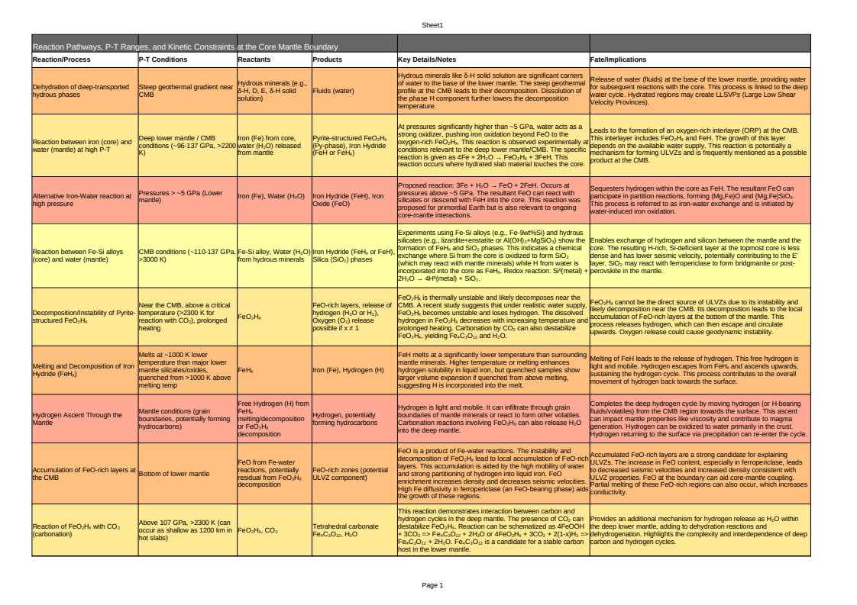
In summary, water delivered to the CMB from the deep mantle facilitates active chemical reactions with iron from the core. These reactions can initially form phases like pyrite-structured FeO₂Hₓ and iron hydride (FeHₓ). If Fe-Si alloys are involved, silica is also produced. However, the FeO₂Hₓ phase is generally unstable near the CMB conditions and decomposes, losing hydrogen and leading to the accumulation of FeO-rich layers. Similarly, FeHₓ melts at lower temperatures and releases its hydrogen. This released hydrogen is mobile and ascends through the mantle, completing a deep hydrogen cycle. The resulting FeO-rich accumulations are considered a primary explanation for the seismic properties of ULVZs, while the hydrogen and silicon exchange can affect the topmost outer core, potentially forming the E' layer. The presence of CO₂ can introduce further complexity by reacting with FeO₂Hₓ, releasing water and forming carbonates.

PART 4.

THE SURFACE

Amagmatic Ghost Plumes: A Source of Liquid Water
A new “hidden” type of mantle plume has been discovered in 2025, called a "ghost plume" that rises from deep inside the Earth but doesn't cause volcanoes because it's blocked by the thick continental crust. These plumes are still very hot and carry water and gases like hydrogen and carbon dioxide upward from the Earth’s core-mantle boundary. Even though they don’t erupt, they change the mantle’s physical properties, lower its resistance to flow, and cause the Earth’s surface to rise slightly. This hidden process could explain mysterious underground water sources, electrical signals in rocks, and why some areas rise without any visible volcanic activity, basically, these ghost plumes reshape parts of the planet from below, using heat and water instead of lava.

Ghost Plumes are a newly identified type of mantle plume that are "hidden" beneath Earth's continents. Unlike typical mantle plumes, which are characterized by surface volcanism due to decompression melting as they ascend, "ghost plumes" are amagmatic, meaning they lack present-day surface volcanic activity. This lack of volcanism is attributed to the thicker continental lithosphere, which restricts the plume's ascent and associated melting and magma transport to the surface.

An example of a ghost plume is the Dani plume in eastern Oman, which is robustly imaged using seismic tomography despite the absence of current surface volcanism. The presence of a ghost plume like Dani suggests that more sub-continental mantle plumes may exist, hidden from traditional detection methods. Their existence prompts a re-evaluation of heat flux estimates from the core-mantle boundary (CMB), as the volume of amagmatic features could significantly increase these estimates, impacting models of Earth's thermal and core evolution. [39].

“Intraplate volcanism has traditionally served as the principal marker for identifying mantle plumes (Morgan, 1971; Courtillot et al., 2003). However, challenges arise in continental regions where complex structure and thick lithosphere inhibit decompression melting and the transport of any molten material to the surface. Typically, when surface volcanism is absent or old, mantle-plume proposals have been rejected, or merely dismissed as “fossil plumes” (Witte et al., 2017; Stein and Hofmann, 1992). “

In total, here is a theorized compilation of sources of amagmatic plumes, as described in this paper thus far. This may be in total considered as a succesful prediction, as seen in the study on “Ghost” Mantle Plumes:

Mantle plumes are fundamentally hot, buoyant upwellings that originate from Earth's core-mantle boundary (CMB). The CMB represents a significant thermal discontinuity, with temperatures in the core being approximately 1,000 degrees Celsius higher than the overlying mantle. This large temperature difference causes the base of the mantle to become hotter and more buoyant, initiating the ascent of plume material. Seismic tomography robustly images these plumes as sub-vertical low-velocity anomalies, confirming the presence of hotter, less dense material rising through the mantle.

Even without extensive decompression melting reaching the surface, volatiles play a critical role in facilitating plume and volatile ascent, and thus, heating of the mantle:

Viscosity Reduction: Volatile components, particularly water (H2O) and carbon dioxide (CO2), significantly modulate the rheology (flow properties) of the Earth's mantle [11]. Water can profoundly reduce mantle viscosity. Hydrogen, released from the decomposition of phases like FeO2Hx, is described as light and mobile, capable of infiltrating through the grain boundaries of mantle minerals or reacting to form other volatiles, thereby reducing viscosity and accelerating plume ascent. [26]

Increased Buoyancy: The presence of these volatiles, coupled with the higher temperatures of the plume material, reduces the density of the mantle material within the plume. This density reduction enhances the buoyancy of the plume, allowing it to ascend from the CMB through the mantle. [30]

Deep Partial Melting (Impeded Surface Transport): While the thick lithosphere in continental regions generally prevents significant decompression melting from reaching the surface, the presence of volatiles like H2O and CO2 can induce partial melting at depth. This partial melting can contribute to areas of anomalous electrical conductivity within the mantle, such as at the lithosphere-asthenosphere boundary or the 410 km discontinuity [10][15]. However, even if some partial melt forms due to these volatiles, its ability to reach the surface is impeded by the overlying thick lithosphere. This means the ascent of the plume and its volatile content is driven by buoyancy and reduced viscosity, rather than being reliant on eruptive volcanism at the surface.

The Dani plume in eastern Oman is presented as a clear example, robustly imaged by seismic tomography as a sub-vertical low-velocity anomaly extending from below 660 km depth into the uppermost mantle. Despite the absence of current surface volcanism, the plume's presence is corroborated, as predicted, by a thermal anomaly indicated by a ~14 km depression of the 410 km discontinuity and a ~20 km upward deflection of the 660 km discontinuity. The region overlying the Dani plume also exhibits positive present-day residual topography, supporting the notion of active mantle upwelling driving uplift even without magmatism. [39].

This demonstrates that through H2O, plumes can rise, transport heat and volatiles, and influence the Earth's surface through dynamic topography, even when the thick continental lithosphere prevents significant melt from reaching the surface.

So what happens if these volatiles are not driving surface volcanism?
As previously discussed:

The volatiles, particularly water (H2O) and hydrogen (H2), are not simply passively transported; they actively modify the physical properties of the mantle, influencing its behavior even without eruption.

Water significantly enhances the electrical conductivity of minerals and silicate melts in the mantle. This effect is so strong that it can explain high-conductivity anomalies observed in regions like the asthenosphere (e.g., at 90-150 km depth) without requiring the presence of partial melt. [20][24]

Water can reduce seismic wave velocities (VP and VS) and affect the VP/VS ratio. Anomalies in seismic velocity that cannot be solely explained by temperature variations are often linked to the presence of water. This was crucial for identifying "ghost plumes," which are robustly imaged as low-velocity anomalies by seismic tomography despite lacking surface volcanism.

Even without magmatic eruption, the buoyant upwelling of hot, volatile-rich material within the plume can cause uplift of the Earth's surface, known as dynamic topography. The Dani plume in eastern Oman, for instance, exhibits positive present-day residual topography, supporting ongoing mantle upwelling and uplift despite the absence of current surface volcanism. This implies an expansion mechanism for the Earth’s surface, not a typical mantle convection gliding effect.

Water can be released from subducting slabs as aqueous solutions, hydrous melts, or supercritical fluids. Small amounts of hydrous melts, even if not erupting, can have effectively infinite residence times within the deep upper mantle, transition zone, or lower mantle due to neutral buoyancy. This suggests long-term storage and circulation without reaching the surface as magma.

The volatiles, even if not leading to surface volcanism, can still be released and cycle through the Earth's interior and potentially to the surface through other means:

- The decomposition of phases like FeO2Hx can lead to the release of hydrogen as H2. Carbonation reactions, such as FeO2Hx reacting with CO2, can also release H2O into the deep mantle. This hydrogen can then ascend through the mantle. [11][26]

- While primarily in deep fluids, this hydrogen can be oxidized into water predominantly in the crust. Anomalously high electrical conductivity observed in rift structures at shallow crustal depths (e.g., 7-20 km) might be due to hydrogen saturation, indicating its ascent. Deep-seated intermetallic diapirs carrying hydrogen might also ascend to shallower depths in tectonically relaxed zones. [29]

- Water from the Earth's interior can be returned to the surface through the exhumation of ultrahigh-pressure metamorphic rocks, a process common in continental subduction zones. [10]

- Minor amounts of water can be transferred to the asthenospheric mantle through lithospheric delamination. [10]

So these hot mantle plumes, when reaching a thick lithosphere, turn into underground water deposits.

The Troposphere and Stratosphere’s Balance
The redox state of Earth’s mantle, essentially, how oxygen-rich or oxygen-poor it is, directly governs the kinds of gases it releases into the atmosphere. A more reduced mantle favors the liberation of hydrogen gas (H₂) during processes like serpentinization, magma ascent, or water-rock interactions at depth. When this H₂ enters the atmosphere, it doesn't just float around harmlessly. It becomes chemically active, especially in the troposphere, where it competes for and consumes hydroxyl radicals (OH), the main molecules responsible for scrubbing methane (CH₄) and other pollutants. As H₂ eats up OH, it reduces the atmosphere’s oxidative capacity, allowing methane to accumulate longer and enhancing the formation of tropospheric ozone. So, mantle redox chemistry isn’t just a deep Earth detail, it directly feeds into surface-level air quality and climate feedback loops, possibly being the most important driving mechanism.
In the stratosphere, H₂ oxidation creates water vapor, which, counterintuitively, can accelerate ozone depletion. The added water increases OH and HO₂ radicals, which catalyze the breakdown of ozone molecules, especially under cold, polar conditions. Meanwhile, if H₂ builds up to a critical level and solar activity is intense, the upper atmosphere can experience hydrodynamic escape: a blow-off of hydrogen atoms into space. This mechanism, especially relevant in Earth’s early history, and other planets like Mars or Venus, could’ve caused significant water loss by dragging oxygen along with the escaping hydrogen. In short, the mantle’s redox fingerprint echoes from magma chambers to the edge of space, altering atmospheric chemistry, climate sensitivity, and even the long-term retention of oceans.

The balance between Earth's troposphere and stratosphere is governed by complex chemical and physical processes, particularly influenced by the presence and interaction of various gases and radicals. As previously stated, the Ratio of VOCs and H2 to H2O and CO2 liberation depends on the redox state of the mantle:
In the troposphere, the mixing ratio of water vapor (H2O) is primarily controlled by the hydrological cycle, which involves evaporation from oceans and precipitation [41]. Methane (CH4) is a significant chemically proven greenhouse gas [29][44]. Its atmospheric abundance is largely controlled by its reaction with hydroxyl radicals (OH)[41]. Methane is generated at depth within marine sediments, but most is consumed by methanotrophic bacteria before reaching the atmosphere [35]. Sources of atmospheric H2 include the oxidation of methane and volatile organic compounds (VOCs).[41]

Extreme ultraviolet (EUV) radiation from the Sun plays a crucial role in heating and expanding the upper atmosphere (thermosphere/exosphere), rather than directly the troposphere [35]. When the thermosphere's temperature increases due to stellar XUV (soft X-rays and EUV) heating, the bulk atmosphere begins to expand hydrodynamically [35][45]. This process, also known as "hydrodynamic escape" or "planetary wind," causes air to flow into the vacuum of space, driven by pressure from below. The atmosphere flows and accelerates smoothly through the sound speed to achieve escape velocity. Hydrodynamic expansion typically starts around 200 km altitude, with bulk velocity increasing with altitude, and temperature moderately increasing before decreasing due to adiabatic cooling. More than half of the absorbed EUV heating energy can be converted into the mechanical energy of escaping hydrogen [46]. The strong EUV flux from the young Sun was capable of inducing such hydrodynamic escape, which could even remove an Earth-sized ocean of hydrogen within hundreds of millions of years [34][35]. This expansion can push the exobase (the level where particle collisions become negligible) to higher altitudes. Increased EUV irradiance heats up and expands the atmosphere, leading to more neutral particle collisions at higher altitudes and increased ionospheric scale height due to photoionization. [34][35][47][48][49][50][51][52]

“A second type of thermal escape is far more dramatic than Jeans’ mechanism. Jeans’ escape applies when a gas evaporates molecule by molecule from an exobase. But if conditions favor faster escape, the air flows into the vacuum of space, pushed along by pressure from below. This can occur if the bulk gas in the upper atmosphere is a good absorber of ultraviolet light and the heated air flows en masse. Unlike Jeans’ case, the bulk atmosphere is no longer static. The atmosphere flows, accelerates smoothly through the sound speed, and then attains the escape speed and higher. This form of thermal escape is called “hydrodynamic escape” or the “planetary wind,” the latter by analogy to the solar wind, the thermal wind of charged particles blown from the Sun into interstellar space. “ [34]

The changes in H2 abundance and its cascading effects on OH, CO, CH4, and water vapor demonstrate a tight coupling between the troposphere and stratosphere. The overall indirect radiative forcing associated with H2 includes contributions from both tropospheric and stratospheric compositional changes. For instance, approximately one-third of the global warming potential (GWP) attributed to H2 stems from the stratospheric response, primarily due to the increase in stratospheric water vapor. This highlights the significant, previously underestimated, role of stratospheric changes in the overall climate impact of atmospheric H2. [41]
Stratospheric ozone is produced via photochemical reactions involving molecular and atomic oxygen [41][42] and is depleted through catalytic reactions involving radicals such as ClOx, BrOx, HOx, and NOx. With increased atmospheric H2, ozone in the upper stratosphere and polar lower stratosphere decreases. These decreases are driven by the increase in hydroxyl radicals and, in polar regions, by the increased water vapor which plays a role in enhancing polar ozone depletion, particularly in the Antarctic springtime. While significant, these changes in total column ozone are relatively small (5-10 DU). If the CH4 response to increased H2 is factored in, there may be no statistically significant total column ozone depletion, with small increases observed in mid-latitude and tropical total column ozone due to large increases in tropospheric ozone. [41]
OH is the major oxidant in the troposphere and plays a vital role in the budget of tropospheric ozone. It is also a primary removal mechanism for atmospheric H2. Increases in atmospheric H2 lead to a decrease in tropospheric OH because H2 reacts with OH (H2 + OH = H2O + H (R1)), reducing the OH concentration. This reduction in OH can in turn increase the atmospheric lifetime of methane and its impact on climate: [41]

In the stratosphere, however, OH is modeled to increase with increasing atmospheric H2, as H2 reacts with energetically excited oxygen atoms
(H2 + O(1D) → OH + H (R5)).

Additionally, OH is formed in the stratosphere through reactions of O(1D) with water vapor and methane:

(H2O + O(1D) → 2OH (R6)),

(CH4 + O(1D) → OH + CH3 (R7)).

Increased stratospheric H2, H2O, and CH4 can significantly boost stratospheric OH production via these reactions.

Decomposition and Formation of Gases:

CH3 + H2O: The primary atmospheric sink for methane (CH4) is its reaction with hydroxyl radicals (OH), which produces methyl radical (CH3) and water (H2O):

CH4 + OH = CH3 + H2O (R2).

2OH: The reaction of water vapor with energetically excited oxygen atoms in the stratosphere produces two hydroxyl radicals:

(H2O + O(1D) → 2OH (R6)),

H: Hydrogen atoms (H) are produced when H2 reacts with OH :

(H2 + OH = H2O + H (R1)).

CH3: Methyl radicals (CH3) are formed from the reaction of methane with OH:

(CH4 + OH = CH3 + H2O (R2)).

C2H6 (Ethane) and C2H2 (Acetylene): These hydrocarbons are photochemically produced hydrocarbons, which serve as infrared emitters. Specifically, methane photolysis by high-energy photons leads to the production of ethane and other hydrocarbons. While CH4 reacts with OH to form CH3, C2H6 or C2H2 are formed via a direct CH4 + OH reaction, but rather through photolysis of methane and subsequent hydrocarbon chemistry. This can possibly occur during an EUV expansion of the atmosphere. [35][45][47]

Ozone (O3) in the troposphere is not directly emitted but is produced through a complex series of photochemical reactions. These reactions involve carbon monoxide (CO), methane (CH4), and volatile organic compounds (VOCs) in the presence of nitrogen oxides (NOx). The rate-controlling reaction in ozone production mechanisms is between nitric oxide (NO) and peroxy radicals (RO2), followed by the photolysis of nitrogen dioxide (NO2) to form ozone. Hydroperoxyl radical (HO2) is identified as the most important peroxy radical, with other organic radicals, which are breakdown products of CH4 and VOCs, also playing a role. [41]
Hydrogen (H2) is removed from the atmosphere primarily by uptake to soils, but also through reaction with hydroxyl radicals (OH). This reaction is H2 + OH = H2O + H (R1)
A Decreased OH, Increased HO2 reaction is an important sink for OH, leading to a decrease in OH concentrations throughout the troposphere as H2 levels increase. The decrease in OH, in turn, leads to an increase in HO2 following the recombination of H with O2.
In a NOx-rich environment, an increase in H2, by leading to an increase in HO2 (via reaction R1), will result in an increase in tropospheric ozone. Model simulations confirm that tropospheric column ozone generally increases as atmospheric H2 increases, particularly in the tropics and Northern Hemisphere midlatitudes. For example, an increase of H2 from 500 ppb to 2000 ppb leads to a global mean increase of 0.59 DU in tropospheric column ozone. When the anticipated increase in CH4 (due to reduced OH) is also considered, this effect on tropospheric ozone is enhanced. [41]

In scenarios with reductions in CO, NOx, and VOC emissions, tropospheric ozone can decrease despite increases in atmospheric hydrogen and methane, which is considered a positive outcome for air quality.

Increasing H2 levels can lead to a reduction in cloud droplet number concentration (CDNC), which lowers cloud albedo. This decrease in reflected light serves as a positive radiative forcing in the short wavelength region, which would be expected to increase global mean surface temperature (GMST). Higher levels of H2 in the atmosphere actually destroy the higher, stratosphere Ozone layer.

Leakage of hydrogen into the atmosphere is expected to lead to increases in water vapor (H2O) throughout the atmosphere, with potentially significant increases in the stratosphere. Specifically, a 1.5 ppm increase in H2 can result in more than a 1 ppm increase in H2O in the upper stratosphere, and stratospheric water vapor mixing ratios could increase by up to 25% with increasing H2. More ozone depletion would lead to an increase in UV radiation reaching lower parts of the atmosphere. It also induces polar cloud cover. [41][42]

Increases in greenhouse gases such as tropospheric ozone, stratospheric water vapor, and methane (which are consequences of increased atmospheric hydrogen) all contribute to an increase in the planet's radiative forcing [41]. An increased radiative forcing means that the Earth system traps more heat and is therefore less efficient at liberating it [53]. Upper stratosphere water vapor, as a potent greenhouse gas, directly contributes to this by absorbing and re-emitting longwave radiation. [41][53][54]

A warmer and wetter stratosphere can promote increased hydrogen escape from the atmosphere [34][55]. When surface temperatures are sufficiently high (e.g., exceeding ~340 K or 70°C), the stratosphere can become water-dominated, leading to the photodissociation of H2O and the subsequent escape of hydrogen to space, like in Venus [29][34][35][55]. Additionally, strong solar extreme ultraviolet (EUV) radiation heating effectively induces hydrogen escape [35][45][47], with escape rates increasing as the homopause hydrogen mixing ratio rises. [46]

“… Because of the low exospheric temperature of Venus (≈ 275 K), which is caused by the large abundance of CO2, a strong infrared emitter, present thermal escape of hydrogen on Venus is almost negligible. But at epochs in the past when the water abundance in Venus’ atmosphere was higher and when the Sun was a more powerful EUV emitter, the exospheric temperature was probably much higher and thermal escape could have taken the form of a “hydrodynamic” escape. Hydrodynamic escape is a global, cometary-like, expansion of the atmosphere. It requires the deposition of a large flux of EUV energy into the atmosphere to allow species to overcome gravity. Such conditions may have been reached in H- or He-rich thermospheres heated by the strong EUV flux of the young Sun (Sekiya et al. 1980, 1981; Watson et al. 1981; Zahnle and Walker 1982; Yelle 2004, 2006; Tian et al. 2005; Munoz 2007; Penz et al. 2008), e.g. in the following cases… “[35]

An ozone rich troposphere and wet stratosphere is effectively a swapped version of the ideal situation. Our troposphere should be rich in water vapor, and our stratosphere rich in Ozone.
Water vapor in the troposphere is primarily controlled by the hydrological cycle, involving evaporation and precipitation. In contrast, the stratosphere is notably dry, with water vapor mixing ratios typically around 3-5 parts per million by volume (ppmv) on modern Earth. This dryness is maintained because stratospheric water vapor levels are limited by condensation at the coldest point of the equatorial troposphere. [34][41][43]
“For planets with climates that are not yet in a runaway state, the rate of water loss is constrained by the supply of H2O to the high atmosphere. A key factor in this is the temperature of the coldest region of the atmosphere or cold trap, which limits the local H2O mixing ratio by condensation. When cold trap temperatures are low, the bottleneck in water loss becomes diffusion of H2O through the homopause, rather than the rate of H2O. We prefer the term ‘moist stratosphere’ to the more commonly used ‘moist greenhouse’ because Earth today is a planet where the greenhouse effect is dominated by water vapour. “ [43]

Therefore, directly, the habitability of the planet favours a redox state of the mantle where H2O and CO2 dominate from high water content in the mantle. If the mantle is degassing primarily VOCs due to a lack of water in the mantle, it will shift its balance into overheating [29] and hydrogen escape. [12][27][34][35][55]
“Atmospheric escape has consequences. We have mentioned the lack of air on Callisto and Ganymede, and the absence of water on Venus. A more subtle consequence is that escape tends to oxidize planets, because hydrogen is lost more easily than oxygen. Hydrogen escape is the ultimate reason why Mars and Venus are red, and probably also why much of Earth’s continental crust is red. Mars started out the gray-black color of volcanic rock. Its redness arises from oxidation of volcanic minerals to iron oxides, which requires that an amount of hydrogen from water has been lost to space to balance the oxygen left behind. Loss of hydrogen from water equivalent to a global layer meters to tens of meters deep accounts for Mars’s observed oxidation. Under Venus’s veil of clouds, there is also a red surface similarly attributable to hydrogen escape. In 2001, we suggested that Earth’s accumulation of photosynthetic oxygen 2.4 billion years ago (when Earth’s continental surface first turned red) was accelerated by the escape of hydrogen from an atmosphere rich in biogenic methane that preceded oxygenation. In Earth’s case, we proposed that water molecules were broken microbially and the hydrogen passed like a baton from organic matter to methane, before reaching space. Cumulative hydrogen loss is consistent with a net excess of oxidized material now present in the overall inventory of Earth’s crust, ocean and atmosphere. “[34]

=--------------------============================------ EDITED CITING TO HERE

The Great Greenhouse Contradiction
The Earth's climate, atmosphere, and inner layers are all deeply connected. CO2 can both trap heat at the surface and help cool the upper atmosphere, depending on where it is. It also helps keep the upper atmosphere dry, which protects the ozone layer and slows the escape of hydrogen (and thus water) into space. Water vapor in combination with the upper layer ozone in the lower atmosphere move heat around, especially in the tropics, helping the planet release energy. But Earth’s internal heat, from radioactive decay and deep chemical reactions, also builds up and needs to escape. This happens mostly through mantle convection (hot rock rising and cooler rock sinking), which drives plate tectonics. Water, which is moved deep into the planet by plate tectonics, directly softens rock and helps the mantle flow more easily, promoting deep volcanic activity and cooling, releasing CO2 instead of nasty gases. This cycle also supports the Earth’s magnetic field, which protects us from solar wind. Without this delicate balance of CO2, water, and tectonic movement, Earth would overheat, dry out, or lose its magnetic shield. And yes, hot plumes from deep inside Earth, when they hit a thick crust, can sometimes cool down and turn into underground water deposits.
CO2 and thermal absorption
If the saturation of thermal radiation absorption by carbon dioxide (CO2) is exceeded, it can be presumed that any additional CO2 emitted into the atmosphere would not absorb thermal radiation and therefore would not contribute to the greenhouse effect.

Experimental research has demonstrated that for thermal radiation, the absorption process in carbon dioxide reaches complete saturation. This phenomenon challenges theoretical models that previously suggested absorption could increase indefinitely with the mass of CO2, as absorption, by definition, cannot exceed a value of 1. The Schwarzschild equation, a well-known model for radiative transfer, supports the concept that absorption must saturate and reach a maximum value for a sufficiently large absorbing mass.

Experiments showed that nearly full saturation of thermal radiation absorption in CO2 occurs at an absorbing mass of approximately 1.5 kg/m². Given that the current concentration of CO2 in Earth's atmosphere (400 ppm) corresponds to an absorbing mass of about 6 kg/m², this atmospheric mass already significantly exceeds the experimentally determined saturation limit by several times.
When the absorption of thermal radiation by carbon dioxide (CO2) reaches saturation, it means that additional CO2 in the atmosphere no longer absorbs thermal radiation. Once this limit is reached (or exceeded by adding more CO2), the additional CO2 simply does not absorb more thermal radiation and, therefore, is presumed not to contribute further to the greenhouse effect.

While increased solar activity would typically lead to more warming, the presence of significant CO2 in the atmosphere can increase planetary albedo, particularly at higher temperatures. This effect through Rayleigh scattering, can reduce the amount of solar radiation absorbed by the planet, thereby limiting the warming effect from the Sun. This effectively lessens the external energy input from the Sun.
Despite CO2's role as a greenhouse gas at the surface under lower concentrations than what we have, its strong infrared absorption bands (especially 15 µm and 4.3 µm) enable efficient cooling to space in the middle and upper atmosphere, particularly at low pressures. This directly helps to radiate excess heat away from the atmospheric layers. This cooling effect also helps to keep the exobase level closer to the planetary surface, which can protect the atmosphere from erosion by the solar wind.
In simple terms, this means that carbon dioxide (CO₂) can only absorb a limited amount of infrared radiation in specific wavelengths, and once those absorption bands become saturated, meaning they already absorb nearly all the radiation in those frequencies, adding more CO₂ has a diminishing effect on surface-level warming. This is because most of the infrared radiation in those key bands is already being absorbed and re-emitted close to the surface. However, CO₂ still plays an important role in the climate system, especially in the upper atmosphere. There, where the air is thinner and less saturated, CO₂ can effectively emit infrared radiation into space, helping to cool those higher layers. So rather than trapping more heat, additional CO₂ at high altitudes actually acts like a thermal release valve, radiating excess energy outward. Additional CO₂ doesn’t keep linearly increasing surface warming forever.

More CO2 increases the planetary albedo, preserving stratosphere dryness, preventing a wet stratosphere, preserving the upper stratosphere ozone layer. Higher troposphere levels of O3 (ozone) due to VOC release (non CO2, like CH4/H2) prevent this, and make the stratosphere wetter and warmer, destroying the upper stratosphere ozone layer, decreasing UV production, decreasing tropical convection, making the planet not able to liberate heat efficiently and increasing hydrogen escape.
If the internal heating and any unmitigated solar input still result in a net positive energy balance, the Earth's Energy Imbalance (EEI) would be positive. To counteract this, the planet would increase its overall thermal radiation back to space, although this process might not immediately achieve full balance, leading to a general warming of oceans, land, and atmosphere.
Tropical convection
Tropical convection and associated monsoon circulations play a vital role in the Earth's energy balance. They act to balance the positive Top-of-Atmosphere (TOA) radiation budget by efficiently exporting Moist Static Energy (MSE) away from tropical regions. This process, driven by the latent heat of water vapor and radiative effects, helps to release excess heat from the planet's surface and atmosphere. The "lot of water vapor in the atmosphere" contributes to the greenhouse effect, only initially trapping heat at the surface. However, its role in convection and latent heat transfer is crucial for redistributing and ultimately releasing this energy.
Monsoon circulation, a key manifestation of tropical convection, balances the positive Top-of-Atmosphere (TOA) radiation budget by exporting Moist Static Energy (MSE) from the monsoon domains. MSE includes the latent heat associated with water vapor, which is released when water vapor condenses.
While atmospheric convection and escape are vital for dissipating energy, particularly absorbed solar radiation, they are generally not sufficient to balance the planet's entire energy budget, especially the substantial internal heat generated within the Earth, without requiring mantle movements. The Earth's energy balance is a complex system of "whole planet coupling"

While hydrodynamic escape can remove a significant amount of hydrogen (e.g., an Earth-sized ocean in a few hundred million years under primitive solar EUV conditions) and thus cool the atmosphere forcefully, this primarily addresses volatile loss and atmospheric energy. It does not account for the large internal heat budget of the planet, which is managed by mantle convection and other deep Earth processes. Without these internal mechanisms, excess heat from the core and mantle would accumulate, leading to widespread melting and vastly different planetary conditions, regardless of atmospheric convection.

Heat emission at Earth's surface is considered evidence for a deep-seated source that comprises the main energy for geological change on the planet, with energy flux several orders of magnitude greater than that of surface volcanism or seismicity. Mantle plumes, for example, are hot, buoyant upwellings that rise from the core-mantle boundary (CMB). Heat bursts at the CMB are powered by radiogenic energy, estimated between 15–38 TW. More recent estimates of heat flow across the CMB are as high as 133–144 TW.

Tidal dissipation, particularly for planets orbiting close to their stars, can also generate significant internal heating, potentially leading to thermal runaway and large-scale melting if the orbital period is short enough (e.g., less than 30 days). This heating can be on the order of several terawatts and can significantly increase internal temperatures.

Plate tectonics is the surface expression of mantle convection and is an efficient mechanism for cooling the mantle by continuously subducting cold slabs into the deep interior. This process helps maintain a high heat flow out of the core, which is crucial for generating a magnetic field. The magnetic field, in turn, shields the atmosphere from the solar wind, helping to retain liquid surface water.

The "primordially hydridic Earth" hypothesis suggests that periodic hydrogen movement from the deep interior serves as a crucial mechanism for expelling substantial quantities of heat to the outer geospheres. Hydrogen, due to its high heat capacity and diffusibility, is considered a very efficient heat-transfer agent within the mantle.

The climate, mantle, and core are intricately linked. A cool climate, favorable for plate tectonics, is also favorable for long-term magnetic field generation, while hot climates, leading to stagnant lid convection, are unfavorable for the dynamo. The planet's ability to retain surface water depends on this whole-planet coupling, where the magnetic field (possibly from the FeO) prevents water loss, and water enables silicate weathering for a cool climate and continued mantle activity.

If CO2 is "not allowing hydrogen escape to space through a cold trap between the troposphere and stratosphere," and the stratosphere is "not wet." This indicates that the cold trap remains effective, limiting stratospheric water vapor. This dry stratosphere is crucial for preserving the ozone layer, as less water vapor leads to reduced production of ozone-destroying hydroxyl radicals. Furthermore, by mitigating hydrogen escape, the planet retains its water inventory, preventing desiccation. The "wet mantle condition" implies that the primary volatile release from the interior would indeed be CO2 and H2O, consistent with a wet, oxidized upper mantle.
Plate tectonics is presented as the surface expression of Mantle convection. It is considered a vital mechanism for Efficient Mantle Cooling:

Plate tectonics efficiently cools the mantle by continuously subducting cold slabs into the deep interior. This efficient mantle cooling is crucial for maintaining a high heat flow out of the core, which is necessary to drive the geodynamo and sustain the Earth's magnetic field over long geological timescales. It also facilitates the long-term carbon cycle, which helps regulate Earth's climate and maintain habitable conditions. It transports water into the deep Earth, where it modulates mantle properties, influences deep chemical reactions (like those forming FeO-rich layers at the CMB), and enhances mantle convection. The enhanced mantle convection and cooling (due to water's influence) then feed back into the efficiency of plate tectonics and the core dynamo, by sustaining the production of a FeO rich layer. The Earth's magnetic field, in turn, helps protect the atmosphere from solar wind, allowing the planet to retain surface water that is essential for the long-term carbon cycle and plate tectonics. This creates a self-sustaining feedback loop for habitability.

Possible periodic hydrogen “degassing” from the deep interior from chemical reactions and the deep water cycle seem to serve as a crucial mechanism for expelling substantial quantities of heat to the outer geospheres. Tectonic and magmatic activity, as well as the magnetic field, are primarily due to the systematics of hydrogen migration through the mantle. Water enhances mantle convection by softening rocks. It also significantly lowers the solidus (melting temperature) of silicates, thereby generating magmas.

FeO's role in electrical conductivity and its connection to water at the CMB are significant for Earth's magnetic field and deep processes. Water modulates and enables plate tectonics, and plate tectonics drives the deep water cycle and efficiently cools the planet, maintaining the magnetic field. It is a system of intricate feedbacks and interdependencies, where water is an essential component. Higher troposphere levels of O3 (ozone) due to VOC release (non CO2, like CH4/H2) prevent this, and make the stratosphere wetter and warmer, destroying the upper stratosphere ozone layer, decreasing UV shielding, decreasing tropical convection, making the planet not able to liberate heat efficiently and increasing hydrogen escape.
In the context of atmospheric escape, a more dramatic form of thermal escape, distinct from molecular Jeans escape, is "hydrodynamic escape" or the "planetary wind." This occurs when heated air flows en masse into the vacuum of space, accelerating smoothly through the sound speed and attaining escape velocity. This process can happen if the bulk gas in the upper atmosphere is a good absorber of ultraviolet light. This bulk expansion leads to adiabatic cooling in the exobase temperature. Usually, this gas is Hydrogen.

Hydrogen at the Atmosphere

Usually, the atmosphere will then evaporate the liquid water through heat from the sun, with help of surrounding vegetation, to create volatile compounds that can condense clouds through particles, delivering water back into the surface and finishing the cycle. If the hydrogen does not come into contact with solar wind, it will not escape into the exosphere. Thus the hydrogen can then return to the surface of the planet through precipitation, eventually entering the mantle, and forming FeO, maintaining core-mantle coupling, and completing the Hydrogen cycle.

In the presence of a strong magnetic field, the rate at which ionized planetary species (like hydrogen ions) are swept away by the stellar wind decreases with increasing magnetopause distance and magnetic field strength. Stronger magnetic fields expose a lower density of planetary species to the solar wind. Weaker (or non-existent) planetary magnetic fields allow the solar wind to interact more directly with the "top" of the atmosphere, potentially rendering the magnetic escape limit less relevant.

Without magnetic shielding, significant water loss could occur. For planets orbiting very active solar mass stars or very close to active small mass stars, where stellar winds are stronger, maintaining a magnetic field may be crucial for preserving liquid surface water over billion-year timescales.

Specifically regarding hydrogen, the dipole magnetosphere screens out the corpuscular radiation from the Sun and conditions the stability of the ionosphere, which absorbs ultraviolet and X-rays. The potential for photodissociation of water and for the dissipation of hydrogen from the planet are greatly reduced by the magnetosphere's effects. The process of hydrogen dissipation (escape) on Venus is suggested to be stronger than on Earth because Venus has no external dipole field.

Volcanic outgassing releases hydrogen-bearing compounds like H₂ and H₂O into the atmosphere. These molecules can ascend to the upper atmosphere, where they may dissociate into atomic hydrogen. Under certain conditions, especially during CMEs, this hydrogen can gain sufficient energy to escape into space.
Volcanic eruptions emit gases, including water vapor and molecular hydrogen, into the atmosphere. These gases can rise through atmospheric layers, undergoing photodissociation under solar ultraviolet radiation, resulting in atomic hydrogen. The efficiency of this transport and subsequent dissociation is influenced by atmospheric composition, temperature gradients, and the presence of other chemical species.
Hydrogen (H₂) is identified as one of the most abundant trace species in volcanic emissions. Measurements at Erebus volcano in Antarctica recorded continuous H₂ emissions from a lava lake and surrounding fumaroles, contributing to the atmospheric output. The H₂ content observed is consistent with the redox conditions inferred in the lava lake and suggests H₂ is kinetically inert in the gas/aerosol plume, retaining the signature of high-temperature chemical equilibrium from the lake. The estimated hydrogen flux from Erebus is 0.03 kg s⁻¹ or 2.8 Mg day⁻¹. Hydrogen also exists as super-critical fluids in volcanoes and the Earth's crust. Abrupt heating of silicate material can be accompanied by the formation of water and other volatile compounds. Juvenile hydrogen has been discovered in oceanic rift zones where metals are close to the surface.
Also, under intense heating, such as from solar extreme ultraviolet (EUV) radiation, the upper atmosphere can expand and flow outward like a fluid, dragging lighter elements like hydrogen with it .
These Molecules Can Ascend to the Upper Atmosphere, Where They May Dissociate into Atomic Hydrogen. Hydrogen-bearing molecules like water vapor (H₂O) and methane (CH₄) on Earth tend to stay in the lower atmosphere, but some molecules reach the stratosphere. These molecules can decompose in the stratosphere, releasing hydrogen. This hydrogen then slowly diffuses upward to the exobase. Ultraviolet radiation or other processes in the upper atmosphere can cause the decomposition or dissociation of molecules, including water (H₂O), into atoms like hydrogen and oxygen. Photochemical escape involves molecules being ionized by solar radiation and then recombining or colliding, splitting into atoms with enough speed to escape. The structure of Earth's atmosphere, with an outer rarefied hydrogen-rich layer, facilitates the rise of hydrogen to levels where it can dissipate into space. Ultraviolet images reveal a halo of hydrogen atoms surrounding Earth, confirming that hydrogen reaches these outer regions.

Solar Flares, Coronal Mass Ejections

Birkeland currents, also known as field-aligned currents (FACs), were first proposed by Kristian Birkeland at the turn of the twentieth century. They are an important component of solar wind-magnetosphere-ionosphere coupling and connect the ionosphere to the magnetosphere. They flow along the Earth's magnetic field lines and were initially controversial but later confirmed by satellite measurements.

The large-scale Birkeland current system chiefly comprises two rings of current encircling the geomagnetic pole: The R1 current is upward (out of the ionosphere) on the dusk side of the polar cap and downward (into the ionosphere) on the dawn side. The R2 current flows in the opposite sense to R1 (downward on dusk, upward on dawn)

Should a local Birkeland current manage to reverse Earth's jet stream, a geomagnetic reversal could follow. However, this is presented as a potential cause of a geomagnetic reversal, not a description of the Birkeland current system itself undergoing periodic global reversals. The strength of the resulting magnetic field and jet stream would be weaker than usual, but not enough to cause a decoupling.

Birkeland currents are fundamentally driven by solar wind-magnetosphere-ionosphere coupling. The magnitude and location of R1 and R2 currents are consistent with driving by magnetic reconnection, both dayside and nightside.

Southward IMF BZ leads to intensification and equatorward movement of the Birkeland current systems. An enhanced solar wind electric field is a crucial factor in driving Birkeland current intensities during southward IMF. The current ovals expand during periods of dominant dayside reconnection and contract with dominant nightside reconnection, consistent with the Expanding/Contracting Polar Cap (ECPC) paradigm.

Geomagnetic storms are characterized by more extreme behavior and are more likely to drive extreme current densities, particularly in the R2 current system on the dayside. This is unexpected as R1 currents are generally larger. The R2 currents in these extreme cases may flow in the opposite direction to the average R2 current system, possibly due to closure through an intensified ring current. The mean current density's standard deviation is largest during geomagnetic storms.

Substorms are key drivers of nightside Birkeland currents. The mean current density is largest during substorms, and current densities above a low threshold are more likely during substorms than storms. The current ovals expand during the growth phase of a substorm, reaching maximum size around 15 minutes after the expansion phase onset, before contracting. Some studies show that R1 and R2 currents are both intensified during substorms. However, the exact morphology of the substorm current wedge (SCW), particularly whether it's a "single loop" or "two loop" system, remains an open question.

Birkeland currents are intimately related to auroral displays, as they facilitate the travel of particles into the ionosphere. Upward Birkeland currents are thought to be colocated with auroral precipitation. Birkeland currents vary with ionospheric conductivity, which is primarily influenced by solar illumination on the dayside and particle precipitation at nightside magnetic local times. Understanding Birkeland current dynamics is crucial for space weather forecasting, as extreme currents can negatively affect operations and infrastructure.

Observations show that upward and downward currents in the Northern Hemisphere appear systematically stronger than those in the Southern Hemisphere. This asymmetry is consistent with differences in ionospheric convection linked to Earth's magnetic field asymmetries. The cause of this asymmetry remains an open question...

A ~25 year cycle is noted in Earth's rotation speed, which is stated to be partially confirmed and corresponds roughly to twice the period of a solar cycle. This cycle in Earth's rotation is linked to the local Birkeland current, which may then be directly connected to the sun, influencing day lengths. A dominant 22-year period is found in volcanic eruption frequencies. This coincides with the 22-year period of the solar background magnetic field (SBMF). More volcanic eruptions tend to occur during the maximum phases of the doubled solar cycles (22 years) when the SBMF has southern polarity.

However, what about Solar Flares?

Solar flares are powerful, explosive events in the Sun's corona that involve the liberation of magnetic energy. They are characterized by a sudden and significant enhancement of extreme ultraviolet (EUV) and X-ray radiation, and they can also produce Solar Energetic Particles (SEPs). The most intense solar flares are consistently correlated with Coronal Mass Ejections (CMEs). The most energetic flares on the Sun can reach an energy of 10^32 ergs, occurring approximately once per solar cycle
.
Mechanism and Causes

The prevailing scientific model for solar flares posits that they are powered by magnetic reconnection, a process that changes the topology of magnetic fields. A crucial element in this process is the formation of a current sheet, which is a region where magnetic energy is converted and dissipated. This current sheet typically forms in the wake of an erupting magnetic flux rope or when a closed magnetic structure becomes highly stretched. Magnetic reconnection initiates at a specific location within the current sheet and then propagates throughout it as the flare progresses. Observations suggest that these current sheets possess intricate, dynamic internal structures that facilitate efficient magnetic reconnection, and strong turbulence has been observed within their diffusion regions.

Some research proposes an alternative or contributing mechanism, suggesting that solar tides, generated by the gravitational pull of planets like Mercury, Venus, Earth, and Jupiter, can influence solar activity, including flares. This hypothesis posits that tidal forces disturb the balance between solar atmospheric pressure, gravitational fields, and magnetic fields acting on plasma in the coronal magnetic field lines, leading to magnetic field reconnection and subsequent solar flares. Statistical analysis indicates that 25 out of the 38 largest documented solar flares initiated when one or more of these tide-producing planets were nearly directly above or opposite the event positions (within 10° longitude). The probability of this occurring randomly is extremely low, at 0.039%, suggesting a genuine relationship. The Sun's rotation period, which is approximately 25 to 35 times that of Earth, is considered a factor that could significantly amplify these tidal effects on the Sun.

However, some sources challenge the conventional view of magnetic reconnection, describing it as a "pseudo physics notion". They argue that the theory of magnetic reconnection predicts a very slow discharge of energy over years, which contradicts the observed rapid energy release (in minutes) during solar flares. These sources propose alternative explanations, such as the "exploding double layer" (DL) phenomenon and the Plasma Pinch Discharge Mechanism (PPDM), which involve electric charge flow in plasma, accelerating particles and generating high-energy radiation. It's also noted that the rotation of sunspots builds magnetic energy that is released in flares, but flares themselves can also cause sunspots to rotate faster.

Effects on Earth

Solar flares significantly contribute to "space weather" events that can have substantial impacts on Earth. Flares are considered "active experiments" on Earth's upper atmosphere and ionosphere. They create a "second sunrise" effect, leading to rapid changes in electron density, electron temperature, and plasma dynamics. This includes bursts of upward diffusion and plasma escape, with upward fluxes that can be comparable to or even exceed typical daytime values. Despite these surges, Earth's robust geomagnetic field effectively contains the ionospheric plasma, so these episodic escape events do not have long-term evolutionary consequences for the planet, as the plasmasphere quickly refills. Increased UV light during flares also enhances ionospheric plasma density, allowing greater electrical current flow. X-rays primarily affect the lower D-layer and E-layer, while EUV influences the F-layer.

Solar flares contribute to solar activity that influences the dense proton population in Earth's inner radiation belt. Solar Energetic Protons (SEPs) associated with flares can temporarily provide protons access to lower latitudes and polar regions. Conversely, increased solar activity can lead to a decrease in proton flux in the inner radiation belt due to increased atmospheric density and greater absorption of trapped protons. The variation in proton flux within the South Atlantic Anomaly (SAA) is anti-correlated with the F10.7 solar activity index.

Flares trigger upward plasma drifts and atmospheric escape from Mars. The sudden increase in EUV radiation enhances ionospheric plasma, leading to heating of the upper atmosphere and a significant increase in hydrogen escape. Estimates suggest a flare can temporarily double plasma escape from the Martian dayside ionosphere. Over billions of years, especially considering the Sun's higher activity in its early history, this could be a substantial contributor to atmospheric loss. Mars, lacking a global magnetic field, is more susceptible to atmospheric erosion by solar wind processes like sputtering and ion pick-up, with flares representing a distinct, rapid escape mechanism.

Similar to Mars, Venus lacks a global magnetic field, making its atmosphere vulnerable to sputtering and ion pick-up processes driven by the solar wind. Hydrogen dissipation on Venus is currently more intense than on Earth, and the primary escaping ions from Venus are O+, He+, and H+.

Studies on M-dwarf flares, which can be more frequent and energetic than solar flares, indicate that they significantly increase XUV emission. This warms and ionizes the upper atmospheres of potentially habitable planets, expanding their radii and promoting atmospheric loss
. Such flares can remove substantial amounts of surface water (up to two Earth Oceans equivalent) and raise atmospheric oxygen partial pressures. XUV radiation from flares photolyzes atmospheric water and drives hydrogen escape. Flares appear to play their most critical role in water escape for exoplanets with masses between 2 and 5 Earth masses.

The observed correlation between solar flares and planetary positions suggests a potential method for forecasting the largest solar flares (X9.0 and greater) once giant sunspots become visible. These flares are most likely to occur when the sunspots rotate into a region where at least one of the four tide-producing planets (Mercury, Venus, Earth, or Jupiter) is either directly overhead or at the opposing end of the Sun (within 10° longitude). Conversely, they are least likely when sunspots are 36° longitude or further away from these planetary positions. This forecasting method could also be beneficial for predicting large flares on the far side of the Sun, which may affect space weather near Earth even if not directly observable. Longer-term solar activity forecasts might also be possible by studying long-term tidal behaviors.

Solar flares can generate geomagnetic pulsations and are associated with geomagnetic storms. These storms are caused by solar matter streams disturbing Earth's atmosphere. Strong geomagnetic storms have been linked to periods of increased volcanism and earthquakes They can induce telluric currents (electrical currents within Earth's crust) through geomagnetic pulsations, which arise from changes in ionospheric conductivity. Numerical models indicate that the density of these flare-induced currents (around 10^-6 A/m^2) is comparable to that generated by artificial power sources known to trigger seismic activity. A statistical analysis of the X9.3 solar flare on September 6, 2017, revealed a 68% increase in global earthquakes (magnitude M ≥ 4) and a 120% increase in regional seismicity in Greece (M ≥ 3) within an 11-day window following the flare. This evidence suggests a possible causal link between strong solar flares and earthquake triggering.

One proposed mechanism is that Coronal Mass Ejections (CMEs) can lead to geomagnetic storms, which in turn can induce telluric currents in conductive areas of the Earth's lithosphere, and that these currents, interacting with Earth's magnetic field, generate the electromagnetic (Lorentz) force which is hypothesized to trigger seismic activity.

Numerical estimations indicate that telluric currents induced by geomagnetic pulsations generated by solar flares can have a similar current density (10-6 A/m2) at the depth of earthquake sources compared to artificial power sources (10-7 – 10-8 A/m2) that have resulted in observed redistribution of seismic activity in specific regions. If the electrical conductivity is higher in crust layers at depths like 10 km, the current density can increase.

Coronal mass ejections (CMEs) are listed as a main solar agent for geomagnetic activity, especially during sunspot maximum. The effectiveness of a CME in generating a large magnetic storm depends on the strength and polarity of the magnetic field within and near the CME. Geomagnetic storms themselves can be induced by interplanetary CMEs, among other solar wind particles and interplanetary magnetic fields.

Strong geomagnetic storms are noted to cause periods of increased volcanism on Earth. A number of studies indicate a correlation between geomagnetic storms and strong earthquakes, which are then said to trigger volcanic activity. Magnetic storms occurring during maximum years of solar activity are found to affect fault properties and are associated with large earthquakes. There is an ongoing discussion about the impact of strong variations of space weather, including solar flares and geomagnetic storms, on the lithosphere and the possible triggering of earthquakes.

The mechanism linking geomagnetic storms to seismic activity often involves the induction of electrical currents in the Earth. Currents generated by solar winds (which cause magnetic field fluctuations on Earth's surface) induce electrical currents, known as telluric currents, which penetrate deep into the Earth. Strong variations of space weather can generate a flash of geomagnetically induced currents in the conductive subsurface structures. Numerical estimations demonstrate that telluric currents induced by geomagnetic pulsations generated by solar flares have a similar density at the depth of earthquake sources compared to artificial power sources that have resulted in observed redistribution of seismic activity.

Electric current concentrates in the crust layers with increased electrical conductivity. One possible reason for earthquake triggering is the concentration of electric current in narrow, highly conductive fault zones. High-conductivity anomalies are occasionally present in different tectonic environments, such as mid-ocean ridges, subduction zones, and volcanic regions, thought to be caused by the presence of melt or water-bearing minerals. As previously stated, these coincide with the LLSVPs.

In the presence of Earth’s magnetic field, these induced electrical currents generate an electromagnetic force, specifically the Lorentz force, in the conductive crust. This Lorentz force is then proposed as a mechanism that can trigger the release of stress-strain energy and cause earthquakes and fractures in Earth’s crust. The Lorentz force is a volume force given by J × B, where J is the electric current density and B is the magnetic field.

Recall that dissolved water weakening mantle minerals has a significant effect on seismic velocity. Areas of the mantle that are conductive due to hydration, like the LLSVP, may be hotspots for hydrogen interaction with the ionosphere due to volcanic activity, and also hotspots for telluric current excitation of volcanic activity, due to the same conductivity of these LLSVPs.
Dissolved water can significantly affect the properties of mantle minerals, including their rheological strength and seismic velocity. Water dissolved in nominally anhydrous minerals reduces their rheological strength, known as the hydrolytic weakening effect. This can influence mantle convection and plate motion. Regarding seismic velocity, water has a disproportionately large effect on the elastic properties and density of minerals, which in turn affects P-wave (Vp) and S-wave (Vs) velocities. Modeling results suggest that water could cause up to a 0.7% reduction in the velocity of the upper mantle and up to a 4.7% reduction in the transition zone. Samples with even small amounts of hydrogen (e.g., ~6 ppm water in olivine) have been shown to be approximately a factor of two weaker than "dry" samples.
Areas of the mantle can be conductive, and that this conductivity is closely linked to the presence of water or melt. Electrical conductivity is even more sensitive to the presence of water than seismic velocity. The electrical conductivity of olivine, a main mantle mineral, is enhanced by an order of magnitude by several hundred ppm water, and laboratory studies show that small amounts of impurity like hydrogen can enhance the electrical conduction of silicate mantle minerals. This hydrogen-induced enhancement of conductivity could potentially explain high conductivity observed near the top of the asthenosphere without needing partial melt. High-conductivity anomalies observed in magnetotelluric surveys in the mantle can potentially be explained by solid-state mechanisms like hydrous olivine. There is also evidence of anomalously high electrical conductivity in rift structures at various shallow depths (7-20 km).
Large Low Shear Velocity Provinces (LLSVPs) and Ultralow-velocity zones (ULVZs), exhibit reduced seismic wave velocities. Iron enrichment in mantle minerals is a significant factor contributing to the properties of ULVZs, and iron-rich mantle minerals exhibit low sound velocities. The sources propose that iron-water exchange between the core and mantle under hydrous conditions can lead to profound iron enrichment within silicate, explaining the seismic anomalies observed in ULVZs. Water is suggested to be transported to the deep lower mantle via hydrous phases and nominally anhydrous minerals through plate subduction. Dehydration from subducting slabs is thought to produce fluids or hydrous melts near the top of the lower mantle, potentially creating anomalous Q and Vs regions. Hydrated regions at the base of the lower mantle may create LLSVPs. The presence of dense, volatile-rich magmas is suggested as a cause for low seismic velocity regions at the bottom of the upper mantle and potentially the top of the lower mantle. The seismic signatures observed in ULVZs are interpreted to indicate whole mantle convection accompanied by deep water cycles from the crust to the core.
Electrical conductivity is a powerful approach to deduce the temperature and chemical components of melts and fluids, and their accumulation and distribution in the Earth’s interior. High-conductivity anomalies are observed in various tectonic environments, including volcanic regions. Partial melting induced by volatile components, primarily H2O and CO2, is used to explain these anomalies. Electrical conductivity is extremely sensitive to magmatic liquids, and the presence of an interconnected network of a conductive phase like a fluid or melt can dominate the bulk conductivity of a rock.
Water, or hydrogen in various forms, significantly enhances electrical conductivity in mantle materials. The electrical conductivity of the upper mantle may be elevated by one to three orders of magnitude by small amounts of water (6–60 ppm). This hydrogen-induced enhancement might explain the relatively high conductivity near the top of the asthenosphere (depths of ~90–150 km) without necessarily requiring the presence of partial melt. However, partial melting forming interconnected paths, especially from hydrous or carbonate melts, is also proposed as a cause for high conductivity anomalies in the asthenosphere.
The mantle transition zone is suggested to be a major water reservoir, at least locally. High conductivity anomalies in the transition zone, particularly beneath areas with subducting slabs like Mariana, are preferably explained by compositional differences, specifically the existence of small ions like H+ from water, which significantly enhance electrical conductivity more than affecting seismic velocity. Estimates suggest ~0.3 wt% H2O in such regions could explain the conductivity and seismic anomalies.
Hydrated, conductive regions (like LLSVPs) as hotspots for hydrogen interaction with the ionosphere due to volcanic activity:
The sources connect LLSVPs to hotspots and plumes. Specifically, the African LLVP boundary is associated with hotspots, interpreted as heat plume upwellings from the outer core.
Hotspots (like Azores, Iceland) are noted to have higher water content than normal mid-ocean ridge basalt (MORB) sources, potentially implying increased retained water at depth in the mantle below these areas. This aligns with the idea of LLSVPs potentially being hydrated regions and linked to plumes.
Hydrogen is an abundant trace species in volcanic emissions. This confirms that hydrogen is transported from the Earth's interior (via magma) to the atmosphere during volcanic eruptions.
Therefore, the sources support a chain where LLSVP regions may be hydrated, linked to plumes/hotspots, which source volcanic activity, and volcanic emissions contain abundant hydrogen. This establishes a direct path for hydrogen from potentially hydrated LLSVP-related regions to reach the atmosphere.
Hydrated, conductive regions (like LLSVPs) as hotspots for telluric current excitation of volcanic activity:
One source proposes that geomagnetic storms induced by solar activity can cause sporadic electric currents along surface breaks or induce piezoelectric tension, potentially leading to volcanoes. This mechanism involves external electromagnetic fields interacting with conductive pathways near the surface.
Another model posits that hydrogen degassing from the planetary interior is linked to tectonic and magmatic activity. In this model, a mantle layer plasticized by dissolved hydrogen is injected into fractures, forming magmatized zones, and low-viscosity melts eventually intrude the crust and effuse on the surface. High electrical conductivity in rift structures and coastal geomagnetic anomalies are linked to hydrogen flows and a conductive mantle layer. This model suggests that hydrogen flow, potentially associated with conductivity, causes the activity, rather than external telluric currents exciting it via bulk conductivity. As discussed, LLSVPs themselves may be conductive due to hydration, and are pathways for the Hydrogen cycle. Regions of enhanced conductivity exist in the mantle, possibly linked to hydration (including potentially LLSVPs) and propose mechanisms where external fields or internal hydrogen flow (related to conductivity) could influence volcanic activity.
Areas like the asthenosphere-lithosphere boundaries surrounding the LLSVPs are prime candidates both to experience tectonic and volcanic activity, and for plume generation.
Under Certain Conditions, Especially During CMEs, This Hydrogen Can Gain Sufficient Energy to Escape into Space: Atomic hydrogen, being the lightest gas, most easily overcomes a planet's gravity to escape. Escape can occur through various thermal (Jeans escape, hydrodynamic escape) and non-thermal mechanisms. Non-thermal escape includes processes where atoms gain energy from chemical reactions or particle-particle collisions.
The interaction between a planet's exosphere (containing neutral hydrogen) and the stellar wind (like solar wind protons) is a key mechanism. Charge exchange between stellar wind protons and neutral hydrogen atoms produces energetic neutral atoms (ENAs). These ENAs can have enough speed to escape. This process accounts for a significant portion of present hydrogen loss from Earth and most from Venus. Ion pickup is another stellar wind-induced process where exospheric neutral atoms are ionized (by charge exchange or photoionization) and then accelerated and lost by the stellar wind plasma flow around the planet.

Observations confirm the impact of solar activity. Absorption in the stellar Lyman-α line around the exoplanet HD 209458b revealed high-velocity atomic hydrogen that can be explained by interaction with the stellar wind, and radiation pressure alone cannot explain it. This is considered the first observation of energetic neutral atoms outside the solar system. A strong solar storm (space weather event) that impacted Mars significantly increased the hydrogen escape rate (by a factor of 5) through increased upper atmospheric temperature. This short-term increase was comparable to seasonal escape trends. Energetic hydrogen atom precipitation from the magnetosphere (itself produced by charge exchange) is a source of hot hydrogen in the upper thermosphere, potentially enhancing temperature through cascade heating and increasing the escape rate. Observations during geomagnetic storms show increases in hydrogen atoms in the exosphere, likely linked to coupling effects with the plasmasphere/magnetosphere. Stronger stellar wind increases the number of ENAs around a planet.

CMEs can compress its magnetosphere and inject substantial energy into the upper atmosphere. This would lead to:
- Increased Atmospheric Heating: Elevated temperatures can enhance thermal escape processes.
- Enhanced Ionization: Greater ionization rates can lead to more efficient non-thermal escape mechanisms.
- Dynamic Atmospheric Responses: Rapid changes in atmospheric density and composition can occur, influencing the overall escape rates.
For instance, studies on Mars have shown that during CME events, hydrogen escape rates can increase by up to a factor of five, primarily due to enhanced upper atmospheric temperatures and ionization levels .
The coincidence of volcanic activity and CME events can synergistically amplify hydrogen escape:
Increased Hydrogen Availability: Volcanic eruptions supply additional hydrogen-bearing species to the upper atmosphere.
Enhanced Escape Conditions: CMEs provide the necessary energy to drive both thermal and non-thermal escape processes more efficiently.
This interplay suggests that periods of intense volcanic activity coinciding with frequent CMEs could lead to significant atmospheric hydrogen loss, potentially altering a planet's atmospheric composition and evolution.
Hydrogen dissipation may even increase abruptly during times of magnetic field weakening on Earth when the protective outer dipole field is absent.

================================ EDITED TO HERE

PART 5.

THE COSMOS

The Influences outside of the Earth.
J.J. Smulsky's astounding physics work investigates the profound influence of the gravitational forces and torques exerted by other celestial bodies, including the Sun, Moon, and planets, on Earth's rotational dynamics. His research forms a possible cornerstone of a new astronomical theory of climate change, focusing on the long-term evolution of Earth's rotational movement influenced by cosmic factors. His approach is rooted in Newtonian gravitational action on an axisymmetric Earth, aiming for the most accurate solutions based solely on this fundamental interaction. He emphasizes that the gravitational influence of the Moon, Sun, and other planets drives the precession of Earth's axis. The differential equations for orbital and rotational motion account for the actions of ten bodies: the Sun, eight planets, and the Moon. The Earth's rotational motion is particularly affected by three characteristics of its orbital motion: the precession of Earth's orbit (with a period of about 68.7 thousand years), the varying movement of its perihelion, and eccentricity oscillations.
His model traces the evolution of Earth's rotational movement over millions of years, with results presented for intervals from 100 years up to 20 million years. His work reveals that the Earth's rotational axis precesses around a fixed direction in space, which is distinct from the precession direction of planetary orbits. This precession is not constant but exhibits significant oscillations. The long-term oscillations of Earth's axis are primarily caused by the oscillations of its orbit, leading to changes in the positions of the Moon and Sun relative to Earth's equatorial plane.

The Earth's rotational axis undergoes both short-period and long-period oscillations. Short-period oscillations include additional precession movements with half-month, half-year periods, and an 18.6-year period. The amplitude of obliquity (tilt of the Earth's spin axis) for the 18.6-year period is 9.2 arcseconds, which coincides with observations.

Long-period oscillations are irregular or "chaotic" in their occurrence order, but are strictly determined by the gravitational interactions. These oscillations lead to significant variations in Earth's obliquity, ranging from 14.68° to 32.68°. This range of oscillation in tilt is maintained over intervals as long as 20 million years. This phenomenon of changing tilt over long timescales can be considered a form of "pole wandering," distinct from the much smaller, shorter-period Chandler wobble.

Smulsky calculates the average precession period of the Earth's axis to be 25.74 thousand years. His work suggests that the varying speeds of relative precession movements influence the period of the "Great Year," causing variability in its duration. The query refers to a range of 23,300 to 26,000 years for the vernal equinox duration variability, which aligns with the known variable nature of the precession of the equinoxes.

There is a body of strong support for the idea that planetary gravitational forces are the fundamental cause of tidal effects. The Moon's gravitational pull on Earth's oceans is a well-known example of tidal action on a "smaller" scale, leading to the deformation of both the ocean surface and the continental crust. Beyond the Moon, there is also work on how solar and planetary alignments and their gravitational influence contribute to various phenomena. For instance, tidal forces from the Moon and Sun can excite oscillatory modes in the fluid outer core, amplifying dynamic responses at the Core-Mantle Boundary (CMB). Tide-producing planets like Mercury, Venus, Earth, and Jupiter are hypothesized to disturb the force or momentum balance in the solar corona, leading to solar flares and storms. An 11-year planet alignment cycle has also been observed to approximately match the sunspot cycle, supporting a connection between solar tidal effects and solar activity.

It has to be stressed that Smulsky’s work is mechanically coherent, predictive, applies thermodynamics in a comprehensive and cohesive manner and is able to explain the rotational behavior and anomalies of the Earth in a simplistic manner-of-fact without relying on massive or unproven theoretical constructs, based on existing data. His methodology involves redefining differential equations for orbital and rotational motion, developing new solution methods, and utilizing numerical integration with supercomputers. e explicitly states that his work avoids "unsubstantiated hypotheses" and focuses on obtaining "the most accurate solutions possible on the basis of only gravitational interaction". He emphasizes a "force" approach in mechanics rather than an "energy" one, which allows for a direct understanding of how the moment of force determines the oscillations and periods of Earth's axis. This commitment to fundamental gravitational principles aims to explain rotational behavior and anomalies without relying on "massive or unproven theoretical constructs".
The reliability of Smulsky's solutions has been confirmed through various checks and by comparison with observations. His new astronomical theory of climate change, incorporating these rotational dynamics, has shown consistency with paleoclimate information over the past 50,000 years, suggesting its ability to systematize past knowledge and clarify ages to a high degree of accuracy.

Tidal Forces and Gravitational Interaction in the Mantle
Tidal forces arise from the gravitational pull of celestial bodies, primarily the Moon and the Sun, but also, to a lesser extent, other planets. These forces cause deformation of the solid Earth and oceans. While some studies have shown a lack of correlation between Earthquakes and tides, other research suggests that tidal forces can play a role in triggering certain seismic events, particularly when the tectonic background is in a high-stress state. For instance, tidal deformations can generate shear stress rates at plate interfaces, potentially strong enough to trigger slow slip events (SSEs) when superimposed on pre-existing stresses. The amplitude of these tidal forces and the resulting deformation can be influenced by the Earth's internal structure and physical properties.
There is also possible planetary gravitational influences (which cause tides) in the context of solar activity. For exoplanets, strong gravitational tides from nearby stars can reduce the planetary rotation rate and generate significant internal heating via tidal dissipation in the mantle and core. While this specifically pertains to exoplanets, it illustrates how external tidal forces can directly impact the dynamics and thermal state of a planet's interior.
The Earth's mantle contains a significant amount of water (hydrogen) stored within nominally anhydrous minerals (NAMs) and potentially in hydrous melts or fluids. This water is transported into the mantle primarily through plate subduction. The distribution of water in the mantle is heterogeneous, with the mantle transition zone potentially holding more water than the upper and lower mantle.
The presence of hydrogen in mantle minerals has a profound impact on their physical properties:
- Rheological Strength: Water dissolved in NAMs significantly reduces their strength, an effect known as hydrolytic weakening. This weakening is believed to strongly influence mantle convection and plate motion. Dehydration can lead to strengthening.
- Melting: Water significantly lowers the solidus temperature of rocks, promoting melting. This is particularly evident in subduction zones, but also influences melting at mid-ocean ridges and hotspots. Hydrated silicate melts can serve as a major water reservoir in the mantle, and their properties, such as density and viscosity, are affected by water content.
- Seismic Velocity: Water can reduce seismic velocity.
- Electrical Conductivity: Electrical conductivity is highly sensitive to the presence of water in both minerals and melts. For minerals, hydrogen enhances electrical conductivity via proton conduction, although this effect may be less significant at high temperatures compared to conduction mechanisms involving iron. For silicate melts, water enhances conductivity by increasing cation mobility and through OH participation. High-conductivity anomalies observed in the mantle can be explained by hydrous minerals or, more likely, partial melt.
Based on what we have discussed so far, there are strongly supported interactions that are possible due to the compounding effects of the characteristics of the planet:
- Tidal Triggering and Mantle Fluids: As mentioned earlier, fluids in faults can affect their sensitivity to tidal triggering of slow earthquakes. This indicates that the presence and distribution of water-bearing fluids in mantle fault zones can modulate the Earth's seismic response to tidal forces. If tidal forces stress a region, the presence of water-weakened minerals or fluids could influence how that stress is accommodated (e.g., through creep, fracture, or seismic slip).
- Influence on Mantle Dynamics: Tidal forces cause periodic stresses and deformations within the Earth's interior. These stresses could potentially interact with the water-dependent rheology of mantle rocks. It is plausible that tidal stresses, particularly in conjunction with mantle convection and the movement of water, could influence processes like fluid migration, dehydration, or even trigger localized melting in regions close to the wet solidus, similar to how they can trigger seismic events.
- Tidal Dissipation and Water: Tidal dissipation in the mantle generates heat. The efficiency of this dissipation depends on the anelastic properties of the mantle. Water affects anelasticity. Therefore, mantle water content could potentially influence the rate of tidal heating, which in turn might affect local temperatures and potentially water speciation or migration, although this connection is indirect and not detailed in the sources.
Conversely, the presence of water in the mantle can influence how the mantle responds to tidal forces:
- Modulating Stress Response: Water-weakened regions or the presence of fluids would deform differently under tidal stress compared to dry, stronger regions. This heterogeneity in response could potentially influence the overall tidal deformation of the solid Earth.
- Electrical Conductivity and EM Coupling: Mantle water significantly enhances electrical conductivity. This is relevant because the electrical conductivity of the mantle, particularly near the core-mantle boundary (CMB), is crucial for electromagnetic (EM) coupling between the liquid outer core and the solid mantle.
Earth's rotation exhibits slight variations, including fluctuations in the length of day and wobble. These variations are theorized to be partly attributed to the exchange of angular momentum between the core and mantle. Electromagnetic coupling at the CMB is considered a significant mechanism for this angular momentum exchange, particularly for decade-scale fluctuations in the length of day. This EM coupling requires the mantle to be electrically conductive.
As discussed, mantle water (hydrogen) significantly enhances electrical conductivity. Therefore, the distribution and amount of water in the lower mantle, especially in a potentially conductive layer near the CMB, could influence the strength of the EM coupling between the core and mantle. A more conductive mantle (potentially due to higher water content) would facilitate stronger EM coupling, potentially leading to more efficient transfer of angular momentum between the core and mantle.
This brings us back to Smulsky's work. While Smulsky's focus appears to be on the gravitational influence of planets on Earth's axis and long-term rotational evolution, the underlying principle is the external gravitational force affecting the Earth's rotation and orientation. The Earth's internal response to these external forces involves the interaction of its various components, including the core and mantle, and the exchange of angular momentum between them. EM coupling may be a key process in this exchange, and mantle conductivity, heavily influenced by water, modulates this coupling. Therefore, mantle water indirectly plays a role in the internal dynamics that underlie Earth's rotational behavior, which is subject to external gravitational influences (tidal forces) studied by Smulsky. While Smulsky's specific publications provided do not mention mantle water, his area of research on planetary gravitational effects on Earth's rotation naturally intersects with the internal physics of the Earth, where mantle water is a significant factor influencing crucial properties like electrical conductivity and rheology.
In summary, based on the sources:
- Tidal forces cause Earth deformation and can trigger seismic events, particularly where fluids are present in faults.
- Mantle water (hydrogen) significantly affects mantle properties like rheology, melting, and especially electrical conductivity.
- Mantle water's influence on conductivity is critical for electromagnetic coupling between the core and mantle, a mechanism explaining Earth's rotation variations.
- Smulsky's work investigates the relationship between external planetary gravitational influences and Earth's rotation.
- Therefore, mantle water, by influencing the internal dynamics (specifically core-mantle coupling via conductivity) that govern Earth's rotational response, is indirectly relevant to the phenomena investigated by Smulsky. Tidal forces, being the cause of the external gravitational influence, could interact with a mantle whose response properties (like rheology and conductivity) are modified by the presence of water. The most direct link found is water/fluid in faults affecting tidal triggering of earthquakes.
- Tidal forces arise from the gravitational pull of one body on another, causing deformations. The Moon and Sun create tidal bulges in Earth’s oceans and crust, subtly altering its shape. Smulsky’s predictions have an interesting correlation that imply that resonant modes from Jupiter, Saturn, and Venus contribute to the geoid’s precession.
While the Moon and Sun dominate short-term tidal effects, the persistent, albeit subtle, gravitational influence of these distant planets, when integrated over millions of years, could have left a measurable imprint on our planet. This alignment with the geoid’s shape suggests that their tidal or gravitational forces may resonate within Earth’s internal structure, amplifying their impact way beyond what their distance might imply. The planets, per his calculations, indeed tug on Earth’s mass unevenly. Smulsky’s mathematical prediction of the gravitational resonant forces of Jupiter, Saturn, and Venus (planets with atmosphere) effect on the planet’s precession have a corresponding clustering shape that is astoundingly similar to the geoid shape’s bulges, euler axis, and existing LLSVP zones of the planet:
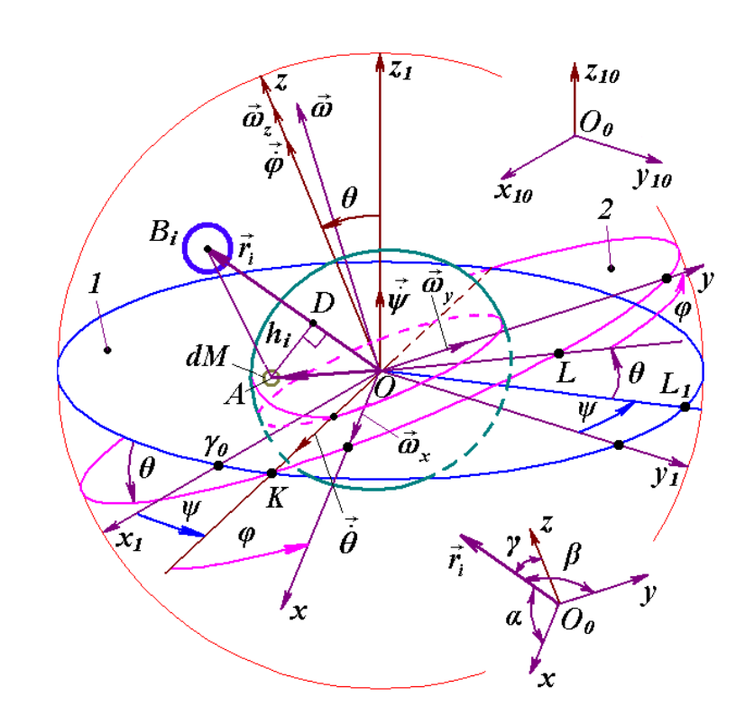
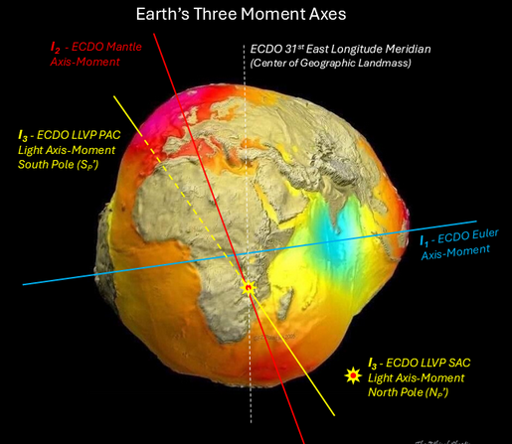

Influence of the Moon
Tidal phenomena on Earth are well-understood and serve as a reference for studying similar effects on the Sun. The gravitational pull of the Moon and Sun creates a tidal bulge in the solid Earth. For the semidiurnal M2 tide, this bulge can result in vertical displacements of 30–40 cm and horizontal displacements of 15–20 cm. This tidal bulge is slightly displaced eastward (0.2°-0.3° to 2.9°) relative to the gravitational alignment of the Earth and Moon, due to the anelastic (non-elastic) response of Earth's materials. This misalignment generates a westerly-directed horizontal torque on the lithosphere, contributing to the secular slowing of Earth's rotation. The Earth is currently slowing its spin by about 2 milliseconds per century, and the Moon is receding at a rate of 3.8 cm per year. In the early Paleozoic, the Earth rotated faster, with a day lasting about 21 hours and a year around 400 days, implying that tidal effects and plate motions would have been more pronounced in the past.
The Moon's gravitational influence contributes to the precession of Earth's axis, which averages around 25.74 thousand years. Earth's rotational axis also undergoes shorter-period oscillations, specifically with half-month, half-year, and an 18.6-year period, which corresponds to the Moon's orbit precession. The amplitude of these half-month oscillations is greater when the Moon is closest to Earth (at perigee). These oscillations contribute to variations in Earth's obliquity (axial tilt) ranging from 14.7° to 32.1°, which are significantly larger than previously theorized. The 18.6-year period of Moon's orbit precession can cause an obliquity oscillation amplitude of 9.2 arcseconds. Furthermore, the evolution of the Moon's orbital axis has been shown to be similar to the evolution of Earth's axis of rotation. Some research suggests that the Moon's gravitational influence might help stabilize Earth's rotational oscillations
The dynamical evolution of the Earth-Moon system significantly alters the periods of Milanković cycles, which are rhythmic changes in Earth's orbital parameters caused by planetary gravitational interactions. These cycles are recorded in geological sediments like banded iron formations (BIF) and stromatolites, which are thought to form due to lunar tides and/or solar insolation variations, serving as a "chronometer" for Earth's past climate history. The power of the obliquity term in these cycles was much lower around 3 billion years ago, as the stronger gravitational torque at that time suppressed obliquity oscillation amplitudes.
The combined gravitational attraction of the Moon and Sun, along with Earth's rotation, provides part of an astronomical control over plate tectonics. Tidal forces actively modulate plate motions, particularly where the mantle's low-velocity zone (LVZ) exhibits low viscosity. The LVZ functions as a low-pass filter, significantly attenuating high-frequency tidal signals (e.g., semidiurnal, diurnal, monthly) but allowing low-frequency oscillations to pass through with little attenuation, thereby making them highly effective in influencing plate tectonics. Modulations in plate motion observed through GPS measurements are consistent with the periods of the Solar year, Lunar perigee, and Lunar nodes, clearly demonstrating the influence of lunar and solar tidal forces. Anomalies such as a negligible Moon node harmonic in intraplate baselines are considered crucial evidence that Moon tides trigger tectonic plate movements. The concept of "westward tidal lag" has also been proposed as a driving force for plate tectonics.
Moon tidal forces deform the crust and can build strain, potentially promoting crack nucleation. Water within the crust and lithosphere weakens rocks and can influence fault behavior. While not explicitly stated in the sources, it is plausible that tidal stresses act upon faults or rock volumes that are already weakened or influenced by the presence of water or hydrous phases inside the mantle itself, in the same way that it exerts forces on tides. Such an effect could be piezoelectric, or migratory.
Both the Moon's tidal forces and solar activity (including sunspots, flares, and related geomagnetic phenomena) plausibly influence earthquake occurrence and magnitude. Water is a critical component within the Earth's mantle and lithosphere, significantly affecting rock strength, melting behavior, and electrical conductivity, and plays a role in seismicity through processes like dehydration embrittlement.

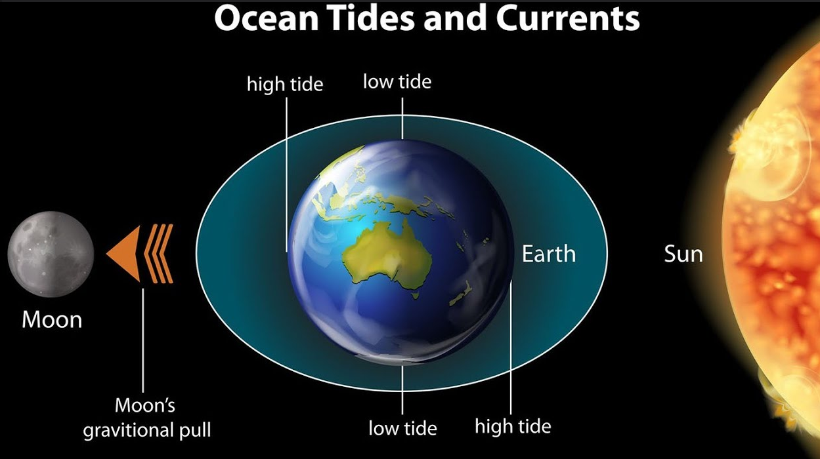
Lunar eclipses have a fascinating impact on Earth’s tides. During a lunar eclipse, the Earth, Moon, and Sun align in a straight line, an event that can only occur during a full moon. This alignment enhances the gravitational pull on Earth’s oceans, leading to higher than usual tides known as spring tides.

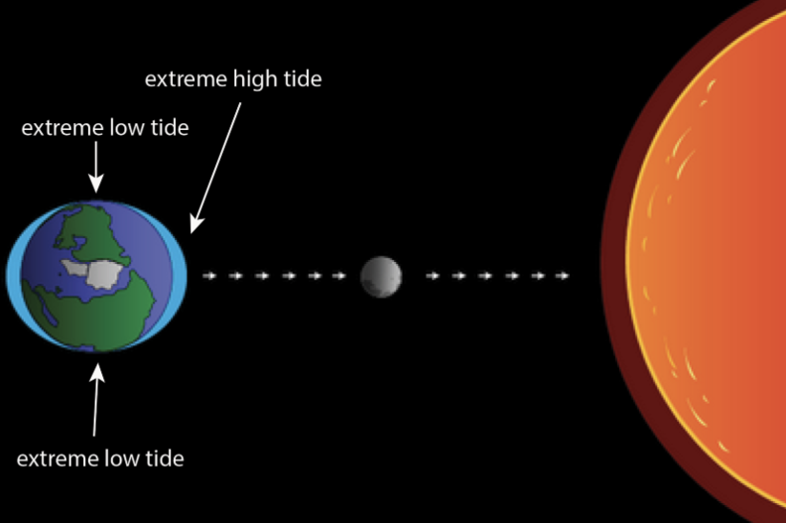
Tidal forces interact with faults and fluid within them. If a fault is in a critically stressed state (from plumes) and contains fluid, the small periodic stress changes from tides could potentially influence the fluid pressure or migration, contributing to triggering. And how does water (a fluid) get moved by the moon and sun? Essentially, at the equator, away from the core and towards the surface.

A mantle plume rising during a lunar eclipse would have a higher speed of ascent.

Studies using earthquake catalogs have investigated the influence of the Moon, specifically its tidal forces, on seismic activity. The Moon's tidal force can deform not only the ocean surface but also the continental crust. This deformation is hypothesized to play a role in the rate at which elastic strain energy builds up in faults and to promote the appearance of cracks (nucleations) in the crust that can evolve into an earthquake.
Analysis using methods from dynamical systems indicates that the motion of the Moon is uni-directionally coupled with the earthquake generating process, suggesting that the Moon's position has an influence on it. While this influence's extent cannot be precisely inferred solely from these methods, calculating the Moon's differential pull at the location and time of earthquakes shows a positive correlation between tidal force and earthquake magnitude. This means there is a slight-to-moderate tendency for larger earthquakes to occur when the tidal force is relatively large at the earthquake's location.
Given the potential links between Moon tides, solar activity, and earthquakes, recent research has explored using data from both sources to improve earthquake forecasting. One study specifically aimed to improve next-day largest earthquake magnitude forecasting with the aid of Moon tidal force and sunspot data.
This research instrumentalized earthquake catalogs from different regions and calculated the Moon tidal force at the time and location of each earthquake. It also utilized sunspot data. The study used a prediction framework that calculates distances between earthquake patterns and incorporates vectors representing daily sunspot numbers and hourly tidal force data.
The findings suggest that using Moon tidal force data can improve forecasting accuracy. Furthermore, the accuracy is improved even more when both Moon tidal force data and sunspot number data are used simultaneously. In tests on different regions, including Japan, New Zealand, and the Balkan peninsula, including both types of data generally resulted in the highest correlation or odds-ratio for forecasting the logarithm of the number of earthquakes (which relates to magnitude) or the maximum magnitude.
The study notes that while the combined 'causal' effects of sunspot numbers and Moon tidal force on earthquakes had not been widely investigated before, the analysis strongly indicates the existence of a causal relation between Moon tidal force and earthquake magnitude. These results encourage the inclusion of data from Moon tidal forces and Sun activity in earthquake forecasting models.
Tidal forces from celestial bodies, including the Sun and Moon, generate tidal stress that is superimposed on tectonic stress. This tidal stress, although small in magnitude compared to the average stress drop of an earthquake (on the order of 10³ Pa vs. 10⁶ Pa), is thought to play a triggering role. The peaks of tidal stress are considered the final catalyst when the stress on a fault reaches its maximum and is in a critical state near the threshold for rapid release of accumulated stress. When periodical tidal loading is shorter than the earthquake nucleation time, earthquakes might be expected to occur near the tides' maxima, assuming a simple model of faults with instantaneous instability at the threshold. This is highly related to the local geological tectonic background.
Specific tidal periods show correlations with different types of earthquakes. For tectonic earthquakes, a high correlation is found with semidiurnal and diurnal tides, as well as 14-day tides. Aftershocks have also been found to be triggered by semidiurnal and diurnal tides and during periods of lunar tidal variations. Very large tectonic earthquakes (M ≥ 7) often occur near the maximum tidal stress amplitude. A reasonable explanation is that increasing tidal stress increases the possibility of small rock fractures expanding into huge ruptures. Shallow earthquakes (less than 70 km deep) show a significant correlation with tides, possibly because the confinement stress at these depths is less than that of the tide. Thrust and normal tectonic faults show a higher correlation with tidal stresses compared to strike-slip faults.
For volcanic earthquakes, observations indicate a strong correlation with tidal forces, mostly those with semidiurnal and diurnal periods, particularly for volcanoes in near-shore volcanic areas and mid-ocean ridges. Some volcanic activities have also shown a lunar period. Slow earthquakes, such as tremors, exhibit a periodicity that is highly correlated with semidiurnal and diurnal tides. This tidal sensitivity is affected by fluid in the fault, and if the shear strength is very weak (e.g., due to fluid migration and a small friction coefficient), tidal forces can trigger slow slip events (SSEs).
Recent studies have investigated the influence of the Moon using dynamical system tools, suggesting that the motion of the Moon is unidirectionally coupled with the earthquake generating process to some extent, meaning the Moon's position influences earthquakes. While this coupling's extent cannot be solely inferred from these methods, analysis of the relation between calculated Moon differential pull and earthquake magnitudes indicates a positive correlation. This is interpreted as a slight-to-moderate tendency for larger earthquakes to occur when the tidal force is relatively large at the location they occur.
Plate motions themselves are modulated by lunar nutation cyclicities (8.8 and 18.6 years), indicating an astronomical control on plate tectonics. Low- frequency horizontal tidal oscillations are less attenuated by the lithosphere and mantle compared to high-frequency ones, allowing them to effectively drag the lithosphere over the asthenospheric mantle. This mechanism contributes to the observed westward drift of the lithosphere.
It is worth noting that diverse results regarding tidal triggering have been found even in the same region using different time periods of earthquake data. This suggests that both seismic data and the physical mechanism need to be well understood. Some possible reasons for contradictory results include clustering in aftershock sequences, lower magnitude completeness levels, and insufficient sampling cycles. Using physically meaningful calculations like the Tidal Coulomb Failure Stress can improve statistical analysis. Furthermore, there is a possible cause from failure of data given that the Moon’s effect on plate tectonics, logically, would be reliant on the presence of water in the mantle. No water, no influence.
A massive moon, like Earth's, can stabilize a planet's axial tilt and precession by exerting a significant gravitational torque that regularizes the planet's spin axis. Planets with multiple moons (e.g., Jupiter with 95 known moons or Saturn with 145) experience complex gravitational interactions. Multiple moons can create competing torques, potentially leading to less predictable or less stable precession, or on the contrary, a better average with higher noise, compared to a single dominant moon.
Mars, with two small moons (Phobos and Deimos), experiences more chaotic precession and tilt variations due to the lack of a massive moon to anchor its spin axis. Jupiter and Saturn have many moons, but their rapid rotation and massive size dominate their dynamics, making the moons' influence on precession less significant. Their precession is relatively stable but complex due to multiple gravitational interactions. Venus, a planet with permanent horizontal nutation, extremely slow rotation, (a day lasts 243 Earth days) and retrograde spin (it rotates opposite to its orbit), has no moon, thus lacks the stabilizing gravitational torque that a massive moon (like Earth's) provides. This makes Venus' axial precession more susceptible to perturbations from other planets (e.g., Jupiter and the Sun), dragging its poles to the position they are now.

On the topic of disasters, in the book The Astrology of Inner Space, in the chapter entitled "Parallel Line Theory," Carl Payne Tobey found found Moon Wobbles to be associated with disasters. A Moon Wobble occurs every 86.5 days when the Sun is conjunct or square the Lunar Nodes. Its effects are felt for 2 weeks before and 1 week after the Moon Wobble. All eclipses are Moon Wobbles, but not all Moon Wobbles are eclipses. This may be the missing correlation factor between the eclipse data and natural disasters.
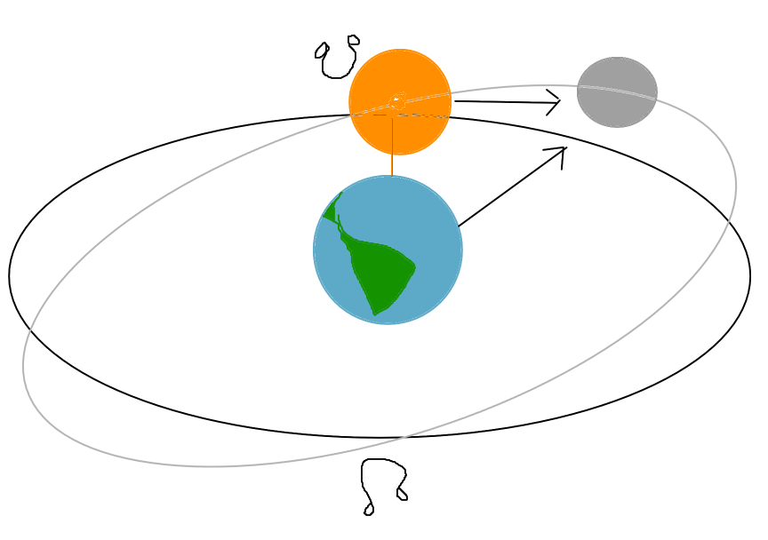
This is easily explained by the Sun and the Earth temporarily having the closest dual resonant influence on the moon’s tilt by degree, when it usually is just the Earth.

A little wobble from the Sun or orbital influence is unlikely to shift the planet’s axis to an upside down, 90 degree or 104 degree angle on its own, given the moon and the content of water in the mantle stabilize it through tidal forces exciting energy release, creation and maintenance of the FeO patch, and gravitational torque.

This provides a plausible mechanism for the moon and the Earth maintaining axial balance and equilibrium through a dynamic self correcting process that would have a cyclic harmonic length equal to the precession cycle. The Earth-Moon system seems to operates as a codependent thermo-electro-magneto-hydrodynamic system involving energy and matter transfer between the two bodies. In the relation to the moon’s closeness, the rate of the moon “fleeing” has a chance of not being constant at all through thousands of years, but rather it being a cycle equal to the precession of the equinoxes, where the moon gets further and closer to Earth depending on both influencing eachother’s torque.

Recent research led by @NASAGoddard and the University of Leeds has uncovered a surprising link between Earth’s magnetic field strength and atmospheric oxygen levels over the past 540 million years. By comparing paleomagnetic data, measured through Earth's dipole magnetic moment, with geochemical indicators of oxygen, such as fossilized charcoal and ocean anoxia records, scientists found a strong correlation. This link is especially clear between 330 and 220 million years ago, when both oxygen levels and magnetic intensity peaked. However:

“The factor they're forgetting, about Earth and magnetosphere dynamics, is the Moon. During this time, the Moon slowed its retreat rate from Earth considerably. Thus, the Moon became more stabilized in its distance and in its effects on both the Earth's internal dynamo, and its tidal effects in the upper atmosphere & radiation belts. That's likely what allowed the Earth's magnetic field to strengthen.” - Beau

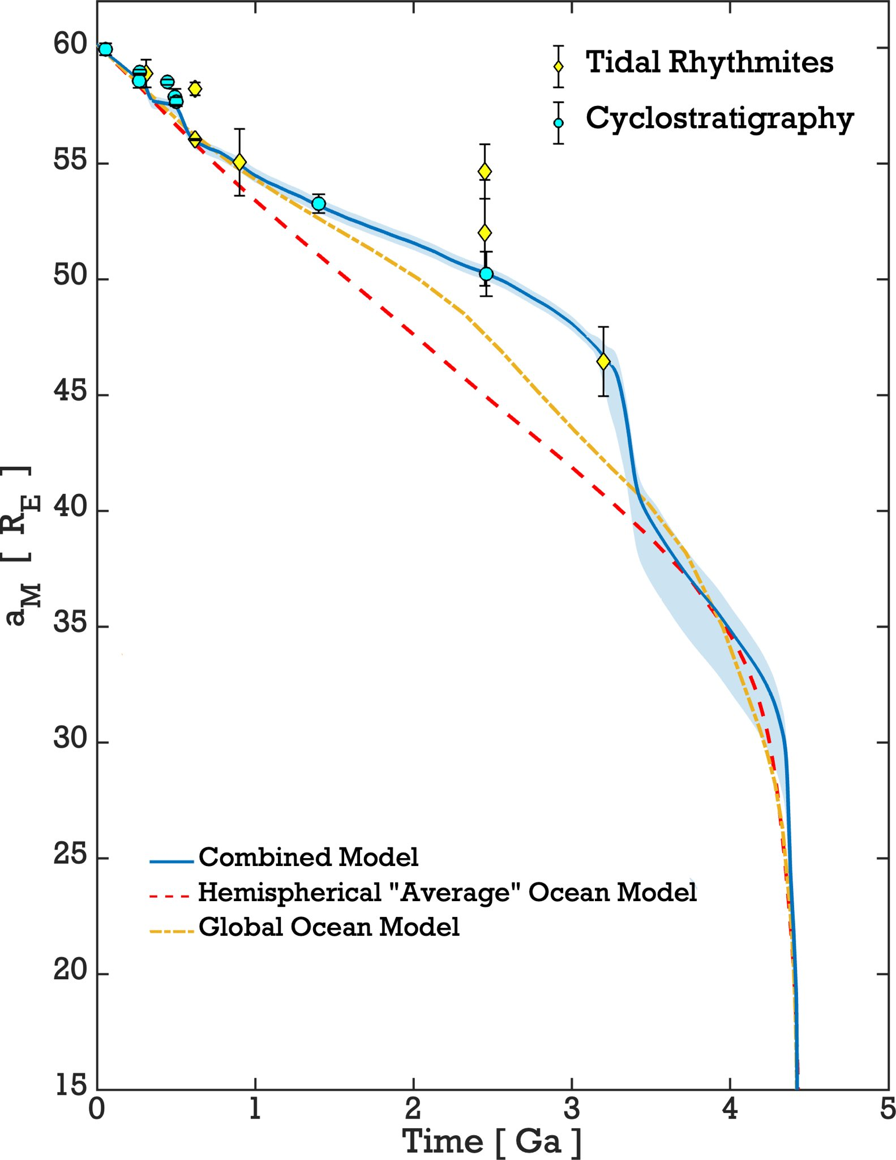

Solar Flares, Solar Sunspot Activity, and the 11 year Sun Cycle can be Predicted by Planet Alignment
The potential for predicting solar flares by planetary alignment stems from a hypothesis that the gravitational tides exerted by planets, particularly Mercury, Venus, Earth, and Jupiter, can influence solar activity. While this idea has been studied in the past, it is currently often considered unlikely by many scientists, with today's textbooks generally not mentioning it (unsurprising). However, statistical analysis suggests a clear relationship exists between solar flares and solar tides caused by planets.

The central hypothesis is that the tide-driving gravities from the planets can disturb the force or momentum balance on plasma trapped within the looping magnetic field lines in the solar corona. This disturbance could lead to magnetic field reconnection, which is believed to be the process that releases the energy powering solar flares and solar storms. The effect is thought to be particularly significant when the solar tides caused by individual planets converge and diverge as the planets come into and out of alignment. Planetary alignment is expected to have a significant tidal effect because it ensures a broad global tide, with significant variation in tide potential during one solar rotation. Perfect alignment results in a high and narrow tide, while near alignment creates a broad tide, where the solar atmosphere experiences a moderate tidal force for a longer time; both scenarios could have significant tidal effects. The sources note that the Sun's rotation period relative to those of the planets is about 25 to 35 times the Earth's rotation period, which could favor large tidal effects on the Sun by a factor of about 625 to 1025 compared to tides on Earth. These effects might be even larger if the period of effective tides is prolonged due to near alignment of the planets. It is hypothesized that the changes in solar activity caused by tide-driving displacement of hot plasma are proportional to the magnitude of the tide-driving gravity and the square of the length of time the active region is under its influence.

Statistical analysis presented in the sources provides evidence supporting this hypothesis, particularly for large solar flares. Among the 38 largest known solar flares (X9.0 and larger), 25 were observed to start when one or more of the tide-producing planets (Mercury, Venus, Earth, and Jupiter) were either nearly above the event position (<10° longitude relative to the flare position from the Sun's center, essentially overhead or underfoot) or at the opposing side of the Sun. The probability for this to happen randomly is calculated to be very low, at 0.039 percent. For the 18 largest flares studied (combining pre-1975 and top 10 GOES flares), 15 happened within 10° from the overhead or underfoot points of at least one of the four planets, with a random probability of about 0.0093 percent. These results suggest that the relation between large solar flare position and the planet or vertical tide position is real with a confidence level of nearly 4 standard deviations (decimals) for the 18 largest flares, and about 3 standard deviations for the 38 largest flares. For smaller flares (11th to 30th largest), the correlation is less frequent but still above random chance. This suggests that the contribution of solar tides might be essential for generating the largest solar flares but less necessary for smaller ones.
An 11-year cycle of alignment of Venus, Earth, and Jupiter has been observed from 1840 to 2000 using daily planet position data. This planet alignment cycle approximately matches the 11-year sunspot cycle. This observation supports a hypothesis of resonance and beat between the cycle of small tides caused by planet alignment and the cycle of independent, large, and irregular nontidal solar activity. When these two cycles were least matched (1875 to 1930), sunspot numbers were low, while they were highest in the late 1950s when the cycles were best matched. This resonance-beat hypothesis suggests that the regular tidal cycle can magnify the irregular non-tidal solar activity when they are in step, and reduce it, potentially explaining periods like the Maunder Minimum when few sunspots were observed despite regular planet movement. The source notes that Mercury's tide doesn't appear to resonate with the 11-year cycle, possibly due to its rapid movement. A proposed Tidal Torque theory suggests that periodic alignments of Venus and Earth create temporary solar tidal bulges, and Jupiter's gravitational force acts on these bulges, influencing the rotation of the Sun's plasma and leading to changes in solar activity.

Based on these observed relations, a potential method for forecasting the times of the largest solar flares (X9.0 and larger) is proposed. This method is applicable shortly after giant sunspots appear. The forecasting relies on tracking when these sunspot groups rotate into specific longitudinal positions relative to the tide-producing planets. The following rules for forecasting, based on past events, then are:
1. Largest solar flares (X9.0 and larger) are most likely to start when giant sunspot groups rotate into a region where at least one of the four tide-producing planets is either overhead or underfoot (within 10° longitude). These are locations where the tidal effects caused by individual planets reach their peak and reverse.
2. Large flares are also likely to start when these sunspot groups are approximately 28° to 32° longitude away from the overhead or underfoot points of at least one of the four tidal planets. Some of the largest flares that did not occur near the overhead/underfoot points were observed to happen about 30° away, often after the active region had already flared several times in previous days when near high tides. This could be when the sunspot enters an area where both vertical and horizontal tide-driving gravity are significant.
3. Large flares are least likely to occur when these sunspots are at 36° longitude or further away from the overhead or underfoot points of all four planets.

A trial forecast based on these rules using sunspot group 960 in June 2007 showed some success, correctly predicting an M8.9 flare (though the rules were based on larger X9.0+ flares) within the first forecasted window and smaller flares in the 28°-32° windows, although the forecast for being far away (>36°) worked only marginally well.

But there is a degree of uncertainty: What planetary cycle controls the FULL Solar cycle?

JUPITER, NEPTUNE, PLUTO, AND THE SUN

An entire section here is dedicated to the excerpts from the book “Recent advances in natal astrology”, by Geoffrey A. Dean, 1976 ( a very rare book), due to the richness of the information in it. Starting at page 509:

“However, Despite over a century of study the cause of solar cycles remains a mystery to both science and astrology. Planets are the obvious first choice: unfortunately planetary forces seem to be far too small to affect the Sun, planetary periods do not match solar periods, and the irregularity of the solar cycle (particularly the intervals of negligible activity) is incompatible with the relative regularity of planetary cycles. Hence current opinion denies any link between planets and the solar cycle.

This opinion appears to be the result of an overly simplistic approach to the problem. Thus it is not sufficient to assume that only single planets are relevant, nor is it sufficient to consider period without also considering phase. A more fundamental approach which takes these factors into account reveals the link between planets and solar cycles almost inmediately, as follows:
The phenomenon of latitudinal passage in solar cycles shows that:
1. The primary causative factor cannot be aspects because an aspect cannot act in different places at different times.
2. The causative factor must synchronise with the solar equator because sunspot formation is symmetrical about the equator.
Hence the key question is: What planetary factor synchronises with the solar equator in tune with the solar cycle?
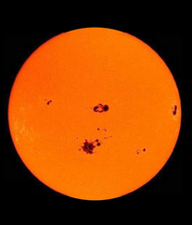
As shown on page 270, the factor could be a planet, a midpoint, a mean point, or a part. A survey of these factors revealed the following correspondence with the major solar cycles (SE = solar equator):
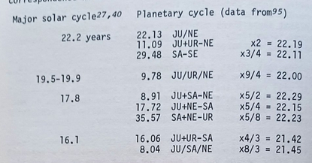
The phasing of the 22.2-year solar cycle (obtained by inspection shows that JU/NE square SE (solar equator) and JU + UR – NE conjunct SE coincide with minima, and that JU/NE and SA conjunct SE coincide with maxima. The synchrony of these aspects is remarkable: over 300 years each pair has averaged <1 year apart. JU/NE ascending coincides with positive cycles, JU/NE descending coincides with negative cycles. Details together with those of relevant aspect cycles for comparison are as follows:
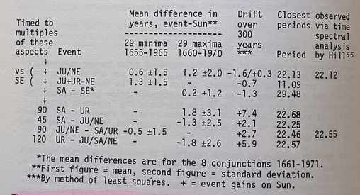
The above JU/NE results are for ecliptic positions. The results for the actually bodily midpoint are only slightly better by about 0.1 year.
The dates of minima and maxima were taken from Waldmeier (87). Most of the difference is due to a few extreme values which can be accounted for by other factors, see later. If these are omitted the mean difference is less than half that given above, much of which can be accounted for by the uncertainty in the minima and especially maxima. For example Waldmeier’s minima differ from those derived from Hill’s data by an average of about 0.6 years, which is comparable with the above; in each case the minima were obtained from smoothed sunspot surves...

… The timing of the aspect cycles is little better than chance (chance difference = 2.9 years) and their drift clearly disqualifies them as major controlling factors in the solar cycle. However this does not mean that they will be without effect, see later note.

On the other hand the JU/NE cycle shows excellent timing and negligible drift. Its succesive ascending and descending sweeps across the solar equator not only correlate with successive positive and negative cycles but are also entirely consistent with the sawtooth pattern of spot formation on the sun (Figure 14.1 on Page 493). Hence it is reasonable to assume that the major controlling factor in the solar cycle is JU/NE.

The phasing indicates that the midpoint is not exclusively the midpoint of the minimum distance, I.e does not jump 180 degrees twice per cycle, but moves without jumps as shown in Figure 14.7 below. This suggests that the midpoint is a vector quantity which is directed inwards and outwards respectively for successive conjunctions, which means that the identification of the midpoint as ascending or descending is arbitrary, although of course once one is defined then all the others follow. In this case the arbitrary choice is positive cycle = ascending midpoint.

Analysis of the major solar periods which correlate with the mean-point of 3 planets indicates that the mean-point of the 3 planets lies on 3 axes (see Figure 14.7 below, right), each of which has the same effect as the single midpoint axes between two planets.

The question arises: why JU/NE? The answer seems to be that not only are all the major solar periods small integral harmonics of the JU/NE period (see upper table opposite) but also there is a remarkable clustering of periods and harmonics at the JU/NE period, as follows:
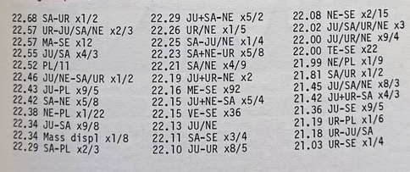
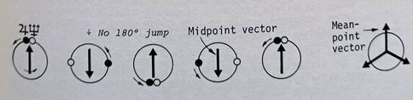

Figure 14.7 - MIDPOINT AND MEAN-POINT VECTORS
Position of the JU/NE midpoint every 270 degrees of Jupiter’s movement.
Right: The mean point of 3 bodies has 3 vectors 120 degrees apart.
The planets cross in relation to the solar equator at opposite points in a vector.
There are 18 periods within 0.7% of JU/NE and 29 within 2.0%, which is remarkable. No other period has such a large number, which easily explains the dominance of this period. In other words the dominance of JU/NE is simply due to the following:
1. Resonance. This is the main reason.
2. The uniformity of Neptune’s orbit which helps to maintain synchronicity. Thus over the last 300 years the conjunctions and squares of UR/NE with the SE have occurred within an average of 0.8 years of respectively conjunctions and squares of JU/NE with SE.
3. The large mass of the planets involved. Jupiter and Neptune rank 1st and 3rd respectively in mass displacement, see page 508.
Can the Maunder and other minima be explained? Figure 14.8 shows that over at least 4000 years minima have appeared near every simultaneous NE/PL-90-SE and NE-180-PL. This may be due to the pronounced resonance exhibited by the Neptune-Pluto system (90), which is remarkably linked to the solar equator. The period of NE-PL is exactly within 0.01%, see under (95) twice that of Pluto and thus exactly 2 ½ times that of NE/PL. Hence NE-PL conjunctions always occur in nearly the same degree which, significantly, is close to the solar equator. Furthermore NE/PL square SE occurs almost simultaneously with NE-180-PL; thus in 1646, at the start of the Maunder Minimum, they occurred <1 year apart.
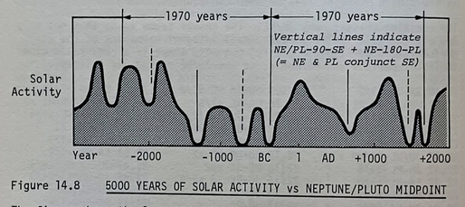
The figure shows the long-term envelope over solar sunspot activity as indicated by radiocarbon (carbon-14) measurements. Carbon-14 is produced in the Earth’s upper atmosphere by cosmic rays whose intensity is reduced when the interplanetary magnetic field is increased by solar activity. Trees assimilate carbon-14 as carbon dioxide during photosynthesis, hence carbon-14 levels in tree rings provide a record of past solar activity. The Maunder Minimum of 1645-1715 is clearly visible.
The figure shows that since at least 2000 BC every NE/PL square SE in which NE is opposition PL has coincided with a prolonged period of negligible solar activity. Three other minima have coincided with NE/PL square SE alone (shown dashed). Before 2000BC the match is less good but can be explained by the considerable uncertainty in the data. The effect is consistent with the correspondence between sunspot minima and JU/NE square SE, has no accepted explanation, and has considerable implications for both astrology and science. Solar curve is from Eddy(47a)…
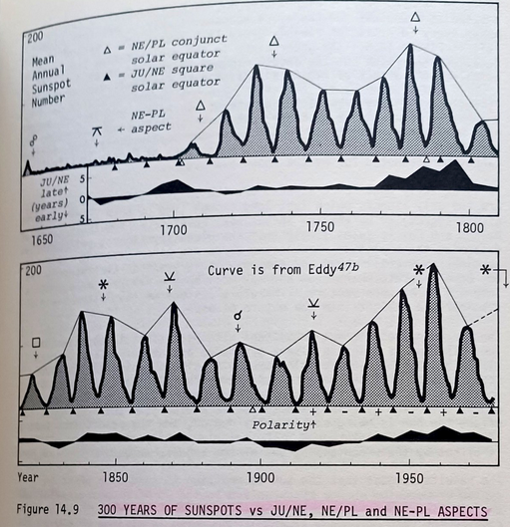
The figure shows how JU/NE square the solar equator consistently times minima in the sunspot cycle over the entire recorded period. Despite some out-of-step periods the overal synchronicity is unaffected. Such periods seem to be due to competition from other factors notably NE/PL, and will also reflect interaction with the cycles listed on page 510. It is significant that the worst out-of-step period (1770-1800) coincides with an unusually large number of important factors, namely NE/PL-0-SE, NE-120-PL, PL-180-SE, and UR-90-NE, all within a few years.
If phase effects are real then at the time of an effective NE/PL the JU/NE cycles should be alternately augmented and diminished dependent on how their phase matches that of NE/PL. This effect is evident on either side of the 1900 NE/PL-0-SE but it is not clear-cut for the others.
The figure also shows how the wave envelope tends to vary in accordance with the NE-PL aspect, and it is notable that it is increased by trines and sextiles and decreased by squares and oppositions. (The successive trines and sextiles are due to PL temporarily moving faster than NE.) Around 2020 there will be NE-60-PL and NE/PL-180-SE a few years apart, which suggests that the next 50 years may be something like 1750-1800…
...occurrence repeats every 5 midpoint cycles with alternately ascending and descending midpoints and therefore repeats exactly in both position and phase every 10 cycles or roughly every 1970 years. This period is visible in Figure 14.8; the uncertainty in the earliest data precludes a detailed comparison but the double minimum at the end of each period is notable. The effect of Pluto is confirmed by Figure 14.9 on page 513.
It follows that any transplutonian planet may have a significant long term effect on the wave envelope, but no worthwhile conclusions can be made until the existence of such planets has been established. It is open to argument whether there are any features of Figure 14.8 that cannot be accounted for by the known planets.
It is unlikely that NE-PL aspects are the only effective ones but they are the only aspects which last long enough (two or more years for orbs of one degree) to be evident by the wave envelope. From the results of Nelson and Fox is seems likely that the planetary aspects collectively determine the amplitude whereas the JU/NE and other resonant cycles determine the overall phase and timing. It is possible that aspects may not be a separate phenomenon and may well be the natural consequence of interaction between vectors. Therefore a study of the latter may give considerable insight into the nature of aspects.
Thus preceding results are consistent with variations in angular momentum. The Sun is spinning like a gyroscope and hence resists changes in tilt. However the entire solar system is also spinning like a gyroscope, except that the weights (and hence the tilt) are being continuously shifted. Hence there are two gyroscopes working against each other, one fixed (the Sun) and the other moving (the solar system). In effect the Sun is being continuously nudged, and the result is a continuous cycle of disturbance. The relatively tiny mass of the planets is offset by them containing 98% of the angular momentum.
The results suggest that the Sun is reacting to resonance peaks in cycles of momentum change synchronised to the JU/NE midpoint cycle. As the midpoint reaches its maximum distance from the plane of the solar equator the rate of change of angular momentum is minimum – and so is solar activity. As the midpoint sweeps across the solar equator the rate of change is maximum – and so is solar activity.
This model differs from that of Jose(60) in that resonance is considered and cycles are timed with respect to the solar equator; the remarkable synchronicity is strong evidence that the effect is real. Furthermore the variation in observed solar periods is entirely compatible with the marked variation in a multiple cycle due to eccentricity effects. The model allows (1) the timing of solar activity to be predicted within a year or two over any period, and (2) an estimate to be made of the wave envelope including minima. With further research refinements should be possible; in particular the phase and timing of the other cycles listed on page 510 need to be compared with those of the cycles obtained by harmonic analysis of sunspot data. If the relevant celestial cycles can be identified then precise solar prediction will be within sight.
Landscheidt (64) examined data for 3000 solar flares 1954-1964 and found that they occur significantly more frequently on the side of the Sun facing the galactic centre. Furthermore, they tend to follow whichever end of the JU/PL midpoint axis is passing through the hemisphere facing the galactic centre. As one end moves out of the hemisphere, the other moves in, and the centre of flare production jumps 180 degrees. The effect is said to be significant at the p<10^-8 level.
Landscheidt gives no details hence his results are beyond assessment. However the solar equator intersects the ecliptic only 11 degrees before the galactic centre, and over 1954-1964 the JU/NE axis was 30-31 degrees before the JU/PL axis, hence the real correlation may be with the solar equator (which is more plausible than the galactic centre), and the JU/NE midpoint (which would support the present work).
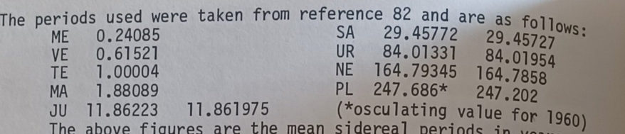
The above figures are the mean sidereal periods in years. The second figure is the mean value over one million years taken from reference 39. The difference between the two figures is due to perturbations over the very different lengths of time involved. The second figure is obviously not applicable to calculations over the past few hundred years but illustrates very-long-term conditions and particularly the exactness of the Neptune-Pluto resonance; it was used to derive the NE-PL contacts shown in Figure 14.8 because of the probable unsuitability of Pluto’s osculating value. The periods of multiple cycles are obtained by simple combination of frequencies. Thus:
The period of JU/NE = 1/(frequency of JU/NE).
Frequency of JU/NE = ( frequency of JU + frequency of NE)/2;
hence the period of JU/NE = 1/((1/JU + 1/NE)/2).
The period of JU+SA-NE = 1/(1/JU + 1/SA – 1/NE).
The period of JU/SA/NE is nominally 1/((1/JU + 1/SA + 1/NE)/3) but because there are three axes the effective period is one-third of the nominal period or simply 1/(1/JU + 1/SA + 1/NE), which is the same as that of the invalid part JU+SA+NE (see page 270).
Ephemeris data for planets and nodes were taken from Erlewine et a, Interface – Planetary Nodes, and The Sun is Shining – Heliocentric Ephemeris 1653-2050 (ref 64 on p 349). The latter presents in conventional polar co-ordinates the ephemeris data given in rectangular co-ordinates in Vols 6 and 12 of Astronomical Papers Prepared for Use of the American Ephemeris and Nautical Almanac.”
Influence of Solar Sunspot Activity and Other Solar Phenomena on Earth
The relationship between solar activity and terrestrial processes, including earthquakes, has also been a subject of study for over 150 years. Long-term changes and trends in solar activity, such as the century-scale Gleissberg cycle and the 11-year sunspot cycle, show connections with seismic activity. Historically, higher seismic activity has been observed around secular solar maximums. These variations in seismic activity relative to solar activity are similar to variations observed in geomagnetic activity, suggesting they may be influenced by the same solar agents.
In the 11-year solar cycle, two maxima in the number of earthquakes are observed: a higher one coinciding with the sunspot maximum and a secondary one on the descending phase of the cycle. Coronal mass ejections (CMEs), which cause major geomagnetic disturbances around sunspot maximum, are linked to numerous weaker earthquakes. High-speed solar wind (HSS), which leads to a secondary geomagnetic activity maximum, is associated with triggering the strongest earthquakes on the descending phase of the cycle. Another hypothesis suggests that solar-induced changes in atmospheric circulation, through redistribution of pressure, could act as a mediator for solar influences on seismic activity.
Some studies indicate that geomagnetic storms caused by solar wind influence Earth's magnetic field and correlate with strong earthquakes, which can then trigger volcanic activity. The proposed mechanism involves solar winds generating currents in the ionosphere, causing magnetic field fluctuations on the Earth's surface. These induce electrical currents (telluric currents) that penetrate deep into the Earth and, in the presence of Earth's magnetic field, generate electromagnetic (Lorentz) forces in the conductive crust. These forces can potentially trigger the release of stress-strain energy, causing earthquakes and fractures. Laboratory and field experiments on earthquake triggering by electrical current injection into the Earth's crust support the idea that similar triggering phenomena might occur from strong electromagnetic impacts from solar flares or geomagnetic storms. Numerical estimations suggest that telluric currents induced by geomagnetic pulsations from solar flares can have a similar density at earthquake source depths (5-10 km) as currents from artificial sources known to affect regional seismic activity.
Analysis of global earthquakes (M ≥ 4) in the time window of ±11 days around the strong X9.3 solar flare on September 6, 2017, showed a significant increase in the number of earthquakes (up to 68%) after the flare. Regional seismicity in Greece (M ≥ 3) also increased by 120% in the same period. This observed pattern is similar to seismicity behavior after injecting DC pulses from artificial power systems.

It is important to note that some previous statistical studies on the correlation between Earth's seismicity and solar processes have yielded contradictory results, including both direct correlation and anti-correlation. This inconsistency highlights the complexity of Sun-Earth interactions and the need for a unifying physical mechanism. The contradictory results in solar-seismicity correlation studies may stem from the fact that the influence of solar/geomagnetic activity on earthquakes is not uniform but rather water-mediated and dependent on specific geological conditions. In regions where faults are already under critical stress and contain mobile fluids (water), the geomagnetically induced telluric currents could act as a final trigger. The electromagnetic stimulation from these currents might encourage fluid migration into fault zones, thereby reducing the fault's strength properties and precipitating an earthquake. This suggests that the impact of external solar forces on Earth's seismicity is not a direct, universal trigger, but rather a modulating factor that exploits pre-existing conditions, particularly the presence and mobility of water within susceptible fault systems and mantle domains.
Planetary alignment can forecast earthquakes stems from hypothesized connections involving tidal forces exerted by celestial bodies and, potentially, indirect effects through solar activity. It is important to note that while these relationships have been studied, they are often debated. This is understandable, as earthquakes stem from a complex mechanism with multiple variables.
Several studies have presented observational evidence regarding the tidal triggering of earthquakes. Some investigations have shown a positive correlation between earthquakes and tides, while others have not found a significant relationship. The correlation appears to vary depending on the type and magnitude of the earthquake. For instance, thrust and normal faults in tectonic earthquakes show a higher correlation with tidal stress than strike-slip faults. Volcanic earthquakes in nearshore areas and mid-ocean ridges also show a strong correlation with tidal forces, mostly with semidiurnal and diurnal periods. Slow earthquakes, too, exhibit a periodicity correlated with semidiurnal and diurnal tides. Regarding magnitude, very large earthquakes (M ≥ 7) often occur near the maximum tidal stress amplitude. Small earthquakes (2.5 < M < 4) have also been found to be triggered by short-time-scale stress changes. High correlations have been found not only before but also after major earthquakes, suggesting tides can influence foreshocks and aftershocks.
One method for investigating the tidal triggering of earthquakes involves examining the relative positions between the Earth and other planets in the solar system. The hypothesis is that celestial gravitation provides a comparatively large force that can trigger earthquakes when Earth and other planets are arranged in a straight line. The relationship between lunar phase and seismicity has been discussed by many researchers, illustrating this idea. This suggests that planetary alignment could, in theory, influence earthquake occurrence by enhancing the overall tidal stress on Earth. However, the complexity of seismic activity means that using tides, including those influenced by planetary alignment, for earthquake prediction has not been fully confirmed.
Another potential, albeit debated, link is through the influence of solar activity on earthquakes, which itself might be linked to planetary alignment, as already discussed.
Bringing these potential links together, planetary alignment could theoretically be related to earthquake forecasting through two possible pathways indicated in the sources:
- Direct Tidal Influence: Planetary alignment enhances the gravitational forces on Earth, contributing to Earth tides, which are hypothesized to trigger earthquakes when faults are in a critical state. Examining the relative positions of planets is a method used to investigate this direct tidal triggering.
- Indirect Influence via Solar Activity: Planetary alignment is hypothesized to influence solar activity (solar flares, sunspots) via tides on the Sun. Solar activity, in turn, is hypothesized to influence earthquakes through electromagnetic effects. Therefore, if planetary alignment influences solar activity, and solar activity influences earthquakes, there could be an indirect link allowing planetary alignment to potentially factor into earthquake considerations.
While some statistical correlations have been observed for certain events, a definitive, widely accepted physical mechanism and predictive capability for earthquakes based solely on planetary alignment is not established in academia. However, the planetary alignment as an earthquake trigger can be systematically and fundamentally explained by its influence on the water in the mantle.
Outside planetary influence here is suggested to have a much bigger role than previously thought, given the correlation of JJ Smulsky’s work in relation to gravitational data of the Earth.
I personally recommend as an avenue of future research to quantify tidal stresses from lunar and planetary alignments (e.g., using data from https://ssd.jpl.nasa.gov/horizons/app.html#/) to support claims about earthquake triggering or plume acceleration.
Another source of data with interesting correlations to geological activity is https://ssgeos.org/, which has tracked correlation with earthquake activity and planetary conjunctions for about 20 years. It could be the same gravity resonance activity mechanism that could be shaping plume formation.
It is also interesting to note that there is also artificial intelligence being developed for assessing the planets' positions as a precursor to earthquake events. A recent study used Artificial Neural Networks (ANN) and Random Forest Regression (RFR) to assess the influence of Earth's position relative to other planets and solar positions on the number of earthquakes. Using a dataset integrating earthquake data and planetary positions, the results from both ANN (68.27% accuracy, R-Squared 0.65) and RFR (65.06% accuracy, R-Squared 0.67) prove a "partial influence" of planets' positions on seismic activity on Earth.
https://www.sciencedirect.com/science/article/abs/pii/S0264370724000401

The Jupiter and Saturn Connection to the Mantle
It has already been explained thus far that the planets exert force on the Sun, and influence planetary tidal events not only from mass, but also due to momentum in an uniquely organic model of the solar system. Jupiter, Neptune, and Saturn, if they exert force on the sun, will invariably also exert force on the Earth, as JJ Smulsky Predicts.

There are dynamical models of solar system formation, such as the "Nice model," where the orbital migration of Jupiter and Saturn played a significant role. In this model, Jupiter initially migrated inward and Saturn outward due to interactions with planetesimals in the disk. After some time, they crossed a mean motion resonance (where Saturn's orbital period was exactly twice that of Jupiter), which dynamically perturbed Uranus and Neptune, throwing them into the outer Solar System. These events led to a great pulse of bombardment by icy planetesimals from the outer Solar System onto the inner planets and the Moon. This migration also explains the low mass of Mars and the structure of the asteroid belt. These outer Solar System planetesimals are suggested as potent sources of volatiles for the growing terrestrial planets. The Grand Tack model specifically proposes that Jupiter migrated inward to about 1.5 AU before migrating outward with Saturn, scattering a swarm of planetesimals from as far out as 13-15 AU into the inner Solar System, remnants of which are carbonaceous chondrites. While not a direct, ongoing tidal force causing deformation on inner planets, this theory highlights Jupiter and Saturn's profound gravitational influence on the distribution of matter and impact history across the solar system.

The precession of Earth's orbit can be efficiently explained as caused by the influence of other planets, with Venus, Jupiter, and Saturn being the most important planetary influences. This effect is analyzed using methods that consider the moment produced by the gradient of the gravitational field from these planets acting on the Earth. As the Earth tilts its spin axis at an angle, this introduces additional forces on different parts of the Earth (represented as rings at various latitudes) which combine to produce a moment that is proportional to the angle of tilt. This non-zero moment causes the precession. This is a form of tidal interaction, where the gravitational pull of the distant planets varies across the non-spherical Earth, causing a torque and leading to the precession of its spin axis and orbit.

For planets in orbits similar to Earth's in our Solar System, the tidal forces from distant giant planets like Jupiter and Saturn are not expected to be a primary driver of atmospheric extension or loss compared to the host star or nearby moons, but still drive tidal influence.

Mantle Plumes and Volcanism
The processes of mantle convection, melting, and volatile ascent are linked to mantle plumes and volcanism. Mantle plumes are thought to originate from the deep mantle, potentially near the CMB. Remember the possible O2 release of the Pyrite at the CMB?
Regarding the decomposition of FeO2Hx, particularly near the CMB, it can decompose under prolonged heating above a critical temperature (>2300 K for reaction with CO2). If the stoichiometry of FeO2Hx is such that x ≠ 1 (i.e., not FeOOH), the decomposition could release essentially oxygen. The high-temperature decomposition of FeO2Hx to Fe2O3 has been observed in experiments. A large-scale release of oxygen could have significant geodynamic implications. This oxygen could rise as O2 or react to form other volatile compounds, potentially reducing the viscosity of the surrounding mantle and accelerating the ascent of plumes. A massive, large-scale oxygen eruption in ORP could even potentially cause geodynamic instability and mantle overturn, analogous to limnic eruptions, though on a much larger scale and longer timescale.
Mantle plumes rising from the deep mantle are thought to reach shallow depths where the reduced pressure causes partial melting by decompression. This process generates large volumes of magma that erupt at the surface, forming hotspots. The basalts erupted at hotspots, known as Ocean Island Basalts (OIBs), have subtly different chemical and isotopic compositions compared to Mid-Ocean Ridge Basalts (MORBs). These differences, including distinct noble gas isotope signatures (e.g., elevated 3He/4He ratios), are interpreted as plumes tapping a deep, primordial reservoir in the lower mantle that has experienced less processing and degassing compared to the upper mantle source of MORBs.
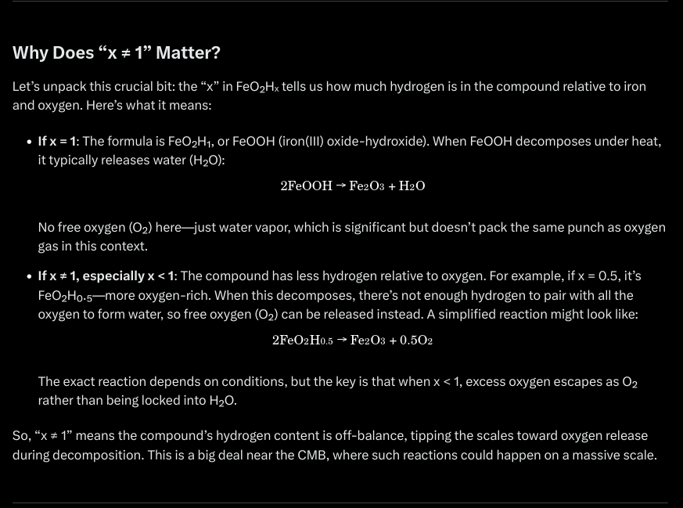
Off balance being, less hydrogen.
Without sufficient water, the hydrogen cycle is disrupted. Ascending O₂ cannot recombine into H₂O, leaving the ORP over-oxidized. This leads to repeated, large oxygen eruptions, as there’s no hydrogen to buffer the system. In the lower mantle, the lack of hydrogen limits FeO₂Hₓ formation, causing existing FeO to decompose into oxygen and other volatiles, further destabilizing the CMB. In the lithosphere-asthenosphere boundary, unbuffered O₂ reacts with carbon to form methane (CH₄) or H₂, tilting the balance away from CO₂ and H₂O in very dry conditions. These VOCs and gases increase geodynamic instability, potentially driving large plumes that accelerate Earth’s rotation abnormally due to mass redistribution. This could culminate in a mantle overturn, disrupting the CMB’s FeO coupling layer.

This concept of geodynamic instability and material transfer from the CMB to the surface via large-scale upwellings connects directly with the "Core Echo" framework as published by Craig Stone. The Core Echo concept describes heat surges (imaged as low-velocity anomalies beneath hotspots) originating at the CMB, powered by radiogenic energy, which ascend through the mantle as plumes. These plumes, carrying heat and potentially chemically heterogeneous or volatile-rich material, reach the surface as volcanic events or climate shifts. The scenario's "large oxygen eruptions" triggering "large plumes" that cause instability and overturn aligns with the Core Echo idea of material/energy bursts from the CMB driving mantle dynamics and impacting the surface, although the specific chemical trigger (oxygen vs. general heat/volatiles) differs.

The evidence for connection to Jupiter and Saturn arises from the Core Echo paper's hypothesis regarding the initiation of these deep events. It directly proposes that heat surges from Earth's core, influenced by solar system gravitational cycles (e.g., Jupiter-Saturn alignments or their harmonics, e.g., a 3700-year harmonic ), travel through the mantle and emerge as episodes of heightened volcanism and climatic disruptions. Tidal forces from the Moon and Sun can excite oscillatory modes in the fluid outer core (or, perhaps, in the water at the mantle), amplifying dynamic responses at the CMB and potentially triggering these heat surges. These gravitational cycles can induce "resonant stratifications" within mantle plumes, manifesting as horizontal thermal, density, and chemical boundary layers that can speed up plume ascent. These layers are extremely likely to be simply, water and hydrated material.
Therefore the gravitational influence of planets like Jupiter and Saturn could be a triggering mechanism for the deep processes that, in the scenario, lead to ORP instability, oxygen eruptions, and large plumes, and thus tectonic activity by shaping VOCs into plumes through resonant stratification, inducing instability and potentially toroidal vortex formation, leading to a more efficient transport of oxygen, hydrogen, or any other volatiles (released from potential decomposition of hydrous phases like ε-FeO2H) to the surface, through tidal force with water in the mantle.

Developing the Probative Construct:

PART 6.
THE CYCLE

A Geomagnetic Weakening?
The Earth's magnetic field has decreased by 10% over the last 150 years, with a notable reduction in strength over the past centuries.
Over the last century, there has been a doubling in the geomagnetic field, which has been linked to an increase in the solar magnetic field. Conversely, a long-term decrease in solar F10.7 flux (a proxy for solar activity) has correlated with an average increase in the inner zone proton population.
Some models predict that the current decline in Earth's geomagnetic moment could lead to a Leschamps-level decay quite soon. Historically, there's evidence linking low geomagnetic field strength to mass extinctions over the last 100,000 years.
Geomagnetic excursions, such as the Gothenburg and Sterno-Etrussia events, and a Mid-Holocene excursion (around 5000 to 3500 BCE) indicate past periods of significant field changes. The Laschamps excursion, about 41,000 years ago, saw the magnetic field tilt by approximately 76 degrees.
While there is no magnetic record in Earth's crust before 3.5 billion years ago, new paleomagnetic data suggest that the Earth's magnetic field at approximately 3.2 billion years ago could have been as strong as it is today, implying that the differentiation of the inner core began no later than that time.
Causes of Geomagnetic Weakening:
The geomagnetic field is primarily generated by convective processes and constant water exchange around the Earth's iron-rich liquid outer core.

Internal processes near the Core-Mantle Boundary (CMB), such as changes in the circulation pattern of flow deep under Canada, can weaken magnetic patches and lead to phenomena like a fast magnetic pole shift towards Siberia.

If the magnetic patch underneath Canada is weakening due to changes in deep flow patterns, and if this region hypothetically contained FeO-rich conductive material at the CMB, it would imply a reduction in the effectiveness or extent of this highly conductive, iron-rich material that facilitates magnetic coupling in that specific area, with heat escape into its surroundings. This reduction or alteration of the conductive material's distribution could lead to the observed weakening of the magnetic field patch rather than a complete "loss of coupling" in terms of the underlying physical mechanism. Conductive iron-rich layers may enhance coupling, so a weakening would imply a decrease in the conditions that promote such enhancement.

Remember that plumes (not LLSVPs) have a slightly horizontal movement after the local decomposition of the FeO layer. In this case, the decomposition could have occurred close to the Middle Atlantic, and traveled towards Canada. An "elongating blob" within the Earth's mantle has been identified as a factor weakening the "Canadian patch" of the magnetic field and causing the rapid shift of the North Magnetic Pole towards Siberia. This is generating a higher rate of escape of CO2 and water vapor, as seen in the last year’s eruptions.

A strong outer planetary magnetic field can reduce the escape rate of hydrogen, helping to preserve a planet's water budget. This shielding effect is crucial, especially for planets exposed to strong stellar winds. The magnetic field influences atmospheric escape during the transition from hydrodynamically limited to diffusion-limited escape through polar caps and cusps. A loss in the planetary magnetic field, means a loss of water at the poles.

Magnetic waves, some with a ~7-year period, originating from the fluid core, are linked to short-term variations in Earth's volcanism. Rapid changes in Earth's magnetic field, causing field lines to "jerk" every 3-12 years due to hydromagnetic waves from the core, also contribute to these effects. Geomagnetic changes can trigger earthquakes, especially in High-Geothermal-Flux (HGF) areas, followed by an increase in volcanism and hydrothermal activity with a delay of 1-2 years.

Along with the previously discussed influences, this implies a triple mechanism, where the faults of the planet are weakened by high geothermal flux from tidal force both lunar, solar and explanetary, then triggered by geomagnetic storms from coronal mass ejections, inducing telluric currents that generate electromagnetic (Lorentz) force in the conductive crust.

Geomagnetic storms and substorms represent significant modes of variability in solar wind-magnetosphere-ionosphere coupling, driving field-aligned currents (Birkeland currents). Extreme Birkeland currents are more likely during geomagnetic storms, especially on the dayside.
The intensity of geomagnetic storms is linked to their duration and strong Interplanetary Magnetic Field (IMF) BZ. Geomagnetic activity exhibits century-scale variations and is highly correlated with sunspot activity. The planetary magnetic field, as is has been shown so far, is weakening.

HOWEVER, this assumption of “weakening” does not take into consideration certain laws of electromagnetism and thermodynamics, that have evidence of affecting the planet.

From the JU/NE astrological source:
“The figure shows the long-term envelope over solar sunspot activity as indicated by radiocarbon (carbon-14) measurements. Carbon-14 is produced in the Earth’s upper atmosphere by cosmic rays whose intensity is reduced when the interplanetary magnetic field is increased by solar activity. Trees assimilate carbon-14 as carbon dioxide during photosynthesis, hence carbon-14 levels in tree rings provide a record of past solar activity. The Maunder Minimum of 1645-1715 is clearly visible.”

The Earth's magnetic field modulates the amount of radiocarbon produced in the atmosphere by solar energetic particles (SEPs); a “weaker” field allows more low-energy SEPs to enter the atmosphere, increasing radiocarbon production. However, if the tectonic and volcanic emissions of the planet are still based on CO2 and H2O, then the mantle is still wet and generating FeO, which means that the planetary magnetic field seems to be concentrating closer to the inner center of the planet, guided by Lorentz-like activity from outside influences. Thus, an interplanetary magnetic field is increased.

Higher gauss is correlated with smaller spherical magnetic fields.
The Magnetic Field Strength (B-field) of an object is measured in Gauss (G) or Tesla (T). 1 T = 10,000 G.
- The field’s spatial distribution doesn't dictate its magnitude directly. You can have:
- A small region with very high field strength,
- A large region with low field strength,
- Or any combination thereof, depending on the energy source and geometry.

Think of it like this: a tightly coiled electromagnet can create an intense B-field in a small space, while Earth (usually) has a weak but vast magnetic field. If the outer magnetic field is weakening, that means that conversely, the magnetic field has retreated. A solar flare could cause the magnetic field to strengthen due to energy influx, and thus retreat. When electrical activity increases in a tighter area (e.g., denser current loops, plasma filaments, or compressed magnetic flux, like water interacting with solar flares at the CMB), the local B-field can absolutely intensify, as the overall volume of field distribution shrinks.

The Pacific and African Large Low Shear Velocity Provinces (LLSVP) near the CMB, possibly rich in iron and carbonatites (good conductors) being ascension pathways for water, may influence magnetic acceleration patterns, as they react to magnetic fields, electric induction, tidal influence, and telluric currents. They are a source of water to keep the lower mantle wet. Furthermore, them becoming a possible axis of rotation due to mass, like a Dhanibekov effect, is more than well justified by their possible chemical composition and physical characteristics.

The electrical conductivity and magnetism of the lower mantle, particularly a thin layer near the CMB, may be the best source of measurement for calculating torque strength in the planet, and thus, the size of the of geomagnetic field (it’s “strength”), its protection, and if the planet will decouple. If the FeO layer increases in its activity by water chemistry from tidal influence under a wet mantle, then we should see planetary rotation speeding up.

And voila:
https://phys.org/news/2021-01-earth-faster.html – The Earth has been spinning faster lately.

The “energetic debt” of the planet is actually liberated through core-mantle interaction, a reduction in the size of the magnetic field, an increase in the strength of the intramagnetic field, and faster rotation. This actually causes it to be more prone to tidal influence from the outside, which is wonderfully harmonic in mechanism with the orbital periods’ influence on tilt that JJ Smulsky calculates.

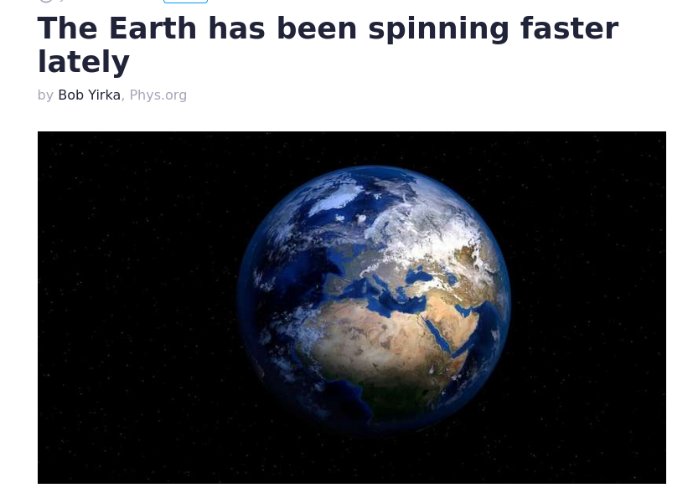

The inner radiation belt's trapped proton flux is inversely correlated with solar activity (F10.7 flux), meaning lower solar activity leads to increased proton flux. The South Atlantic Anomaly (SAA), where the magnetic field is weakest, allows high-energy protons to be observed at lower altitudes.

Recapitulating:

The Moon, in general, exerts significant gravitational influence on Earth. It is a primary driver of tidal forces, causing deformation not only of the oceans but also the solid Earth. These lunar tidal forces are hypothesized to influence phenomena like earthquakes. The Moon's orbit also contributes to the long-term oscillations and precession of Earth's spin axis. Specifically, there is an ~18-20 year peak in earthquake periodicity potentially caused by the 18-year Saros period, which is an eclipse cycle related to the alignment of the Sun, Earth, and Moon. A more precise calculation for the Moon's influence on Earth's axis shows a dominant period of 18.6 years. The Moon's tidal forces are linked to earthquake triggering. Earthquakes originate in the crust and upper mantle. While tidal stresses are generally small, they can potentially trigger events on faults already close to failure. A hypothetical amplification of lunar tidal effects through resonance could theoretically influence stress regimes in the lithosphere and upper mantle, potentially impacting processes like fluid migration or seismic activity.

Lunisolar eclipses cause temporary abnormal movement of fluid away from the core boundary at equatorial regions. This would possibly inhibit the decomposition of the hydrous iron phase into water, by inducing hydrogen starvation from inhibited intake of water at the core-mantle boundary due to tidal force, releasing O2 in larger “chunks” due to a localized redox state. This O2 would be forced to get hydrated closer to the lithosphere, which would cause stronger tectonic activity. Furthermore, the high conductivity at the LLSVP regions from upper mantle hydration would be increased. The ~18-20 year peak in earthquake periodicity potentially caused by the 18-year Saros period, which is an eclipse cycle related to the alignment of the Sun, Earth, and Moon, or even a Tetrad period would facilitate induced currents in hydrated regions, generating either piezoelectric stress or fluid migration, in a prolonged amount of time, while hampering hydrogen intake by the CMB. However, under present wet mantle conditions, this seems unlikely to cause a decoupling.

A "great conjunction" is the apparent closest approach of Jupiter and Saturn in the sky, occurring approximately every 20 years as Jupiter overtakes Saturn in its orbit. These are the rarest naked-eye planet conjunctions. The spacing varies from conjunction to conjunction. The conjunctions repeat approximately every 120°, forming a triangular pattern over about 60 years, and the pattern shifts to a new set of constellations (a "trigon") every ~220 years, returning to the original trigon in about 800-900 years. Very close conjunctions occur on an approximately four-century cycle.

Jupiter and Saturn are the most massive planets and exert powerful gravitational forces that shape the dynamics of the Solar System. Their gravitational interactions are thought to have been particularly significant in the early Solar System, influencing the distribution of planetesimals and delivery of volatiles like water to the inner planets. Jupiter, along with Mercury, Venus, and Earth, is also listed as one of the planets that produces tides on the Sun. Neptune, is also a planet mentioned as a key harmonic driver in the Core Echo paper. Gravitational influence of planets like Jupiter and Saturn could be a triggering mechanism for the deep processes that, in the scenario, lead to ORP instability, oxygen eruptions, and large plumes, by shaping plumes through resonant stratification and potentially toroidal vortex formation, leading to a more efficient transport of oxygen or hydrogen (released from potential decomposition of hydrous phases like ε-FeO2H) to the surface.

There are also secular resonances between planetary orbital frequency terms (like the g2-g5 mode, primarily driven by Venus and Jupiter) that affect Earth's orbital eccentricity and climate forcing over much longer timescales (~405k years). These long-term resonances can significantly alter Earth's climate forcing spectrum.

Synchronized tidal forces from the Moon, Sun, Jupiter and Saturn could create unusually strong stress fields in the crust and upper mantle. Combined with induced currents from geomagnetic storms (triggered by the Venus-Jupiter-Earth alignment), this could trigger Earthquakes in faults already close to failure might slip, leading to a spike in seismic activity, especially in regions like the Ring of Fire, and enhanced fluid migration like water or magma moving through faults or porous rocks could pressurize magma chambers, potentially sparking eruptions, and boosting volcanism.

The gravitational resonance of Jupiter, Saturn and Neptune amplified by tidal effects destabilize the CMB and influence planetary tilt. If the lower mantle is hydrogen-starved due to fluid shifts during the Saros period, hydrous phases could break down, releasing oxygen. This would form mantle plumes: Oxygen-rich plumes might rise, carrying heat and volatiles to the surface. Over time, this could create large igneous provinces (like the Siberian Traps) or fuel hotspot volcanism (e.g., Hawaii).
The eclipse-driven tidal forces might disrupt normal fluid movement at the CMB, creating abnormal hydrogen intake. This could release oxygen, weakening the electromagnetic coupling between the core and mantle locally. The hydrated LLSVP regions could become more conductive, facilitating currents or fluid shifts that amplify surface effects over the eclipse cycle, and becoming a perfect conduit for forcing horizontal plume release.

If these phenomena synchronized: Large Solar flares, multiple Saros (like a Tetrad), and Jupiter-Saturn orbital influence or harmonic, Earth might experience:
- A global uptick in earthquakes and volcanic eruptions, concentrated in tectonically active zones, causing a hydrogen exit out of the mantle,
- Mantle plumes or overturn reshaping Earth’s interior, with effects unfolding over decades or centuries,
- The release of volatiles could lead to short-term cooling (from volcanic ash) after long-term warming (from greenhouse gases), depending on the balance of emissions.
- A reduction in the size of the geomagnetic field and an increase in its strength, speeding up rotation.
However, this would not cause an inherent CMB decoupling event. This would cause a pulse in tectonic activity and geomagnetic wandering. This seems to be a cycle in the planet, conducive to the liberation of excess energy.
So, what would take for a decoupling? If you recall:
“The perturbation (of the FeO layer) could come from a variety of sources ranging from the steady growth of the Oxygen Rich Patch that reached a critical isostasy overload that bends the CMB to cross the thermal boundary (causing energy releases) to a sudden impact by an astronomical object that could also shift the thermal boundary layer and cause a runaway oxygen eruption. “ [26]”
Critical isostasy overload is a situation where the weight or density of this oxygen-rich region gets so high that it breaks the balance of the surrounding rock layers, creating instability. This is in a situation where no energy release happens. In the present condition of the Earth, given we have, coincidentally, lots of tectonic activity, lunar tidal influence and solar cycles that force telluric release, this is unlikely. The most likely option then becomes an impact.
The Orbital Influence
and the records

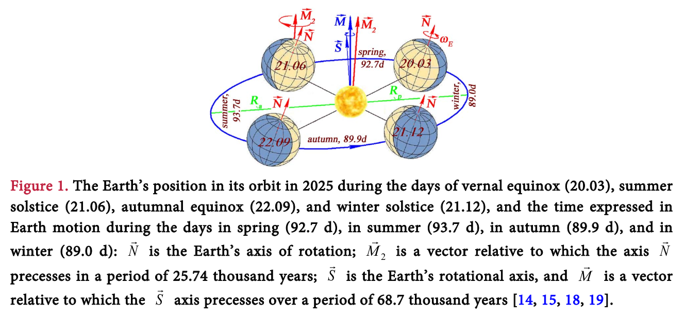
In the 2021 paper per Smulsky, the author makes predictions about the Earth’s position in orbit relative to the other planets.

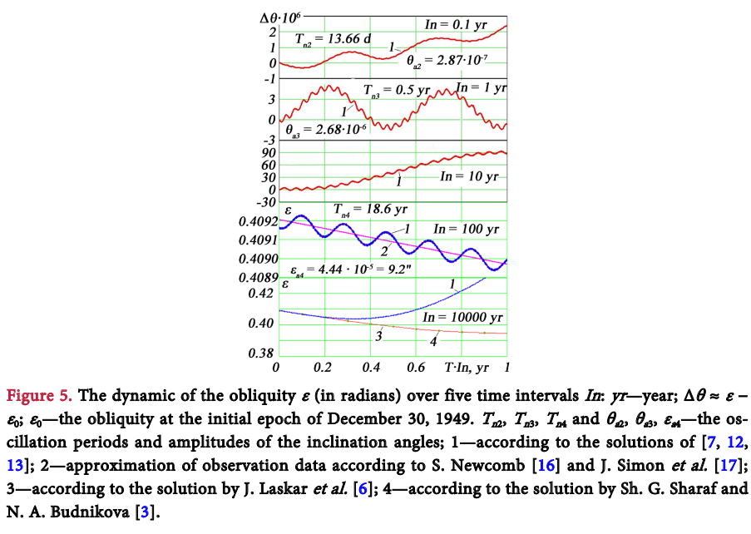
“As it is evident from Figure 5, over the time interval of In = 10 thousand years, a coincidence of the new obliquity ε 1 with the data 2 and 3 yielded by the first version of the Astronomical theory of climate change [1-6] is observed over a span of 2000 years… As can be seen from Figure 5, after 2000 years, obliquity, ε calculated within the new version 1 of the theory shows clear deviation. As it is seen from the graphs of Figure 6, over the time interval of 1 million years the oscillations of ε as yielded by the second version of the theory proceed in the range of 14.7˚ to 32.1˚, whereas the same range in the previous theory was from 22.08˚ to 24.45˚; in other words, the range of oscillations in the second version of the theory proves to be seven times greater.”
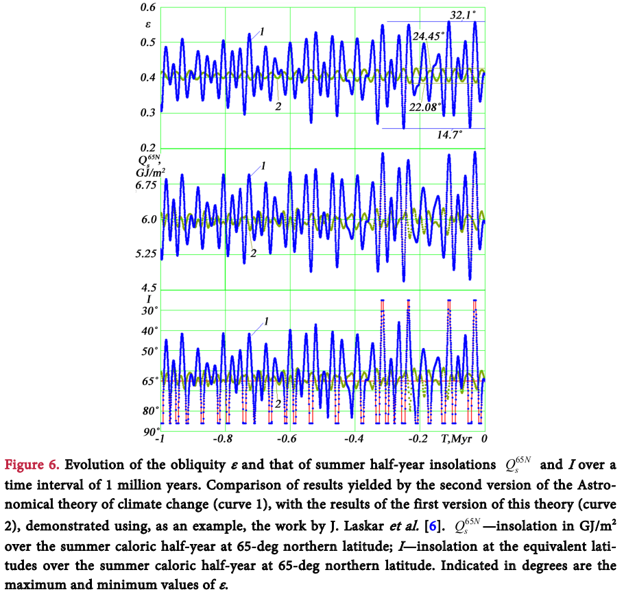
“In order to compare climates in other epochs with the current climate, we consider the insolations at equivalent latitudes I. For calculating of I, we consider the Earth’s latitude φ characterized by receiving same amount of summer solar radiation, Qs as in the current epoch. Figure 6 shows the insolation oscillations at equivalent latitudes I over a time interval of 1 million years. The lowest values I ≈ 90˚ indicate that at latitude 65˚N in summertime, there was less solar radiation on the pole than now. The highest values, such as I ≈ 23˚ at the time −0.031 million years denote epochs in which, in summertime, the amount of solar radiation having reached the Earth at latitude 65˚N exceeds the amount of solar radiation having fallen onto it presently in the tropics, i.e. in the equatorial area. Such profound insolation oscillations lead to substantial climate oscillations.”

So apparently, taking into consideration all the plausible orbital influence on the planet (same as the JU/NE cycle’s influence on the Sun) the planet’s insolation at the poles varies significantly every precession cycle, and not only that, but also the tilt varies from 14.806 degrees to an astounding 32.073 degrees.

A change in planetary insolation patterns at the poles mean different angles of exposure to solar radiation in every cycle, thus making the entire planet react differently when solar minima cycles come with strong flares, causing localized tectonic activity and tides. As previously discussed, this could show up as Geomagnetic wandering, but not true polar wandering. The tilt change is created by orbital influence.

If all gravitational precession forces are taken into consideration for the variable Milankovitch cycle calculation per Smulsky’s work, this would theoretically facilitate a torque mechanism for decoupling due to the tilt. However, these pole-wandering events do not necessarily create nor come with the same triggers that cause a core-mantle decoupling event. Correlation does not equal causation.

For the longer 25.74-thousand-year precession cycle, the deviation of the instantaneous axis from the average axis is about 23.58°, which translates to a movement of the pole over the Earth's surface in a circle with a radius of 2542 kilometers (approximately 2.542 km). This is astoundingly close to some supposed forecasts done by the Freemason Elite (quote Junho’s work), of about a 1700 to 2000 mile pole wandering movement (2736km to 3000km).
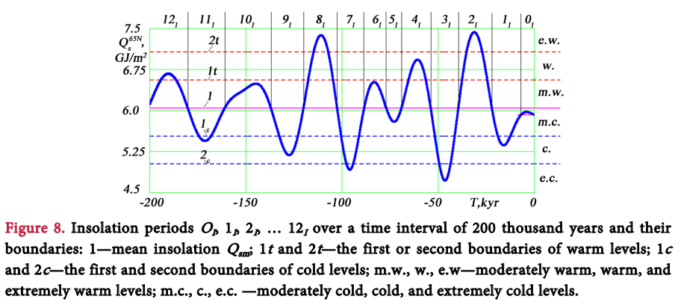
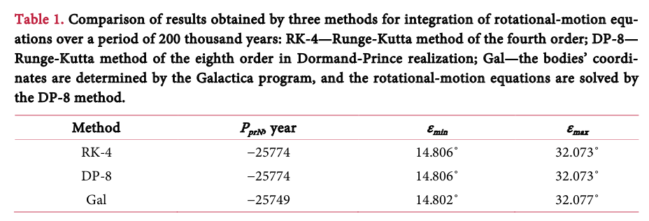
“Over the previous interval of 200 thousand years (see Figure 8), 13 climatic periods OI, 1I, 2I, 12I were identified [19, 22]. As a result of the comparison of these periods with paleoclimate data for Western Siberia over 50 thousand years, it was found that the periods 3I, 2I, 1I, OI refer respectively to the Ermakov ice age, Karginsky warming, Sartan glaciation, and Holocene optimum. Those events also correspond to ice ages and interglacial periods in Europe and North America.”

Jupiter + Neptune = Solar Sunspot

Exact Jupiter + Saturn = Strong tides (planetary tilt)

Jupiter + Venus + Earth = Solar Flare

Comets = Large Scale Decomposition of the ULVZ.

So going one by one, referencing the paleomagnetic record:

We will use Julian Calendar years for the following figures, given that its the standard when tracking astrological bodies. After, we will give tentative exact figures for each event (as the paleomagnetic and geological records are only approximates), given possible planetary orbit influences at around the same time.

Ermakov Ice Age: 44k years BP. Similar event is the Auel Cold Event (ACE), from Germany, 43,500 years BP. America saw the rapid, pronounced expansion of the Laurentide Ice Sheet (LIS) from a local minimum close to 42 ka BP. This was an extremely cold period with an extreme planetary tilt.

Closest Event: The Laschamp or Laschamps event, also termed the Adams event, was a geomagnetic excursion (a short reversal of the Earth's magnetic field). It occurred between 42,200 and 41,500 years BP, during the Last Glacial Period. It was discovered from geomagnetic anomalies found in the Laschamps and Olby lava flows near Clermont-Ferrand, France in the 1960s.
The Laschamp event was the first known geomagnetic excursion and remains the most thoroughly studied among the known geomagnetic excursions. This event involved a brief reversal of Earth’s magnetic field, and its geomagnetic pole positions seem to be aligned in characteristic with the Gothenburg excursion, I.e a stable oblique tilt.

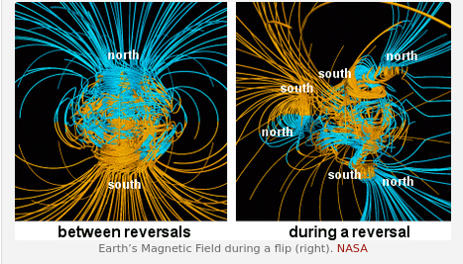

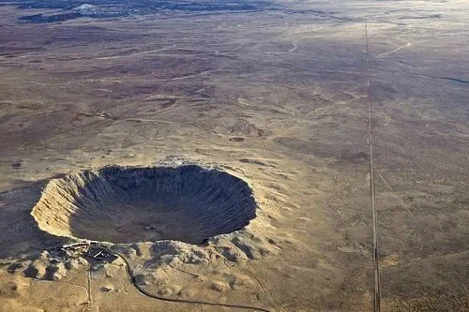
The Arizona Meteor Crater formed around 50,000 years ago. At that time, the local climate stayed much damper and cooler (coincidental with an approaching max cold tilt). The meteorite that created the crater constituted a type known as a nickel-iron meteorite. Estimates place its size at the time of impact at about 160 ft (50 m) in diameter. The latest estimates also place its speed at impact at 28,600 mph (45,760 kph). It didn’t change much of the surface, the area was possibly colonized in centuries.

It is important to note that these events seem to be separated by about 2000 years.
Dates in Julian:
Big crater impact in North America, Arizona: 49,500- 50k years BP = –15,646,220.5 to –15,828,842.5 BCE

Auel Cold Event / Ermakov Ice Age (from planetary tilt): 43,500 – 42,000 BP = –13,454,765.5 to –12,906,902.5.

Laschamp Event (dated from the New Zealand Kauri Tree): 41,560 to 41,050 years BP = –12,746,195.5 to –12,559,921.5.
Karginsky Warming: 36k approx from the chart - +. 60,000 to 25,000 years ago, recorded in Marine Isotope 3 Samplings. Not much else about this one.
Closest Event: Mono Lake Excursion. The Mono Lake Excursion is dated around 34,000 ya BP, and is also found at about 18,000 years B.P. (uncorrected Carbon-14) associated with basalt in Hawaii and exposed lake sediments in Mono Basin, CA. Another excursion is dated to about 26-30kya BP, so it seems this was quite a wobbly time.

Julian date: 34,000 ya BP = –9,984,962.5

Sartan Glaciation: The Sartan Glaciation (Last Glacial Maximum) was limited in extent in the Pekulney Mountains and dates to ∼20,000 yr BP.
Closest Event: Hilina Pali Geomagnetic Excursion (between 17k and 22k years BP). There is contradicting evidence on if this was a true wandering or not. A 2018 paper of data between 20kya and 15kya records no evidence of wandering in the Black Sea (an area not in the Euler axis), but there is evidence from papers in the Tyrrhenian Sea sediment and Jeju Island in Korea. This could be explained by the wandering being limited in degree, as it is caused by natural precession variation.
This excursion is in the time-frame harmonic of 14400 years before the Holocene Jupiter-Saturn perfect crossing. −21256, or 21257 BCE.

The Stellarium program, due to the limited dataset period does not have an accurate calculation for planetary orbits that far in the past (and I sadly don’t have access to Russian orbital calculations). So this will have to satisfy. Take with an enormous grain of salt.
A close Saturn-Jupiter conjunction to that date occurs at -21254, June 3. That is 14398 years apart in the same month.
The other closest conjunctions happens at -21234, January 20 (closest), and -2125, August 4. A Great Conjunction period!
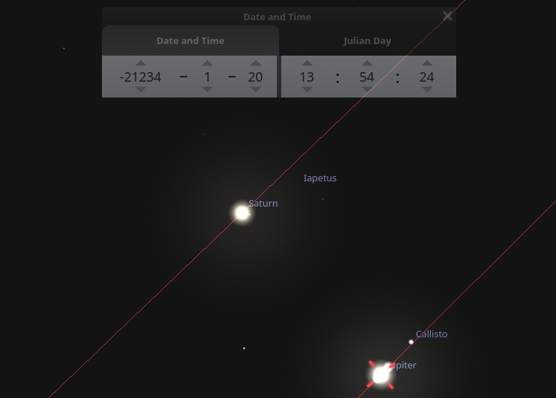
Regardless of if this is somewhat inaccurate, a Jupiter-Saturn conjunction like this would’ve happened around the time that the comet Encke could’ve passed close to the Earth:

“About 20,000 years ago, due to gravitational forces in the inner solar system it (the Comet Encke) undergoes a massive fragmentation event”

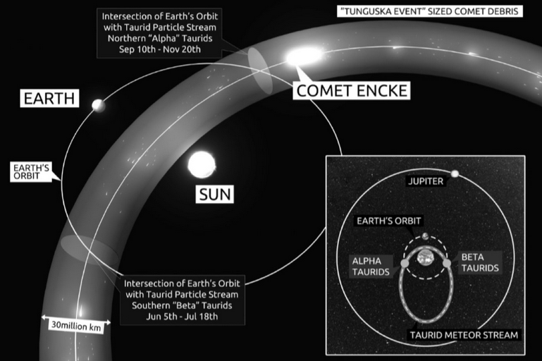

22k Years = –5,602,052.5
20k years, glacial maximum = –4,871,567.5
17k years = –3,775,839.5

The Hilina Pali debris avalanche in Hawaii may coincide with this glacial phase. This cluster of events would’ve given a spectacular, catastrophic like view to the people that got to see it.

Closest Event 1: “Herein we present the discovery of impact-related microspherules and elevated platinum concentrations in fine-grained sediments retained within seven Late Pleistocene bison and mammoth skull fragments from Alaska and the Yukon Territory, which potentially indicate a catastrophic origin for at least part of the frozen Beringian mucks. Our results point to repeated airbursts, including ground/ice impacts, and their associated blast winds33 as major factors in the emplacement of Alaskan and Yukon mucks and their included megafaunal and botanical remains. In addition, we consider an astronomical scenario in which Late-Pleistocene episodes of terrestrial bombardment were caused by cyclic intersections with cometary debris during formation of the Taurid Complex”

“The buried forest layers, range of radiocarbon dates, and microspherules associated with the vertebrate fossils indicate that deposition of the Alaskan and Yukon mucks would have required more than one impact event between ~48 and 18 ka B.P. (Fig. 9; Table S1). A possible mechanism for repetitive impacts on Earth is the cyclical intersection of its orbit with meteoroid streams containing numerous objects large enough (~10–100 m) to generate Tunguska-class airbursts and ground impacts. Since the late 1970s, a group of British astronomers34,61,62 has calculated that such a scenario likely affected Earth throughout Late Pleistocene time during formation of the Taurid Complex.”

“Closest” Event 2: “New SOCOL:14C-Ex model reveals that the Late-Glacial radiocarbon spike
in 12350 BCE was caused by the record-strong extreme geomagnetic solar storm”

Date: 12350 BCE, early March = -2,789,622.5

Sudden spike in atmospheric C-14 is likely linked to a geomagnetic excursion or major solar proton event (or both). This is the strongest known solar storm in late prehistory that may have left biological and cultural fingerprints as deep as it did radioactive ones. The skies burned in March.
This event also coincides in timing with Meltwater Pulse 1A, around 12,750 BCE and 11,550 BCE, in which the global sea level rose between 16 meters (52 ft) and 25 meters (82 ft) in about 400–500 years.

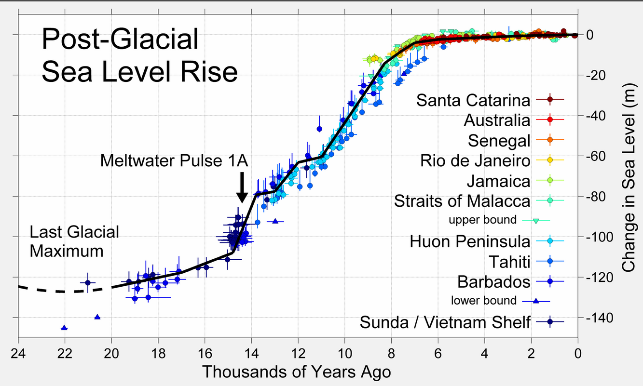
This last glacial maximum also aligns neatly with the previous predicted by Smulsky, and in the timing of a 14,400 harmonic.

Younger Dryas Event = 12,900 to 11,700 years Before Present and not visible in the Smulsky Timeline. The Comet Research Group has evidence proving that this was actually paired with some sort of enormous comet crash event, but there’s also plausible refutation for it.
Date: 12,900 – 11,700 BP = –2,278,345.5 to –1,840,054.5.

Closest events: “The Gotheburg Geomagnetic excursion”; The Gothenburg Magnetic Excursion in a broad sense ranges from 13,750 to 12,350 years BP and ends with the Gothenburg Magnetic Flip at 12,400−12,350 years BP (= the Fjärås Stadial in southern Scandinavia).
Excursion length dates: 13,750 to 12,350 years BP = –2,588,801.5 to –2,077,462.5, length of
Gothenburg magnetic flip length dates: –2,095,724.5 to –2,077,462.5.

The Gothenburg Magnetic Flip represents the shortest length excursion and the most rapid polar change known at present. There are multiple studies that detail the existence of this excursion and its strength.

The Younger Dryas (12900–11700 BP) overlaps with the Gothenburg Excursion (13750–12350 BP).
- The Flip itself (12400–12350 BP) lands just before the deep Younger Dryas plunge.
- If a comet impact occurred ~12,800 BP, it could’ve induced a major geomagnetic excursion and decoupling event as shown in the paleomagnetic data via mantle convection or shock perturbation. It would very easily cause a major decomposition of the ULVZ layer at the core mantle boundary, as previously discussed. This point is also the origin of the “Black Mat” and the 13k.y.a boundary layer.

Note the similarity between 12,350 BP and 12,350 years BCE in the radiocarbon spike. It is easy to get confused, but in fact, these events seem to be separated by 2000 years.

-8092 BCE: -1530321.39649 – close JS cross.

Holocene Optimum: between 9,000 and 5,000 years ago,
Missisipi floods = 9,160-8,900Yr BP.
Closest events: “Cosmogenic radionuclides reveal an extreme solar particle storm near a solar minimum 9125 years BP”
“Tree-rings reveal two strong solar proton events in 7176 and 5259 BCE”
Dates:
Holocene Optimum Start: –853,748.5
Holocene Optimum End: 607,221.5

Missisipi floods start approximate: -912,367
Missisipi floods end approximate: -817,402

Solar storm from cosmogenic radionuclides and Tree ring event 1: –899,402.5
Tree ring event 2: -199,864

These data points show the Holocene optimum was not uniformly quiet, it was peppered with energetic solar outbursts.

The first tree ring event was sandwiched by two J-S occultations of <1 degrees.
One was 19 yrs prior, & 319 years later was the closest in almost 14,400 years: An occultation.

Jupiter/Saturn occultations and near conjunctions predicted to occur in the time interval between 10000 BCE and 10000 CE using planetary ephemerides from the JPL DE-441 from NASA. These predictions depend entirely upon the accuracy of the ephemerides. The images are adapted from Stellarium :

Separation of 0.76 arcminutes or 0.0126 degrees, at January/27/-7194, = -906523.69
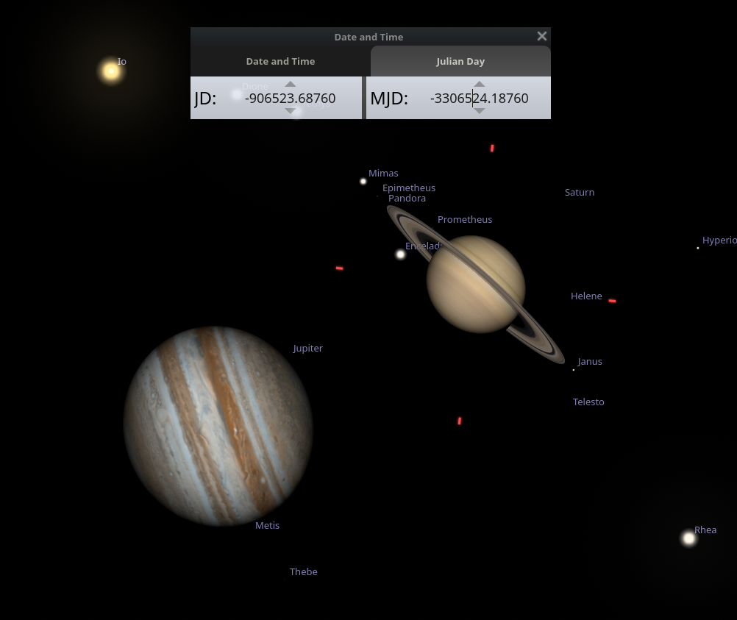

Saturn Jupiter occultation, 319 years later in June/1/-6856 = -782944.15118
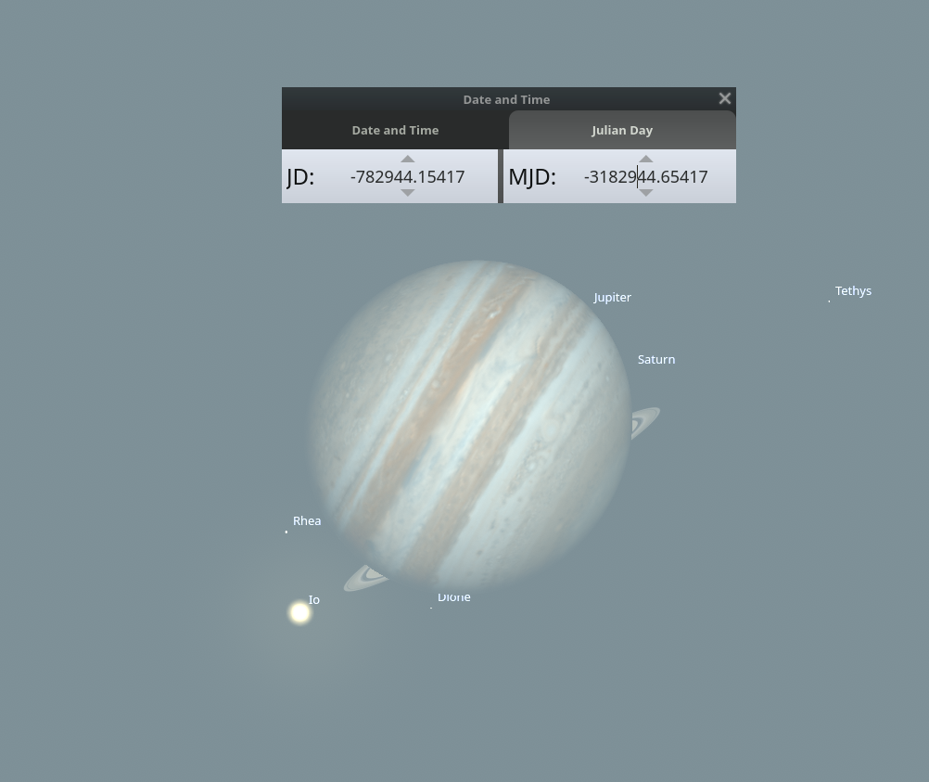

| J–S Conjunction | 1° angle | Approximately -906,523.69 | 7195 BCE |
| Missisipi floods start | Approximately -912,367 | 7,210 BCE |
| First Solar Flare | Strong solar proton event (Tree Ring Δ14C) | –899,402.5 | 7176 BCE |
| Missisipi floods end | Approximately -817,402 | 6,950 BCE |
| J–S Conjunction | Hyper-close occultation (~>0.1° angle) | –782,944.115 | 6857 BCE | in Virgo

This means there was at the same time, a planet tilt peak that at the same time made the planet be exposed to 2 extremely harsh solar flares, that happened within an exact, double, extremely close, J-S transit. Wow!

This event possibly scorched the Earth to great amounts.

These events (between the Younger Dryas and the Holocene warming event with its solar storms) also alignswith the early Holocene sea level rise (EHSLR), a significant jump in sea level by about 60 m (197 ft) during the early Holocene, between about 12,000 and 7,000 years ago, spanning the Eurasian Mesolithic:
Meltwater pulse 1B between c. 11.4–11.1 ka, a 7.5 m (25 ft) rise over about 160 years centered at 11.1 ka, which includes the end of Younger Dryas interval of reduced sea level rise at about 6.0–9.9 mm (0.2–0.4 in)/yr;
Meltwater pulse 1C between c. 8.2–7.6 ka, centered at 8.0 ka, a rise of 6.5 m (21 ft) in less than 140 years.

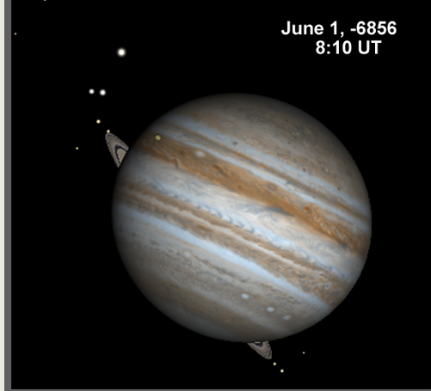

Coincidentally, the next time a Jupiter Saturn occultation like this (of less than 1 degree) will happen in 2 times in a year, then 1 time in a year around a thousand years later, in February 16 7541, June 17 7541, and February 24, 8674.

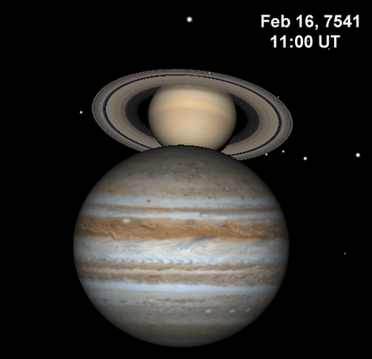
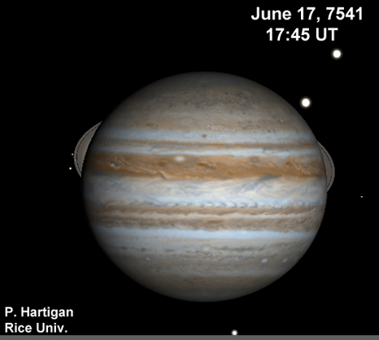
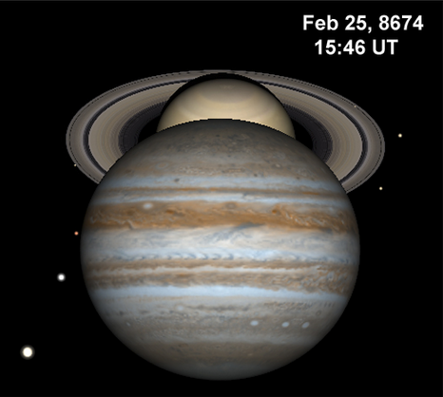
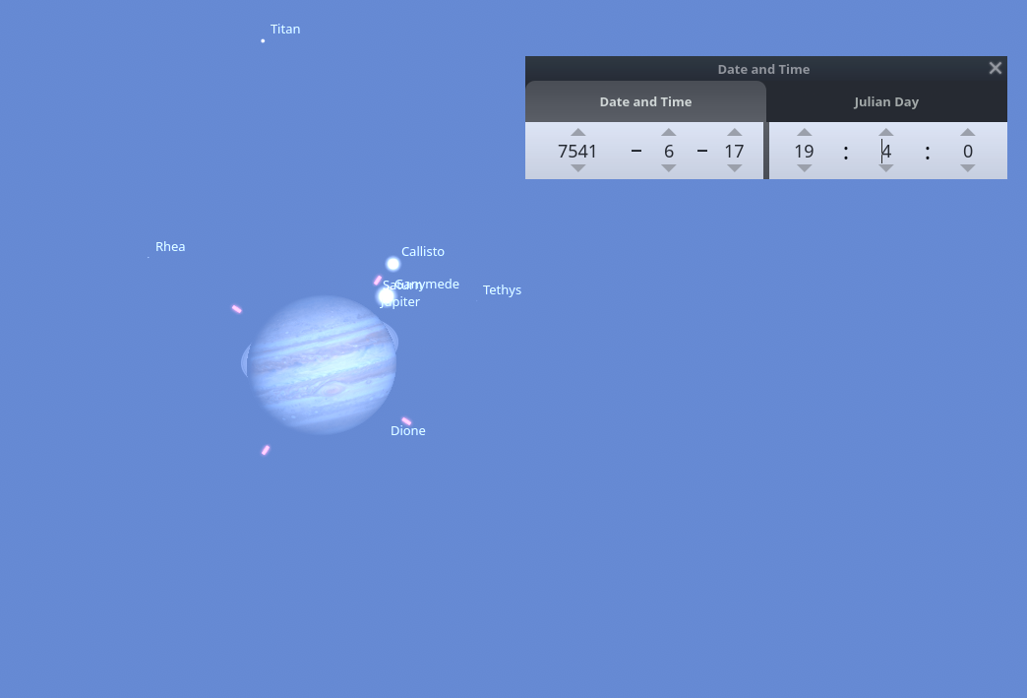
Using 440DTE Data from NASA.
4475521.21150 Julian days.

Between June 1, -6856 and June 17 7541, the time that would’ve passed is about 14,397 years and 16 days. That is 3 years shy from 14,400 years.

The June 1 6856 BCE date and proton storms also coincide with the Mid Holocene Geomagnetic Excursion, which also has inconsistent data on if it was a true ECDO 104 degree tilt event.

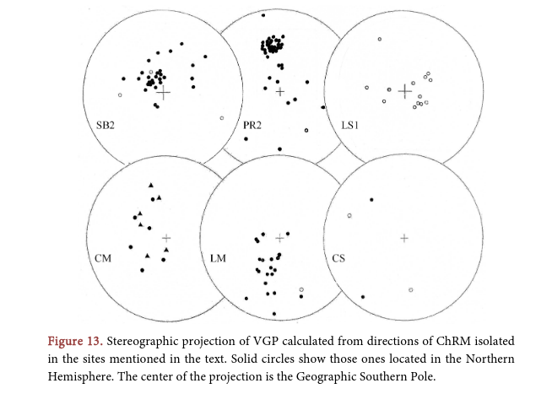

“Figure 13 depicts the virtual geomagnetic pole positions (VGP) calculated from the directions of Table 2. When plotted on a present world map, they show intermediate VGPs from the rotation axis of the Earth in the northern Hemis-phere between 60˚ and 30˚ (mainly in North Africa and Spain) and reverse VGPs located in the southern Hemisphere (Figure 14).”
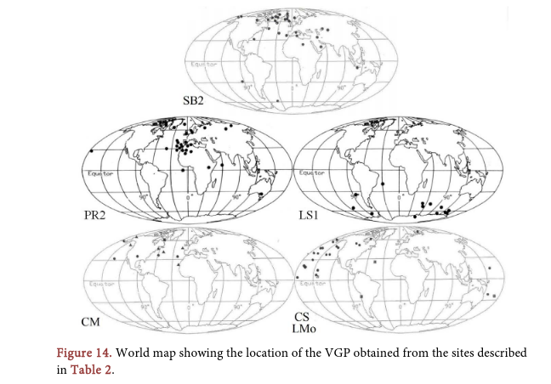

“These positions agree remarkably well with VGPs observed in previous paleomagnetic studies performed on Latest Pleistocene and Holocene sections from the southern cone of South America (Nami, 1999a, 2006, 2008, 2011, 2012; Nami et al., 2017).

Specifically, these positions agree with the following:

“New Paleomagnetic results and evidence for a geomagnetic field excursion during the pleistocene-holocene transition at Pichincha province, Ecuador “
“Paleomagnetic data are reported from three sedimentary sections from northwestern South America (Ecuador). The directions of natural remanent magnetism obtained from 109 oriented samples taken at four sites - Quito (QC), Mullimica (Mu), and El Tingo (ET) - showed that some recorded a magnetic component distinct from the present-day normal geomagnetic field (CGM). The characteristic magnetization was determined by progressive demagnetization of alternating fields. Analysis of the samples showed that the sections recorded a characteristic remanent magnetization of normal, intermediate, and reversed polarities during the Pleistocene-Holocene and Holocene transitions. Normal polarity directions were recorded in QC, while normal and intermediate polarity directions were recorded in Mu, and reversed virtual geomagnetic poles (VGPs) were recorded in the ET. QC and the upper part of Mu correspond to the Holocene paleosecular variation in Ecuador during the ∼≤4.7 ka BP. On the other hand, the lower part of the Mu record represents the transition from normal to intermediate directions that occurred at ≥∼5.6 ka BP. Two stable reverse-oblique records with a large distant fluctuation of the present-day geomagnetic field were observed in ET at ∼10.5 ka BP. The transitional virtual geomagnetic poles (VGPs) generally coincide with those recorded during the possible excursion during the Pleistocene-Holocene transition observed elsewhere on the planet. When plotted on a present-day world map, VGPs calculated from the QC normal samples are well clustered in northern North America, Greenland, and northern Europe; most of the Mu VGPs are located between 30° and 60°N latitude in North America, Greenland, western Europe, Africa, and the North Pacific Ocean. Most of the reverse ET directions cluster in a patch off southern Africa, with a few located in central Africa, eastern Australia, and Antarctica. An Ecuadorian paleopole was calculated from the resulting QC and Mu PGVs; other paleopoles of the same age were also processed from sites in North and South America. Notably, they match well, although they exhibited an angular offset of ∼15° with respect to the Earth's rotational axis. Finally, the hypothesis of a global excursional state of the GMC during the last ∼11.0 ka BP and its potential use as a dating tool for the 10.5 ka BP excursion are discussed.”
“Possible excursion during the Pleistocene-Holocene transition observed elsewhere on the planet”. The Pleistocene-Holocene transition occurred at 11,700 years BP. This date is widely accepted in geological, archaeological, and paleoclimatological contexts as the boundary between these two epochs. There are two stable reverse-oblique records at around the same timeframe. There are random clusters of virtual magnetic poles in the rest of the dates that seem to match up with solar events (and planetary tilts as predicted by Smulsky) including one 2000 years ago, but no oblique stability.

“Remarkably is that this distribution (the stable oblique one) shows strong similarities with the VGPs calculated for the Laschamp and Iceland basin excursions respectively dated at ~40 ky and ~180 - 220 ky BP interval (Laj & Channell, 2007). Is also remarkably, the agreement of VGPs located in southern Africa with the VGPs calculated for the Late Pleistocene excursion identified in several parts of Argentina and dated at ~26 - 30 ky BP (Orgeira et al., 1990, 1996; Vizán & Azcuy, 2010). Besides, the location of transitional VGPs in Africa and Australasia were observed in several records from different periods of the Earth history (e.g., Coe & Glen, 2004; Creer & Ispir, 1970; Gurarii, 2005; Herrero-Bervera & Coe, 1999; Hoffman & Singer, 2004; Ohno et al., 2008).”

“In the particular case presented in the previous sections, SB2, PR2, and mainly LS1 yielded new light to date with precision one of the largest amplitude GF fluctuations with reverse directions that happened during the Middle Holocene showing that one of the peaks of these oscillations oc-
curred at ~5.3 ky BP… As previously was noted by Nami (2012), in some areas of the southern cone of South America, during at least the last ~11 - 10 ky BP, the GF might have been undergoing an anomalous behavior with large amplitude fluctuations, occasionally reaching reverse polarity positions, more than once. If correctly represent the GF record, they are revealing that these kinds of directions might happen in a very short time span, probably decades or centuries; mainly during the terminal Pleistocene and early Holocene (~11 - 9/7 ky BP), middle (~5 - 4 ky BP) and late (~2.5 - 2.0 ky BP) Holocene… “
Again, the large amplitude fluctuations are only observed in the Pleistocene-Holocene transition.

Also, very low negative and positive H. G. Nami inclination values occurred in the last millennia and centuries (i.e. LM and CS; Nami, 2006, 2012). These kind of anomalous records were also observed in several parts of the Earth (Burakow & Nachasova, 1990; Clark & Kennett, 1973;
Dergachev et al., 2004; Guskova et al., 2008; Kochegura & Pisarevsky, 1994; Lund et al., 2007, 2008; Nami, 1999c, 2012, 2015; Nami et al. 2016, 2019; Noël, 1975, 1977; Noël & Tarling, 1975; Pospelova, 1981, 1990; Ransom, 1973; Raspopov et al., 2003; Urrutia Fucugauchi et al., 1995; Ortega-Guerrero & Urrutia Fucugauchi, 1997; Vitorello & Van der Voo, 1977; Woolin et al., 1971; Zhu et al., 1998; Wiegank et al., 1990). Hence, the hypothesis of the global excursional state of the Holocene GF with not coetaneous intermediate and reverse directions was proposed (Nami, 1999c).”

This passage shows three events that show geomagnetic excursions:

- Terminal Pleistocene/Early Holocene: ~11,000–9,000 or 7,000 years ago (right as the Ice Age ended and the Holocene began). The two events that happened here are the following:
-The Gothenburg Geomagnetic Excursion: in a broad sense ranges from 13,750 to 12,350 years BP. Some others disagree. Quite fast. Shows oblique stability in the geomagnetic record. Not as close as the second event:

- The Cluster of Solar flares: “Cosmogenic radionuclides reveal an extreme solar particle storm near a solar minimum 9125 years BP”
“Tree-rings reveal two strong solar proton events in 7176 and 5259 BCE”
7176 BCE= 9125 years ago = is between 7160–6900 BCE. Coincides with the Missisipi floods.
5259 BCE = 7283 years ago.

- Middle Holocene: ~Oscillations 5,000–4,000 years ago (including that peak at 5.3 ky BP), which coincides with the middle Holocene,
- Late Holocene: ~2,500–2,000 years ago (more recent history). 2600 years ago was the Carrington Event.

Carrington Event, From Wikipedia:

“Auroras were seen around the world in the northern and southern hemispheres. The aurora borealis over the Rocky Mountains in the United States was so bright that the glow woke gold miners, who were reported to have begun to prepare breakfast because they thought it was morning. It was also reported that people in the north-eastern United States could read a newspaper by the aurora's light.[8][14] The aurora was also visible from the poles to low latitude areas such as south-central Mexico,[15][16] Cuba, Hawaii, Queensland,[17] southern Japan and China,[18]New Zealand,[19] and even at lower latitudes very close to the equator, such as Colombia…

The signature of a large solar storm has been found for the years 774–775 and 993–994.Carbon-14 levels stored in 775 suggest an event about 20 times the normal variation of the Sun's activity, and 10 or more times the size of the Carrington Event.”

Furthermore, the text doesn’t stop with South America. It says that similar odd magnetic behaviors, like very steep positive or negative angles (called "inclination values"), have been found in rocks from all over the world, including Africa, Australasia, and other regions, even in the last few thousand years or centuries. Examples include:
- Low or reversed magnetic directions in the last millennia (e.g., the past 1,000 years).
- Records from places as far apart as Russia, North America, and China showing the same kind of instability.

Because these unusual magnetic records pop up globally, the author (Nami) proposes a big idea: the Earth’s magnetic field during the Holocene might be in a "global excursional state." This means it’s not just one or two random events, there could be a worldwide pattern of instability, with the magnetic field shifting or reversing in different places at different times (not all at once, or "not coetaneous").

So the Earth is constantly wobbling around and weakening its outer magnetic poles (even 2500 years ago) and this is responsive to Solar Flares. It does not mean that every single geomagnetic excursion (or even polar wander, as detailed in JJ Smulsky’s planetary tilts) coincides with an ULVZ layer decomposition and a planetary tilt, I.e an ECDO event.

Thus, there are only two events we can call true ULVZ decompositions and ECDO events, as they show stable obliquity:
- The Laschamp Excursion (possibly)1
- The period around the Younger Dryas Meteorite Event and subsequent Gothenburg Excursion.

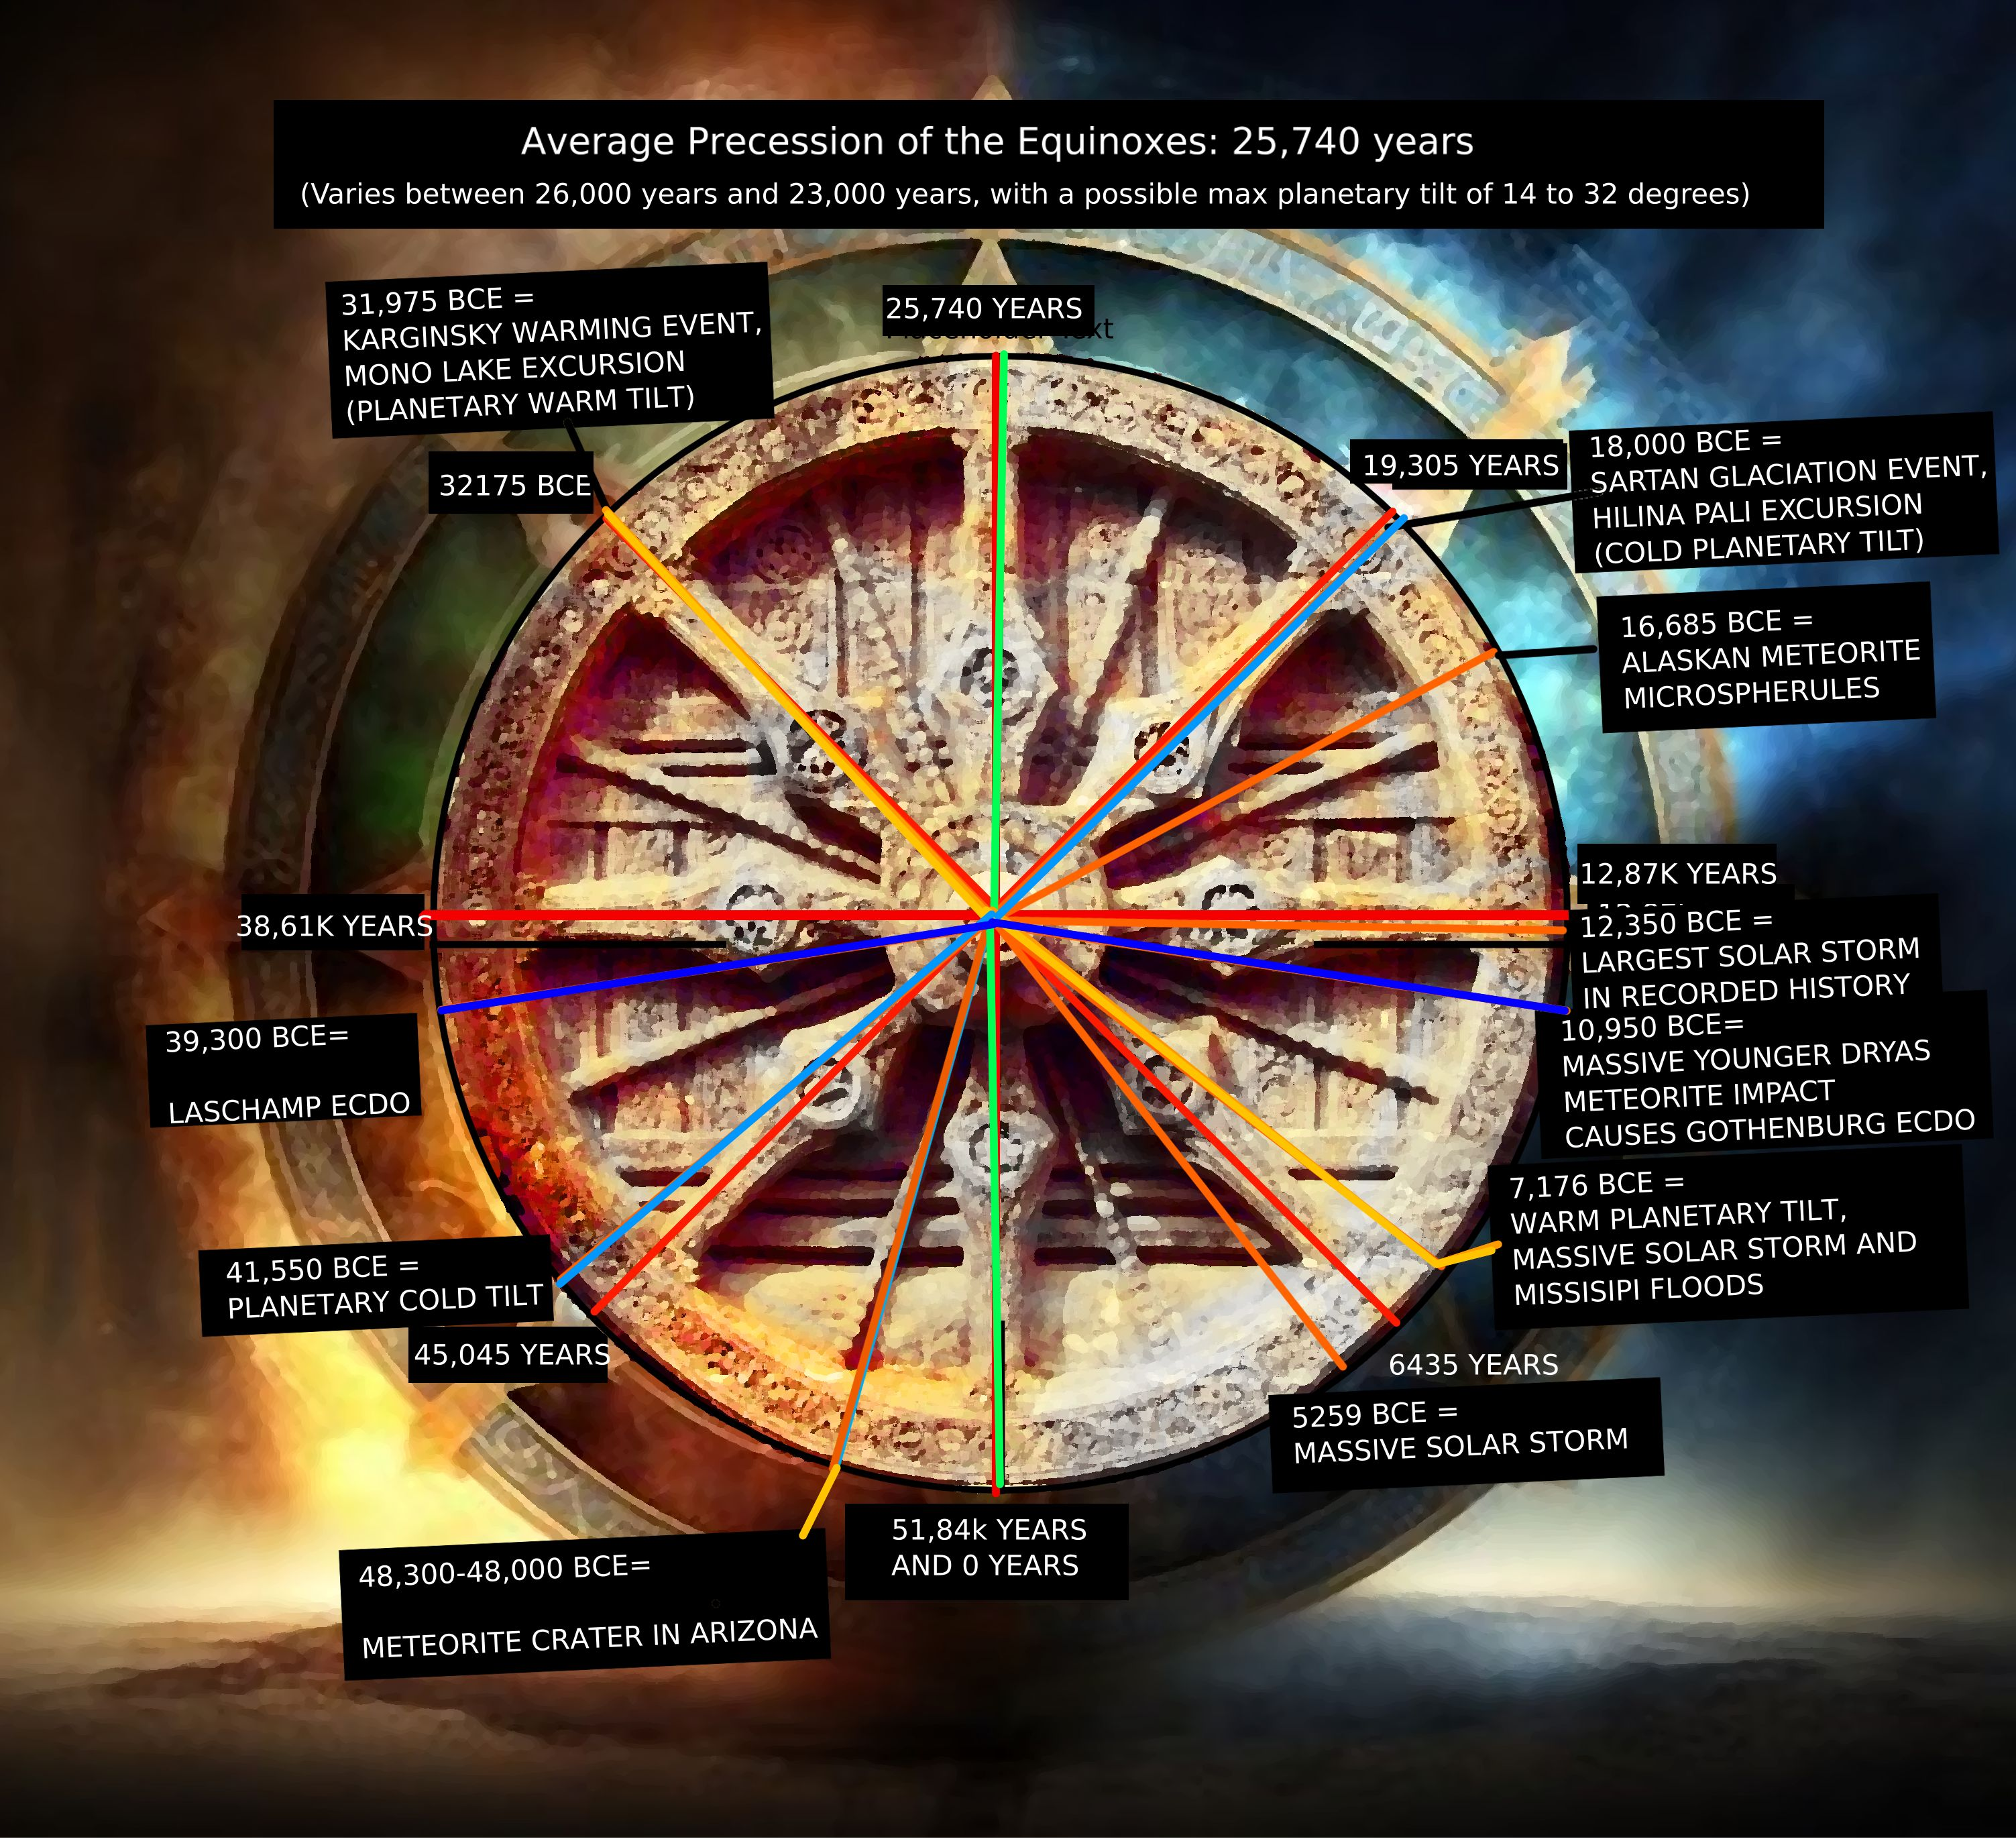
Between the 41,550BCE Planetary cold tilt and the 39,300BCE Laschamp ECDO how many years passed?
2,250 years.
Between the the Younger Dryas event of 10,950 BCE ECDO and the Warm Missisipi Planetary tilt of 7,176BCE and how many years passed?
3,774 years.
Between the Sartan Glaciation Event of 18,000 BCE and the Younger Dryas Event how many years passed?
7,050 years.
Between the Laschamp ECDO and the Mono lake excursion (planetary warm tilt) how many years passed?
7,325 years.
Between the old stable period: 12,870 years approx.
Laschamp Ecdo + Mono lake excursion + Old stable period +Sartan Glaciation Event + Younger Ecdo =

This has NOTHING TO DO WITH THE PRECESSION OF THE EQUINOXES!

This is NOT A NATURAL EARTH CYCLE.
(perhaps the sun is?)

COMET RESEARCH GROUP

The last great conjunction of all cycles likely occurred around 12,375 to 12,350 BCE, accounting for maximum orbital variations.

This timing aligns remarkably well with:
• The onset of the Younger Dryas period
• Major climate transitions at the end of the Pleistocene
• Potential correlation with the "Leo Age catastrophe" mentioned in astronomical literature.

Relevant to this timing, a recent study indicated that around 12,350 BCE, Earth experienced an extreme geomagnetic storm, potentially 500 times more intense than any previously recorded. This event, identified through the SOCOL:14C-Ex model, caused a significant radiocarbon spike detected in geological records. Such a solar event would have had dramatic effects on the environment and early human populations, possibly appearing as an apocalyptic phenomenon.
12,375 BCE corresponds to approximately 14,375 years ago... This places it within the Late Pleistocene epoch, near the end of the Last Glacial Period, a time of significant climatic and environmental change. This means we would be at about the window for another 14,400 year harmonic.

BIBLIOGRAPHY
- Huang, Haijun & Fan, Lili & Liu, Xun & Xu, Feng & Wu, Ye & Yang, G. & Leng, Chunwei & Wang, Qingsong & Weng, Jidong & Wang, Xiang & Cai, Lingcang & Fei, Yingwei. (2022). Inner core composition paradox revealed by sound velocities of Fe and Fe-Si alloy. Nature Communications. 13. 616. 10.1038/s41467-022-28255-2.
- Alfè, D. & Price, Geoffrey & Gillan, M.. (2001). Thermodynamics of hexagonal-close-packed iron under Earth’s core conditions. Phys. Rev. B. 64. 10.1103/PhysRevB.64.045123.
- Hikosaka, Koutaro & Tagawa, Shoh & Hirose, Kei & Okuda, Yoshiyuki & Oka, Kenta & Umemoto, Koichiro & Ohishi, Yasuo. (2022). Melting phase relations in Fe–Si–H at high pressure and implications for Earth’s inner core crystallization. Scientific Reports. 12. 10.1038/s41598-022-14106-z.
- Nishihara, Yu & Doi, Shunta & Tsujino, Noriyoshi & Yamazaki, Daisuke & Matsukage, Kyoko & Tsubokawa, Yumiko & Yoshino, Takashi & Thomson, Andrew & Higo, Yuji & Tange, Yoshinori. (2023). Rheology of Hexagonal Close‐Packed (hcp) Iron. Journal of Geophysical Research: Solid Earth. 128. 10.1029/2022JB026165.
- Kim, Taehyun & O’Rourke, Joseph & Lee, Jeongmin & Chariton, Stella & Prakapenka, Vitali & Husband, Rachel & Giordano, Nico & Liermann, Hanns-Peter & Shim, Sang-Heon & Lee, Yongjae. (2023). A hydrogen-enriched layer in the topmost outer core sourced from deeply subducted water. Nature Geoscience. 16. 1-7. 10.1038/s41561-023-01324-x.
- Vasily, Potapkin & Mccammon, Catherine & Glazyrin, Konstantin & Kantor, Anastasia & Kupenko, Ilya & Prescher, Clemens & Sinmyo, Ryosuke & Smirnov, Gennady & Chumakov, A & Rüffer, R & Dubrovinsky, Leonid. (2013). Effect of iron oxidation state on the electrical conductivity of the Earth's lower mantle. Nature communications. 4. 1427. 10.1038/ncomms2436.
- Lasbleis, Marine & Deguen, Renaud & Cardin, P & Labrosse, Stéphane. (2015). Earth's Inner Core dynamics induced by the Lorentz force. Geophysical Journal International. 202. 548-563. 10.1093/gji/ggv155.
- Kawano, Katsutoshi & Nishi, Masayuki & Kuwahara, Hideharu & Kakizawa, Sho & Inoue, Toru & Kondo, Tadashi. (2024). Extensive iron–water exchange at Earth’s core–mantle boundary can explain seismic anomalies. Nature Communications. 15. 10.1038/s41467-024-52677-9.
- Ohta, Kenji & Cohen, Ronald & Hirose, Kei & Haule, Kristjan & Shimizu, Katsuya & Ohishi, Yasuo. (2012). Experimental and Theoretical Evidence for Pressure-Induced Metallization in FeO with Rocksalt-Type Structure. Physical review letters. 108. 026403. 10.1103/PhysRevLett.108.026403.
- Ni, Huaiwei & Zheng, Yong-Fei & Mao, Zhu & Wang, Qin & Chen, Ren-Xu & Zhang, Li. (2017). Distribution, cycling and impact of water in the Earth's interior. National Science Review. 4. 879-891. 10.1093/nsr/nwx130.
- Boulard, Eglantine & Guyot, François & Menguy, Nicolas & Corgne, Alexandre & Auzende, Anne-Line & Perrillat, Jean-Philippe & Fiquet, Guillaume. (2018). CO2-induced destabilization of pyrite-structured FeO2Hx in the lower mantle. National. 5. 10.1093/nsr/nwy032.
- Hu, Qingyang & Liu, Jin. (2020). Deep mantle hydrogen in the pyrite-type FeO2-FeO2H system. Geoscience Frontiers. 12. 10.1016/j.gsf.2020.04.006.
- Hagedoorn, J.M. & Greiner-Mai, H. & Ballani, L.. (2010). Determining the time-variable part of the toroidal geomagnetic field in the core-mantle boundary zone. Physics of the Earth and Planetary Interiors. 178. 56–67. 10.1016/j.pepi.2009.07.014.
- Stewart, D. N. et al. “Geomagnetism, Earth rotation and the electrical conductivity of the lower mantle.” Physics of the Earth and Planetary Interiors 92 (1995): 199-214.
- Zhang, Bao-Hua & Guo, Xuan & Yoshino, Takashi & Xia, Qun-Ke. (2021). Electrical conductivity of melts: Implications for conductivity anomalies in the Earth's mantle. National Science Review. 8. 10.1093/nsr/nwab064.
- Shebalin, John. (2021). Mantle Electrical Conductivity and the Magnetic Field at the Core–Mantle Boundary. Fluids. 6. 403-411. 10.3390/fluids6110403.
- Fu, Suyu & Chariton, Stella & Prakapenka, Vitali & Shim, Sang-Heon. (2023). Hydrogen and Silicon Effects on Hexagonal Close Packed Fe Alloys at High Pressures: Implications for the Composition of Earth's Inner Core. Journal of Geophysical Research: Solid Earth. 128. 10.1029/2022JB026016.
- Dobrosavljevic, Vasilije & Zhang, Dongzhou & Sturhahn, Wolfgang & Chariton, Stella & Prakapenka, Vitali & Zhao, Jiyong & Toellner, T. & Pardo, Olivia & Jackson, Jennifer. (2023). Melting and defect transitions in FeO up to pressures of Earth’s core-mantle boundary. Nature Communications. 14. 10.1038/s41467-023-43154-w.
- Yoshino, Takashi. (2009). Laboratory Electrical Conductivity Measurement of Mantle Minerals. Surveys in Geophysics. 31. 163-206. 10.1007/s10712-009-9084-0.
- Williams, Quentin & Hemley, Russell. (2001). Hydrogen in the deep Earth. Annual Review of Earth and Planetary Sciences. 10. 365-418.
- Smyth, Joseph & Holl, Christopher & Frost, Daniel & Jacobsen, Steven & Langenhorst, Falko & Mccammon, Catherine. (2003). Structural systematics of hydrous ringwoodite and water in Earth's interior. American Mineralogist. 88. 1402-1407. 10.2138/am-2003-1001.
- Morard, Guillaume & Antonangeli, Daniele & Bouchet, J. & Rivoldini, Attilio & Boccato, Silvia & Miozzi, Francesca & Boulard, Eglantine & Bureau, Helene & Mezouar, Mohamed & Prescher, Clemens & Chariton, Stella & Greenberg, Eran. (2022). Structural and Electronic Transitions in Liquid FeO Under High Pressure. Journal of Geophysical Research: Solid Earth. 127. 10.1029/2022JB025117.
- Hentschel, Bernhard. (2014). Stoichiometric FeO as Metastable Intermediate of the Decomposition of Wustite at 225 °C. Zeitschrift Fur Naturforschung Section A-a Journal of Physical Sciences - Z NATURFORSCH SECT A. 25. 10.1515/zna-1970-1241.
- Koyama, Takao & Shimizu, Hisayoshi & Utada, Hisashi & Ichiki, Masahiro & Ohtani, Eiji & Hae, Ryota. (2006). Water Content in the Mantle Transition Zone Beneath the North Pacific Derived from the Electrical Conductivity Anomaly. AGU Geophysical Monograph Series. 10.1029/168GM13.
- Ohtani, Eiji. (2020). The role of water in Earth's mantle. National Science Review. 7. 224-232. 10.1093/nsr/nwz071.
- Hu, Qingyang & Yang, Liuxiang & Liu, Jin & Kim, Duck Young & Meng, Yue & Zhang, Li & Prakapenka, Vitali & Mao, Wendy. (2017). When water meets iron at Earth's core mantle boundary. National Science Review. 4. 10.1093/nsr/nwx109.
- Foley, Bradford & Driscoll, Peter. (2016). Whole planet coupling between climate, mantle, and core: Implications for rocky planet evolution. Geochemistry, Geophysics, Geosystems. 17. n/a-n/a. 10.1002/2015GC006210.
- https://www.science.org/content/article/electric-material-mantle-could-explain-earths-rotation
- Hydridic Earth, Vladimir N Larin, 1993.
- Saeidi, Hesam & Hansen, Samantha & Nyblade, Andrew. (2023). Deep Mantle Influence on the Cameroon Volcanic Line. Geochemistry, Geophysics, Geosystems. 24. https://doi.org/10.1029/2022GC010621
- Deng, J., Karki, B. B., Ghosh, D. B., & Lee, K. K. M. (2019). First‐principles study of FeO2Hx solid and melt system at high pressures: Implications for ultralow‐velocity zones. Journal of Geophysical Research: Solid Earth, 124, 4566–4575. https://doi.org/10.1029/ 2019JB017376
- Lai, V. H., Helmberger, D. V., Dobrosavljevic, V. V., Wu, W., Sun, D., Jackson, J. M., & Gurnis, M. (2022). Strong ULVZ and slab interaction at the northeastern edge of the Pacific LLSVP favors plume generation. Geochemistry, Geophysics, Geosystems, 23, e2021GC010020. https://doi.org/10.1029/2021GC010020
- Yves Moussallam, Clive Oppenheimer, Alessandro Aiuppa, Gaetano Giudice, Manuel Moussallam, et al.. Hydrogen emissions from Erebus volcano, Antarctica. Bulletin of Volcanology, 2012, 74 (9),pp.2109-2120. 10.1007/s00445-012-0649-2. Insu-00782326.
- Catling & Zahnle, Scientific American,2009, The Escape of Planetary Atmospheres
- Lammer, Helmut & Kasting, James & Chassefière, Eric & Johnson, Robert & Kulikov, Yuri & Tian, Feng. (2009). Atmospheric Escape and Evolution of Terrestrial Planets and Satellites. 10.1007/978-0-387-87825-6_11.
- Rizo, Hanika & Andrault, Denis & Bennett, Neil & Humayun, Munir & Brandon, A. & Vlastélic, Ivan & Moine, Bertrand & Poirier, A. & Bouhifd, Mohamed & Murphy, David. (2019). 182W evidence for core-mantle interaction in the source of mantle plumes. Geochemical Perspectives Letters. 6-11. 10.7185/geochemlet.1917.
- Messling, N., Willbold, M., Kallas, L. et al. Ru and W isotope systematics in ocean island basalts reveals core leakage. Nature 642, 376–380 (2025). https://doi.org/10.1038/s41586-025-09003-0
- Ferrick, Amy & Korenaga, Jun. (2023). Long-term core-mantle interaction explains W-He isotope heterogeneities. Proceedings of the National Academy of Sciences of the United States of America. 120. e2215903120. 10.1073/pnas.2215903120.
- Simone Pilia, Giampiero Iaffaldano, D. Rhodri Davies, Mohammad Ismaiel, Paolo A. Sossi, Scott Whattam, Dapeng Zhao, Hao Hu. Ghost plumes hidden beneath Earth’s continents. Earth and Planetary Science Letters, Volume 666, 2025. 119467, ISSN 0012-821X, https://doi.org/10.1016/j.epsl.2025.119467. (https://www.sciencedirect.com/science/article/pii/S0012821X25002663)
- Parai, Rita. (2022). A dry ancient plume mantle from noble gas isotopes. Proceedings of the National Academy of Sciences. 119. 10.1073/pnas.2201815119.
- Nicola Warwick, Paul Griffiths, James Keeble, Alexander Archibald, John Pyle, University of Cambridge and NCAS and Keith Shine, University of Reading - Atmospheric Implications of Increased Hydrogen Use. April 2022 (Government of UK)
44. Hydrogen Properties - Hydrogen Fuel Cell Engines and Related Technologies: Rev 0, December 2001.
45.
46. Effective hydrodynamic hydrogen escape from an early Earth.
47.

